## **WRIGHT, Joseph**

In late 1927 Lewis Cecil Ward petitioned for the dissolution of his marriage with Mary Ward (formerly Leonard), on the ground of her adultery with one Joseph Wright (who was joined as co-respondent), between January 1, 1920, and April 5, 1927, at Beecroft and other places.

Lewis Cecil Ward married Mary Leonard on 14th May 1900, at Newtown. The children of the marriage, two boys and a girl, were all over the age of 16 years in 1927.**1**

Joseph Wright ‘for many years was a works manager for Stuart Bros., builders, and was now living in partial retirement at Murray-road, Beecroft, where he runs an establishment which includes orchard, poultry farm, a nursery, and a refreshment-room.’

Mary acted as housekeeper and assistant in the nursery and in conducting the refreshment room, also connected with the nursery business.

Mrs. Ward denied the allegations of misconduct.

It was in 1918 that Mrs. Ward first began to work for Mr. Wright, at his home, then in Marrickville. His wife was an invalid, and she visited the house two days a week to do housework.

In 1924, she said, after Mr. Wright had retired from his position as works manager for Stuart Bros, and gone to live at Beecroft, she went to live in his house.

Early in 1926, Mrs. Wright, after some years in a mental hospital, died.

Mr. Wright stated that he first met Mrs. Ward In 1916, when she applied to him, as works manager for Stuart Bros., for a job for her son. Later on, so he said, he engaged Mrs. Ward to do the housework at his home two days a week, as his Invalid wife was not able to attend to It.

Mr. Wright is here described as a bent, bald, little man of sixty-eight, with a very red face and prominent red nose; he was a flower-grower living at Murray-road. Beecroft.**2**

Mr. Wright denied that Ward and the other raiders caught him and Mrs. Ward together in the same bedroom. He had never been familiar with Mrs. Ward at his house at Beecroft or elsewhere. She was his housekeeper and nothing more.

He said that it was a scandalous shame that he had been named as co-respondent, and that it was within his rights to employ a housekeeper.**3**

Joseph Wright, aged 69 years, is also described as ‘a thin, sparse man, grey-haired. partially bald, with a stoop, and a florid countenance whose most marked feature is a nose of the Duke of Wellington type. He Is clean-shaven and inclined to be choleric in disposition.’

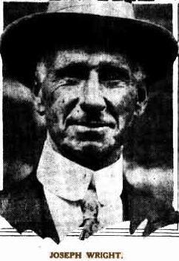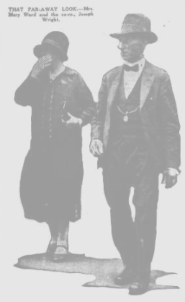

Mrs. Ward Is described as ‘fair, fat, and over forty.’

‘Mary is no Helen of Troy in looks, but she is what is called buxom and 'comfy.'**4**

The Judge came to the conclusion that Mrs. Ward and Wright had committed misconduct on 24th November 1926 and 3rd April 1927, the date of the first raid on the Beecroft property. The raids were conducted by the husband, a detective and another man.

The Judge gave the husband his decree nisi on the grounds of the wife's misconduct, and dismissed the wife's petition for a decree on the grounds of desertion. The husband was ordered to pay the wife's costs, and the co-respondent the husband's costs.**5**

Joseph Wright, late of Murray Farm-road, Beecroft, died on 28th February 1937, aged 78 years. He had two sons – George & Norman. His remains were interred in the Church of England Cemetery, Rookwood (section 12).**6**

**Bibliography**

1 Sydney Morning Herald (NSW: 1842 - 1954), Thursday 24 November 1927

2 Truth (Sydney, NSW, Sun 27 Nov 1927

3 Sun (Sydney, NSW), Fri 9 Dec 1927

4 Truth (Sydney, NSW), Sun 11 Dec 1927

5 Truth (Sydney, NSW, Sun 18 Dec 1927

6 Sydney Morning Herald, Mon 1 Mar 1937