## **TURNER, Henry Floyd**

Henry Floyd Turner was born in early 1866, the third son of Thomas and Jane Emily Turner, at Thongsbridge, Holmfirth, West Yorkshire, England.

He married Catherine Victoria Campbell in 1892, Victoria. It is not known when he arrived in Australia but after the English Census of 1881.**1**

In Feb 1895 H. F. Turner, poultry farmer, was elected to the committee of the Beecroft Progress Association.**2**

In April 1895 Mr. H. F. Turner of “Somerfield,” Beecroft, advertised for sale pure-bred Leghorn Cockerels.**3**

In November 1895 he was advertising for let a furnished cottage in Beecroft for five weeks from the end of November. He was also advertising for sale White Leghorn and Plymouth Cocks and Hens.**4**

In February 1896 he was elected as Honorary Treasurer of the Beecroft Progress Association. This would prove a short-lived position, to be taken over by Mr. Melbourne Green.**5**

That month he advertised for sale a comfortable brick residence at Beecroft, 11 acres of land, part planted, stabling, etc., convenient to the station.**6**

Mr. and Mrs. Turner left Beecroft that month for Coolgardie, and Mr. W. A. Brodie took over the vacated house for residential purposes.**7**

Henry Floyd Turner died on 3rd July 1896 at *Strathview*, Wentworthville-road, Strathfield.

The following year his widow Catherine married John J. Savage, in the district of St. Leonards.**8**

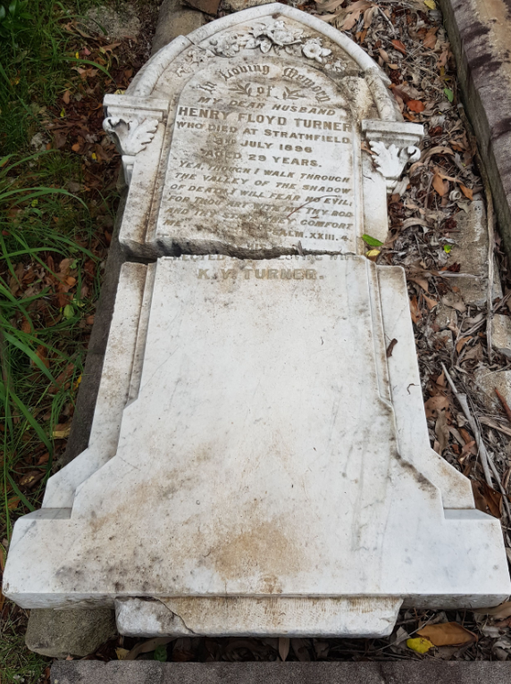

**Bibliography**

1 NSW Registry of Births Deaths and Marriages; The Daily Telegraph, Mon 6 Jul 1896; Ancestry.com

2 The Cumberland Argus and Fruitgrowers Advocate, Sat 9 Feb 1895

3 Evening News, Wed 3 Apr 1895

4 The Daily Telegraph, Sat 2 Nov 1895

5 The Daily Telegraph, Thu 6 Feb 1896; The Cumberland Argus and Fruitgrowers Advocate, Sat 2 May 1896

6 The Daily Telegraph, Sat 8 Feb 1896

7 The Cumberland Argus and Fruitgrowers Advocate, Sat 29 Feb 1896; The Cumberland Argus and Fruitgrowers Advocate, Sat 2 May 1896

8 The Daily Telegraph, Sat 4 Jul 1896; The Daily Telegraph, Mon 6 Jul 1896; The Sydney Mail and NSW Advertiser, Sat 11 Jul 1896; NSW Registry of Births Deaths and Marriages

**NOTE**: Additional information contained within Beecroft Cheltenham History Group book ‘Beecroft and Cheltenham, the Shaping of a Sydney Community to 1914’.