## **STOBO, Thomas**

Thomas Stobo was born on 29th January 1858, at Kiama, N.S.W., the son of Robert (-1891) and Mary (nee Spears; 1827-1914) Stobo.

His father, Captain Stobo then being in charge of the shipping arrangements at Kiama. That year his father was declared insolvent. During the 1860’s and 1870’s his father was the I.S.N. Co.’s [Illawarra Steam Navigation Company] agent at Kiama. The family lived in a house on Church Point, some portions of which residence are still remaining in the structure of the present Church of England Rectory.**1**

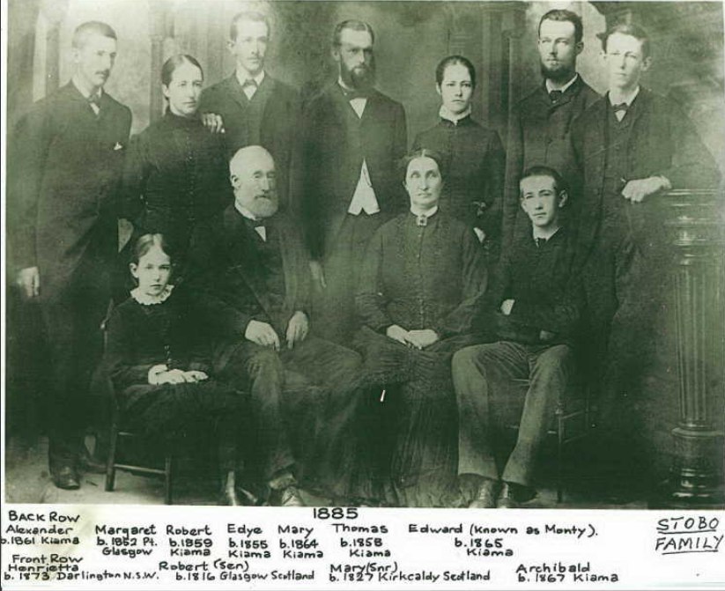

On 24th February 1879 Thomas Stobo married Harriet Susan Wren, daughter of Thomas Wren, at the residence of the bride’s parents, Fort Denison, Port Jackson.**2**

[Thomas’s wife, Mary Ann, would die at Fort Denison in 1880, aged 62 years]

Children of the marriage were:

1879 - Minnie Jane Wren, at Fort Denison, Port Jackson, Sydney; died 1972

1882 – Thomas Charles Wren, at Balmain; died 1947**3**

On 23rd March 1884 Harriet, the wife of Thomas Stobo, died at her residence, 39 St Mary-street, North Kingston (in the district of Newtown), at the age of 27 years.**4**

In his younger days he was a keen sculler, and a member of the Mercantile Rowing Club. He competed in rowing regattas in Sydney harbour. In September 1889 Thomas Stobo was elected as an auditor for the Port Jackson Sailing Club. In 1890 he was appointed starter and umpire of East Sydney Amateur Sailing Club. In 1892 he competed in the sweepstake race for the big boats of the harbour.**5**

On 3rd February 1890, at Bourke-street Congregational Church, Sydney, he married Charlotte Elizabeth MacAlpine, daughter of George W. Macalpine, of Glasgow.**6**

In 1892 a daughter, Elizabeth Macalpine Stobo, was born in the district of Redfern (died 1975).**7**

In October 1893 Thomas Stobo opened a small general store in Beecroft, with authorisation to sell postage stamps. He offered a large room where meetings could be held, and the Beecroft Progress Association held a meeting there in November of that year, and he was unanimously elected a member of the association, after handing out his home brew of hop beer to the association members. This meeting place for the association was used for some years. Stobo’s store offered an economic advantage compared to individual orders from Sydney.**8**

In January 1894 a public meeting was held at the store for the purpose of urging the Railways Commissioners to erect an overhead bridge at Beecroft. In February Thomas was elected to a committee of six, in the Beecroft Progress Association. Further public meetings were held at the store for various issues.**9**

In October 1895 the Postal Department approved of the Post Office being removed from the Railway Station to Stobo’s store, but with reference to the telephone communication it was not considered advisable, seeing that only a short distance separated Stobo’s store from the station. On 1st November the Post Office was removed from the railway station to Mr. Stobo’s store, with Mr. Stobo the designated postmaster, with a microphone connecting with the telegraph at the station to be fixed in his office. Delays in postal services had been experienced at the station, as the stationmaster also had postmaster duties. The new Post Office, under Mr. Stobo’s management was considered a great improvement.**10**

In February 1896 he advertised for let a cottage of 4 rooms, with wood and water, with plenty of ground. In April he was elected as a sideman for the churchwardens of St. John’s Church of England, Beecroft. In September, after 5 years in business, Mr. Stobo was finding his store too small, and erected a shop at the station end of his premises, and the following month occupied the new store, which measured 27 feet by 15 feet, having brick walls and galvanised iron roof, with the floor on the same level as the footpath.**11**

In April 1899 his son, Tom, was driving the grocer’s cart which entered a rut in the road. He was hurled backwards and rendered unconscious, but eventually recovered. In September the Works Department commissioned a water table at the front of his store, the footpath being impassable in wet weather. In 1901 portion of Railway Crescent between Stobo’s store and the police station was almost impassable due to the culvert silting up.**12**

In September 1903 Thomas Stobo was returning from the city with upwards of half a ton of goods, and when opposite Harrison’s, in Beecroft, the wheel of his cart suddenly came off. He fell to the ground under the shaft and the horse, which also fell. His cries for help was heard and assistance soon arrived. In the meantime, the horse had struggled to its feet. Thomas’ right leg was bruised and lacerated but no bones were broken, and he eventually recovered.

The following year Thomas Stobo had employed Jack Meally as carter, who, when loading goods in the railway yard, his young horse got scared by a train, and made off. Meally managed to bring the horse to a standstill, with effort.**13**

In March 1905 it was reported that Mr. Stobo had purchased some land in Copeland street, close to Mr. Slingsby’s property. By this time land was becoming difficult to obtain. In December the land on which the original church of St. John’s, Beecroft, stood was sold by public auction, and was secured by Mr. T. Stobo, at £625. ‘The allotment has a frontage of about 80ft. to the main road, and runs right back to the Railway Parade. A new church is to be built upon a more suitable site secured by the Trustees of the Church some time ago. The present building, when removed, will be re-erected as a school-room.’14

In July 1906 Mr. Stobo was about to have the size of his store doubled. By September extensive additions and improvements were in the course of progress. In February 1907 his postboy, named Healy, had an accident with a pea rifle.**15**

On 3rd June 1908, at St. Alban’s Church, Five Dock, Thomas Wren Stobo, only son of Mr. T. Stobo, Beecroft, married Miss Mabel Ellis, ward of Mr. and Mrs. S. Small, Ryde. Thomas junior would later serve in the 1st World War.**16**

In October 1910, ‘Mr. Stobo, the well-known storekeeper, sold out last week to Messrs. Drummond, of the Northern Rivers. Mr. Stobo, who had been carrying on the Beecroft business for 17 years, intended to enjoy a good holiday with his family, and proposes moving to a waterside suburb for a change.’

In September 1911 Mr. and Mrs. Stobo and Miss Stobo returned to took up their residence in Beecroft, after a sojourn in Waverley.**17**

In 1912 Mr. Stobo was operating as a land agent, as Mr. John Pringle had bought, through Mr. Stobo, a dwelling in York-street, Beecroft, belonging to Mrs. W. Little.**18**

In 1914, Mr. Stobo, in conjunction with Messrs. Hardie and Gorman, were involved in the sale of the whole of the Beresleigh subdivision at Beecroft. A weatherboard cottage realised £710, and the allotments from 15/- to £3/2/6 per foot. Total Sale, £2257/15/-.**19**

In October 1916 Thomas Wren Stobo, now in the Army, wrote home from Salisbury Plain, Wiltshire, England, to say that the training was hard and the weather very cold. In late 1917 it was reported that Mr. Stobo’s son, Thomas junior, gunner, was expected back from the war, invalided.**20**

In August 1919 he was elected as a vice-president of the Beecroft Bowling Club, with a membership of 58, with two associate members and 24 honorary members. Seventeen soldiers were admitted as honorary members.**21**

On 1st August 1927 Thomas Stobo’s wife, Charlotte Elizabeth, died at her residence, “Glenesk,” Copeland-road, Beecroft, aged 65 years. She was the sister of Miss R. Macalpine, Woollahra.**22**

On 12th February 1929, Thomas Stobo married for the third time, to Miss Mary Greig, only daughter of Mr. and Mrs. Grieg, of Bimbi. The wedding took place at *Eurabbo*, Bimbi, home of Mr. and Mrs. Steele Caldwell. Mr. Caldwell is reported to have driven the first load of wool from the Bland to Campbelltown, at the age of 17 years.

The 3rd Mrs. Stobo would die in 1949.**23**

On 18th April 1930 Thomas Stobo died at a private hospital at Eastwood, aged 72 years.

‘Mr. Stobo was born 72 years ago at Kiama, his father, the late Captain Stobo, of Darling House, Miller’s Point, being in charge of the shipping arrangements at Kiama at the time. Mr. Stobo opened one of the first shops in Beecroft, and lived at that centre for 36 years, doing much to develop the suburb. He was one of those responsible for founding the Beecroft Presbyterian Church and the Beecroft Bowling Club, and he was interested in local charities. In his younger days he was a keen sculler, and a member of the Mercantile Rowing Club. One son, Mr. Thomas Stobo (Rose Bay) and two daughters, Mrs. J. Fleming (Eastwood) and Miss Minnie Stobo (Eastwood) survive.’

His remains were cremated at Rookwood.**24**

**Thomas Stobo**

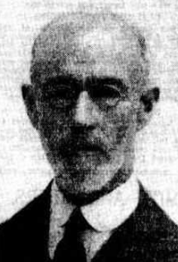

**Bibliography**

1 Registry of Births, Deaths and Marriages; The Sydney Morning Herald, Thu 11 Mar 1858; The Kiama Reporter and Illawarra Journal, Wed 6 Jan 1943; Ancestry.com

2 The Sydney Mail and NSW Advertiser, Sat 8 Mar 1879

3 NSW Registry of Births, Marriages and Deaths

4 NSW Registry of Births, Marriages and Deaths; The Sydney Morning Herald, Mon 24 Mar 1884; The Sydney Morning Herald, Thu 3 Apr 1884

5 Evening News, Mon 13 Apr 1885; The Sydney Morning Herald, Thu 24 Sep 1885; Evening News, Thu 12 Sep 1889; Evening News, Mon 24 Oct 1890; Evening News, Mon 24 Oct 1890; The Australian Star, Thu 10 Mar 1892

6 The Daily Telegraph, Wed 26 Feb 1890

7 NSW Registry of Births Deaths and Marriages

8 New South Wales Government Gazette, Tue 10 Oct 1893; The Cumberland Mercury, Sat 14 Oct 1893; The Cumberland Mercury, Sat 2 Dec 1893; The Cumberland Mercury, Sat 9 Dec 1893

9 The Cumberland Argus and Fruitgrowers Advocate, Sat 20 Jan 1894; The Cumberland Mercury, Sat 3 Feb 1894

10 The Cumberland Argus and Fruitgrowers Advocate, Sat 19 Oct 1895; The Cumberland Argus and Fruitgrowers Advocate, Sat 26 Oct 1895; The Cumberland Argus and Fruitgrowers Advocate, Sat 1 Feb 1896

11 The Daily Telegraph, Thu 6 Feb 1896; The Cumberland Argus and Fruitgrowers Advocate, Sat 23 Apr 1898; The Cumberland Argus and Fruitgrowers Advocate, Sat 17 Sep 1898; The Cumberland Argus and Fruitgrowers Advocate, Sat 22 Oct 1898

12 The Cumberland Argus and Fruitgrowers Advocate, Sat 8 Apr 1899; The Cumberland Argus and Fruitgrowers Advocate, Sat 16 Sep 1899

13 The Cumberland Argus and Fruitgrowers Advocate, Sat 26 Sep 1903; The Cumberland Argus and Fruitgrowers Advocate, Sat 23 Jul 1904

14 The Cumberland Argus and Fruitgrowers Advocate, Sat 11 Mar 1905; The Cumberland Argus and Fruitgrowers Advocate, Sat 9 Dec 1905

15 The Cumberland Argus and Fruitgrowers Advocate, Sat 28 Jul 1906; The Cumberland Argus and Fruitgrowers Advocate, Sat 15 Sep 1906; The Cumberland Argus and Fruitgrowers Advocate, Sat 23 Feb 1907

16 The Daily Telegraph, Tue 30 Jun 1908

17 The Cumberland Argus and Fruitgrowers Advocate, Sat 22 Oct 1910; The Cumberland Argus and Fruitgrowers Advocate, Sat 9 Sep 1911

18 The Cumberland Argus and Fruitgrowers Advocate, Sat 24 Feb 1912

19 The Cumberland Argus and Fruitgrowers Advocate, Sat 24 Feb 1912; Sunday Times, Sun 25 Jan 1914

20 The Cumberland Argus and Fruitgrowers Advocate, Sat 7 Oct 1916; The Cumberland Argus and Fruitgrowers Advocate, Sat 1 Dec 1917

21 The Cumberland Argus and Fruitgrowers Advocate, Sat 9 Aug 1919

22 The Sydney Morning Herald, Tue 2 Aug 1927

23 Cootamundra Herald, Mon 18 Feb 1929; NSW Registry of Births Marriages and Deaths

24 The Sydney Morning Herald, Mon 21 Apr 1930; The Sydney Morning Herald, Mon 21 Apr 1930; The Sydney Morning Herald, Tue 22 Apr 1930

**NOTE**: Additional information contained within Beecroft Cheltenham History Group website and book ‘Beecroft and Cheltenham, the Shaping of a Sydney Community to 1914’.