## **SPURWAY, Robert William**

Robert William Spurway, a scion of an old pioneering family, was born in the parish of Ryde in 1865, on his father's (James Spurway’s) orchard in Dundas, and educated first under the late Mr. Sharp and afterwards at the Fort-street school. He left his studies at the age of 14 in order to help his father, who owned an orchard at Dundas, and remained with him for 6 years.

[James Spurway married Maria Smith in 1858, in the district of Ryde. James was the son of George and Frances.]**1**

In 1885 Robert W. Spurway married Emily Thornton, in the district of Sydney.

Emily was born at Albion Park, on the South Coast, the daughter of Edwin and Rebecca.

Marrying Miss Emily Thornton, he acquired 15 acres of land on Murray-road, Beecroft. The road divided the property, 5 acres lying on the north side and 10 acres on the south. The whole five acres on the north were laid down in oranges, whilst the south orchard contained mostly summer fruit.

‘A young bed of two acres was laid down some 12 months ago [about October 1901] in sevilles, emperor mandarins and other varieties of oranges. Both orchards are thoroughly drained, several hundred feet of drain piping running through both places. Roads 10 feet wide intersect the ground on all hands, as Mr. Spurway is a firm believer in wide roadways through an orchard, and since he was born and bred on an orchard his opinion on this matter should count for something. The oranges on his place are mostly the Parramatta seedlings, though he is experimenting with Joppas and Lisbon lemons. All the trees are budded on to orange stocks, a process to which he pins his faith. His mode of working the ground is breaking it up thoroughly with a hoe once a year and running a Planet, jun., periodically through it. To the south and east of the five-acre plot a stretch of bush land acts as a very desirable break, so that the orchard, which slopes both to north and south, is splendidly sheltered. There is every indication of a splendid main crop for next season, and this season's main crop, all of which has not yet been taken off, was exceedingly good. The secret of his excellent crop is attributed by him to his keeping the ground thoroughly stirred whether weedy or not.’**2**

The only child of the marriage was:

Ethel M., born 1886, district of Ryde**3**

On 30th April 1885 R. W. Spurway’s grandfather, George Spurway senior, died, aged 84 years.

‘He was one of the oldest residents of the Field of Mars and had resided in the district for upwards of 60 years. He was the chief promoter of the building of St. Paul's Church, Pennant Hills, as well as continuing to support the stipend of the minister ever after. Later on he gave the ground for a site to erect the Public School at Dundas, which was opened in 1869 by Sir Henry Parkes. As an ornament he planted the three pine trees in front of the school. At that day one-third of the cost was required from the people. To that Mr. Spurway was the principal contributor. He was made a member of the local Board, and also for many years acted as Road Trustee.

By steady industry he acquired a considerable property. Always having a great desire to see his family in good homes around him he succeeded some years ago in achieving that object by giving and dividing the whole of his property amongst them. Mr. Spurway was first employed in the family of the late Mr. Gregory Blaxland, afterwards with the late Dr. Forster, of the "Brush Farm," and he leased from the latter for several years the oldest orchard in the colony. For many years he gave liberal subscriptions to the principal public charities. For the last twenty years he had lived a retired life. About sixteen years earlier he met with a severe accident whilst driving a restive horse, and, though after months of suffering he recovered, yet ever after he continued to be afflicted with great pain, which he bore with great patience and submission.’

‘The funeral was followed by a long cavalcade of vehicles and horsemen to the vault at Ryde Cemetery, and his remains ware borne to the grave by eight of his grandsons. Mourners included sons William, James and George Spurway, and sons-in-law Thomas Hughes and George Drury, and stepson H. W. Johnston.’**4**

In April 1895 ‘Robert W. Spurway, with his brother George, decided to try their luck at Coolgardie, and left “the land of golden fruit” for the ‘land of yellow metal,’ by the first steamer sailing after the Easter holidays.’**5**

In October 1900 ‘Thomas Alcock, on bail, was charged with having stolen a quantity of oranges, valued at 8s., from the orchard of Robert Spurway, at Beecroft. Mr. Spurway said he had no desire to press the charge, and thought the accused had some excuse for being on the premises, as he was in the company of Aiken, the caretaker. The P.M. said the Bench had arrived at the conclusion, that in view of all the circumstances, a fine instead of imprisonment would meet the ends of justice. The defendant was fined 30s, together with 7s witness' expenses, or 14 days.’**6**

On 3rd January 1901, at Beecroft, Emily Spurway, wife of Robert W. Spurway, died.

‘The fecundity of the land is seen in a patch of oats in front of the house in the southern orchard, which is fully four feet high and as even as a billiard table, besides being very thick. This patch of land was originally the flower garden, but on the death of his wife 2½ year ago, Mr. Spurway could not attend to the garden, and consequently sowed it in oats.’**7**

Robert W. Spurway would go to the Boer War in South Africa.

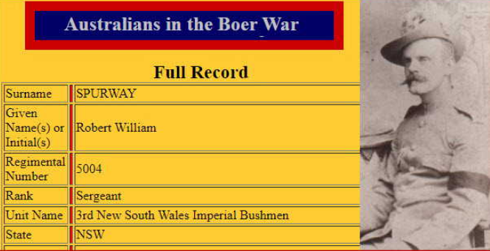

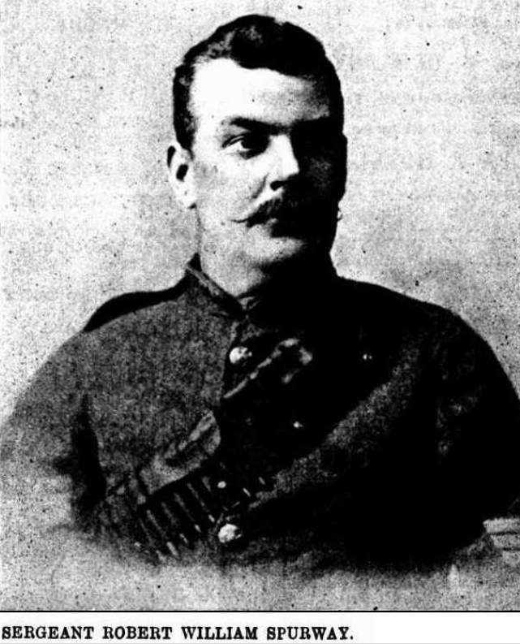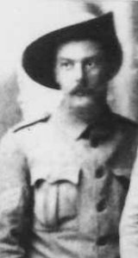

‘For 19 years our subject [Robert W. Spurway] has been a member of ‘H’ Company of the 3rd Infantry regiment. Last February 12 months, when Colonel Cox returned to New South Wales to form the 3rd regiment of mounted rifles for active service in South Africa, no consideration could restrain Mr. Spurway from going to the front. Casting loose the plough, he immediately volunteered and was gladly enrolled owing to his many years of experience in the service. Going to Moore Park, he had hardly left the tram when he met an old friend, Staff-Instructor J. Lamont, who on learning his desire to go to the front, took him to the barracks at once and had him passed as fit for service, after which his examination or test in shooting and riding was a mere matter of form for he had a reputation for both. Mr. Spurway was at once drafted to fill up the 1st mounted rifles, but very shortly was drafted into the 3rd Regiment M.R's. On the 6th April 1901, he left Sydney on the transport Australia.’

‘Orders were received to proceed to Durban [South Africa] and disembark. A landing being effected, the men had to camp for two days on shore without any camping equipage, even blankets being conspicuous by their absence. On the morning of the first day in camp, between two and three, the cold was so severe that the men pulled down some loose boxes and lit a fire to keep life in themselves. On the second day blankets were served out. Many had fallen ill and become otherwise disabled; but the strongest of the party entrained for Pietermaritzburg. Reaching this place, a further journey to the Mooi River was made, and a few days' training gone through with there. Mr. Spurway, it may here be stated, started as troop sergeant. Volkrust was the next objective point ; and a march to the Transvaal by way of Majuba Hill and Lang's Nek, through Ladysmith, Glencoe and Tugela (where Lord Roberts' son was killed and General Sir Redvers Buller's reverses began, his guns being captured) was speedily undertaken. It was a heartrending sight to see numbers of graves in batches, the only solace being that they were extraordinarily well looked after. Arriving at Volkrust, after a two-days' rest, the party set out to join the column which was reported to be at Bakenkop. There Sergeant Spurway and his troop joined Colonel Cox with Colonel Remington, C.B., in command of the flying column. Leaving Bakenkop, a trek was made through the Utrecht district to the Pongola Scrub, where the force was brought into contact with Louis Botha, and this was Sergeant Spurway's introduction to fire. The Boers being in admirable position, the column was forced to return after a slight loss on both sides had been incurred. The strength of the Australian party was between 900 and 1000 men, with a battery of artillery and the Inniskillen Dragoons, altogether about 1000 strong. This force was called upon to endure much hardship and suffered a great deal from exposure and the fact of being for months literally in rags. During his 14 months' experience with the 3rd Mounted Rifles, Sergeant Spurway can account for a hundred and odd night marches, and in many instances the men were from 20 to 24 hours at a stretch in saddle, without dismounting, and sometimes without shifting. Scrapping, skirmishing and fighting were daily occurrences, especially on the flanks and in the rear.’

‘After the 3rd Mounted Rides embarked for New South Wales, Mr. Spurway remained behind for further service. He was chosen one of the six to represent the regiment at the Coronation, but the parsimony of the Government prevented him from being present at that ceremony. He joined the 3rd New South Wales Imperial Bushmen and proceeded to Klerksdorp in the Western Transvaal, 1400 miles from Cape Town. When a good distance from their starting point, peace was declared and their services being no longer required, at the end of July the regiment embarked for home at Durban on the *Drayton Grange* which was not a very comfortable boat by any means. Sickness prevailed after leaving Durban, hospitals were improvised on the aftermost parts of the troop deck. Two days after leaving Albany two troopers were buried and, three successive days after that, a trooper was cast into the sea each day. When the ship arrived in Melbourne all the sick were landed and the rest sailed for Sydney, thankful to see the harbour once more. Speaking of South Africa as a possible home for some of the colonials, Mr. Spurway says that there is a great future for it, both as a mining and agricultural country, and also for stock raising. As an agricultural place it will be a big rival to America. Fruit of all kinds grow exceptionally well, though there are certain drawbacks, such as hail-showers, etc. It is magnificently watered, and, under ordinary circumstances, is very healthy. Having had an opportunity of remaining a few days in Johannesburg, he says, that people would do well to wait a while and not rush the place immediately, as it is in a very unsettled condition just yet.’

‘Mr. Spurway was offered 3000 acres of land at a nominal rental for five years, with the option of purchasing at the end of that time at a stated price, the terms extending over 22 years. The Government would supply fencing material delivered at the nearest railway station free of cost, and stock at prices that ruled prior to the war. The only conditions imposed by the Government were: (1st) That a certain acreage had to be laid down in Australian forest trees and (2nd) that he should possess £500. Of course, the offer to Mr. Spurway would apply to anyone who had taken part in the war on the side of Britain. The only casualty that occurred to Mr. Spurway during his 18 months of continuous active service was the following : — In July three squadrons of the 3rd M.R.'s were sent to drive the Boers across the Klipp River, in the Vrede district, to effect a safe passage to a convoy from Hatrand to Utrecht. Mr. Spurway was troop sergeant to the squadrons, and his mount turned turtle, crushing his chest wall, breaking two ribs and contusing his shoulder severely. Four men were told off to look after him and bring him into camp. Whilst two of these were looking for some timber to improvise a hurdle, a large body of Boers opened fire at 700 to 800 yards range. The pinging of the bullets within a few inches of the heads of the sufferer and his two companions induced Sergeant Spurway to beg his companions to leave him to his fate and save themselves, but the four noble fellows (the other two having returned) indignantly refused. Seeing that argument was useless, Spurway begged them to lift him on to his horse and he would make the attempt to save his companions by saving himself. They lifted him on to his horse, and this heroic soldier, with a smashed chest wall and broken ribs, in excruciating agony rode away, chased by a horde thirsting for the blood of the party ; but at that moment a part of the rear guard led by Sergeant Maxwell, hearing the firing, turned and came to their assistance, dispersing the Boers in double quick time. Once he was chipped on the shoulder by a bullet and another went through the cuff of his jacket.

Mr. Spurway, for his services, sports a medal with two bars, one for the Orange River and the other for the Transvaal, and he also wears the Cape Colonial Star. During his campaign he had one horse shot under him and 4 others worn out and shot.’**8**

In 1907 Robert, orchardist, was living on the Beecroft Road, the property consisting of 5 acres.**9**

In 1909 Robert W. Spurway married Marion Fraser, in the district of Sydney. In 1910 they selected at Byrill Creek, where they resided for 32 years, before moving to Fingal.**10**

Children of the marriage (all at Murwillumbah, N.S.W.):

Mysie F. Spurway, born 1910

Alice C. Spurway, born 1912

Robert J. Spurway, born 1916

John F. Spurway, born 1918

Maria S. Spurway, born 1919**11**

In 1912 Robert’s father, James Spurway, died at his residence, Darley-road, Manly. ‘Mr. James Spurway, J.P., was widely known and highly respected in the districts of Dundas, Parramatta, and Ryde. He was born at Dundas in 1837, in which village he resided for 59 years. He followed the occupation of an orchardist, and has been succeeded by his son, Mr. F. E. Spurway, the present Mayor of Dundas. Fifteen years previous he retired from active business, and went to reside at Manly, where his death took place, his remains being interred in the local cemetery. The late Mr. Spurway leaves a widow and a family of ten - six sons and four daughters. The sons are: Mr. James Spurway, Secretary for Railways; Mr. G. T. Spurway, inspector in the interlocking branch of the Railway Department; Mr. F. E. Spurway, J.P., orchardist, and Mayor of Dundas; Messrs. Robert and Arthur Spurway, dairy farmers on the Tweed River; and Mr. Benjamin Spurway, absent in Canada.’**12**

On 5th March 1920, Robert’s mother, Maria, died at her late residence, "Lloloma," 17 Darley Road. Manly.**13**

On 10th August 1944, the death occurred suddenly in Murwillumbah of Mrs Marion Spurway aged 66 years, wife of Mr Robert William Spurway, of Fingal (two years) and formerly of Byrrill Creek (32 years). Mrs Spurway took an active part in organisations for the betterment of Byrrill creek and was a Sunday-school teacher for a number of years. Besides her husband, a family of three daughters and two sons survive.**14**

On 19th September 1951, Robert William Spurway, of Tweed River district, relict of the late Marion Spurway and loving father of Ethel (Mrs. M. McDonnell, [only child from 1st marriage]), Mysie (Mrs. A. D. O'Hara) Allie (Mrs. F. G. Spurway), Eva (Mrs. S. W. Chad), Robert and John, died in his 87th year.**15**

**Bibliography**

1 NSW Registry of Births Deaths and Marriages; Cumberland Argus and Fruitgrowers Advocate, Sat 25 Oct 1902

2 NSW Registry of Births Deaths and Marriages; Cumberland Argus and Fruitgrowers Advocate, Sat 25 Oct 1902; Tweed Daily (Murwillumbah, NSW), Sat 12 Aug 1944

3 NSW Registry of Births Deaths and Marriages

4 Sydney Morning Herald, Fri 1 May 1885; Sydney Morning Herald, Sat 2 May 1885; Sydney Morning Herald, Mon 4 May 1885; Cumberland Mercury, Sat 9 May 1885

5 Cumberland Argus and Fruitgrowers Advocate, Sat 6 Apr 1895

6 Cumberland Argus and Fruitgrowers Advocate, Sat 27 Oct 1900

7 Sydney Morning Herald, Thu 3 Jan 1901; Cumberland Argus and Fruitgrowers Advocate, Sat 25 Oct 1902

8 Cumberland Argus and Fruitgrowers Advocate, Sat 25 Oct 1902

9 Hornsby Council Ratepayers List 1907

10 NSW Registry of Births Deaths and Marriages; Tweed Daily (Murwillumbah, NSW), Sat 12 Aug 1944

11 NSW Registry of Births Deaths and Marriages

12 NSW Registry of Births Deaths and Marriages; Cumberland Argus and Fruitgrowers Advocate, Sat 20 Jan 1912

13 Daily Telegraph (Sydney, NSW), Sat 6 Mar 1920

14 Tweed Daily (Murwillumbah, NSW), Sat 12 Aug 1944

15 Sydney Morning Herald, Sat 22 Sep 1951

**Further References:**

‘Beecroft and Cheltenham, the Shaping of a Sydney Community to 1914’ by Beecroft Cheltenham History Group