## **SMITH, James**

James Smith was born on 4th March 1816.

He was the son of William (1784-1865, died Pennant Hills) & Isabella (nee Jones; 1790-1864, died Pennant Hills) Smith, who were married at Bedminster, Somerset, England, in July 1801.

William and Isabella would have a very large family, establishing themselves at Pennant Hills.

**Isabella Smith (nee Jones)**

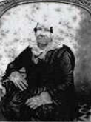

James was baptised on 24th March 1816, at St. John’s Anglican Church, Parramatta.

Samuel Marsden, chaplain, signed the register.

James’ father, William, was a convict who arrived on the ship *Indian* (as noted in the Church Register) on 16th December 1810. He would eventually obtain a Ticket of Leave and a Pardon.**1**

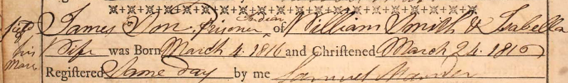

William Smith would become a successful farmer and orchardist.

He died in 1865 aged 81 years, in the district of Parramatta.

His property, *Thorneyfield Farm*, at Pennant Hills, was sold by public auction. The property was of 30 acres, 11 acres planted with fruit trees, 11 acres of bush paddock, and 5 acres of cleared ground under cultivation. The homestead consisted of a snug weatherboard cottage, containing 4 rooms, with detached fruit sheds, cart sheds, stables, out-houses, and two excellent wells of water.**2**

William Smith’s son, James Smith, married Susannah Bellamy in 1837.

Susannah was born on 2nd July 1821 at Pennant Hills, the daughter of James Zadock (1798-1875) & Hannah Maria (nee Singleton; 1802-1869) Bellamy.

The Bellamy family were prominent in Pennant Hills.**3**

**Susannah Smith (nee Bellamy)**

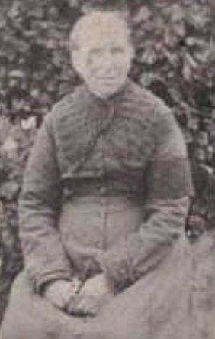

They had a large family. A daughter, Hannah, was born on 11th February 1841, at Castle Hill. She died in 1883.

On 7th October 1890, at *Mount Wilberforce*, Pennant Hills, Susannah Smith, wife of James Smith senior, died. She was buried at Pennant Hills Cemetery.**4**

The house and surroundings of James & Susannah Smith was described in March 1888, thus:

‘Higher up the hill from Mountain View and across the road is the residence of Mr. **James Smith**, one of the pioneer settlers. The house is a substantial, well-built erection of cut stone, quite above the average country residence, being neat without pretence, and comfortable without bareness. A fore-court full of bloom, and a verdant backing of foliage, set off and heighten the appearance of the abode. The first days of settlement are often hard enough, and impress a hardness upon the pioneer which subsequent prosperity does not always do away with. As a consequence, homes are left with their original un-loveliness grown worse with age. This gives many a visitor and possible settler a bad opinion of life in the country, which is credited with de-civilising effects which do not rightfully belong to it. So, when a residence like that of Mr. Smith's is come upon, it is quite a relief, and, indirectly, a reproof, to those who, with ample means for better things, are content with primitive savagery. Being of stone the house is well fitted to face the zephyrs which howl in winter at times up the long western slope and across the narrow crest of the Pennant Hills at *Mount Wilberforce*, as Mr. Smith calls his place. The country on his side of the ridge drops with more suddenness than at Mr. Bellamy's.’**5**

On 14th November 1894 occurred the death of James Smith, widower of Susannah Smith.

His obituary is as follows:

‘That well known and highly respected resident of Pennant Hills, Mr. James Smith, died on Wednesday last. Mr. Smith had been suffering from senile decay and dropsy for the last couple of months; but previous to that led a fairly active life for his age. He was a native of this district, and was born within a short distance of the place where he has lived so long. He was 78 years and 8 months of age, and it can be imagined that he had witnessed some wonderful changes in the development of Pennant Hills. No man could have been thought more of by his neighbours than was Mr. Smith, who was kind-hearted and considerate to all around him. He was one of our largest "land kings," having owned some 600 acres of the pick of Pennant Hills, and a few days before his death he completed the purchase of another good property. He had planted out in orchard over 100 acres. It is over twelve months ago since he apportioned his vast estate between his family but nothing was done about the Bellamy property which he had recently purchased; Mr. C. E. Byrnes, the family solicitor, arriving just as the good old man breathed his last. He leaves a family of eight sons and daughters, Messrs. James, George, Thomas, Edwin, Alfred and Arthur Smith, Mrs. E. Gallard (of Ryde), Mrs. Joseph Harrison (Carlingford), and Mrs. R. W. Cowell (Ermington). The funeral took place at St. Paul's cemetery, Carlingford, on Thursday, and was very largely attended. The Rev. G. McIntosh officiated at the grave.’**6**

**Bibliography**

1 Ancestry.com

2 NSW Births Deaths & Marriages; Sydney Morning Herald (NSW: 1842 - 1954), Monday 27 November 1865, page 7

3 NSW Births Deaths & Marriages; Ancestry.com

4 Sydney Morning Herald (NSW: 1842 - 1954), Wednesday 8 October 1890, page 1; Daily Telegraph (Sydney, NSW: 1883 - 1930), Wednesday 8 October 1890, page 8

5 Australian Town and Country Journal (Sydney, NSW: 1870 - 1919), Saturday 3 March 1888, page 44

6 Cumberland Argus and Fruitgrowers Advocate (Parramatta, NSW: 1888 - 1950), Saturday 17 November 1894, page 8