## **SEALE, John**

John Seale was born on 30th December 1844, at George-street, Sydney, the son of Joseph (1819-1888) and Susannah (nee Owen; 1823-1875) Seale. He was educated at the Sydney Grammar School.**1**

On 30th January 1867 John, eldest son of Joseph Seale of Camperdown, married Maria, fifth daughter of George and Phoebe Colless, of Emu Plains, by special license, at St. Paul’s, Emu Plains.**2**

**John Seale 1860s**

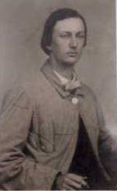

In December 1867 he was gazetted to be Audit Clerk at Newcastle, to date from 1st May 1868. He would eventually become head clerk of the Railway booking office for many years and was employed in the Railway service for 48 years.**3**

In September 1875 his mother, Susannah, died at her residence, Square and Compass Hotel, George and Goulburn Streets, Sydney, leaving behind a husband and eleven children. His father, Joseph, was in the hotel business. Joseph died in June 1888, at his residence, Elswick-street, Leichhardt, aged 69 years. In March 1898 John Seale advertised two builder’s blocks, for private sale, two builder’s blocks in Elswick-street and Myrtle -street, Leichhardt.**4**

In August 1896 Mr. Seale was having a residence erected in Malton-street, Beecroft, for his family - “Mindaribba”, 16 Malton Road.**5**

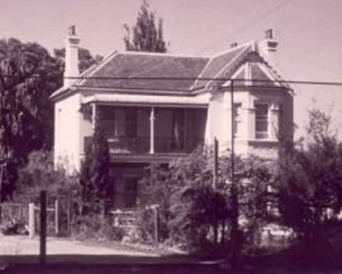

In January 1897 John Seale was elected to the committee of the Beecroft Progress Association, a position he would occupy for several years. In October he became a trustee for the new recreation reserve at Beecroft; also his son, Ernest, was married to Miss Rose Spurway, of Ermington. Ernest, a popular cricketer, would make their home at Roseville.**6**

In September 1898 he advertised for a general servant. In April 1899 he was appointed an auditor for St. John’s, Beecroft, with his brother Edward as a church sideman.**7**

In November 1903, at Maitland, Joseph Richard Seale, third son of John Seale, “Mindaribba,” Beecroft was married to Mary Hilda Noad, of East Maitland. The couple were living at Beecroft in February 1906, when their son, Alan Maitland Seale, aged 13 months, died.**8**

On 17th January 1907 John’s daughter, Hilda Annie, married G. R. Harrison, of Beecroft, at St. John’s Church, Beecroft.**9**

One of his sons, Herbert Percy Seale, tragically died in September 1908 of peritonitis, at Mount Morgan, Queensland, where he was assistant-general manager of the Mount Morgan Goldmining Company. One of his brothers was in America, in the profession of electrical engineer, and another at Broken Hill, engaged in mining pursuits.

In 1911 John Seale forwarded a draft for £100 to the Mount Morgan Technical College Board to be applied towards perpetuating the memory of his son, who was a member of the board. He later despatched two photographs of his son for the Board to make a selection from: - It was decided that an enlarged photograph of the late Mr. Seale should be hung in the hall.**10**

On 15th October 1909, at the Presbyterian Church, Sydney, Oscar Owen, fifth son of John Seale, Beecroft, married Jean Lyall, eldest daughter of D. H. Brown, of “Croyna”, Beecroft.**11**

On December 20th, 1915, at St. Peter’s Church, East Maitland, Lieut. Harry V. Seale, Mining Corps, A.I.E.F., youngest son of Mr. and Mrs. John Seale, of Beecroft, was married to Mary, youngest daughter of Mr. and Mrs. C. T. Butler, of East Maitland. In late 1916 Lieut. H. V. Seale, of Beecroft, returned invalided.**1**2

On 11th September 1917 his son, Frank Lancelot Seale, aged 33 years, was killed in France. He was an electrical engineer who left for the front with the 26th Battery, 7th Field Artillery, A.I.F., on March 11, 1916, and was engaged to be married to Mrs. John Kidd, jun., of Moore-street, Liverpool.**13**

On 3rd March 1933, John’s wife, Maria, died at the family home, “Mindaribba,” Beecroft, aged 89 years.**14**

She was buried at St. Thomas Anglican Cemetery.

**John & Maria Seale**

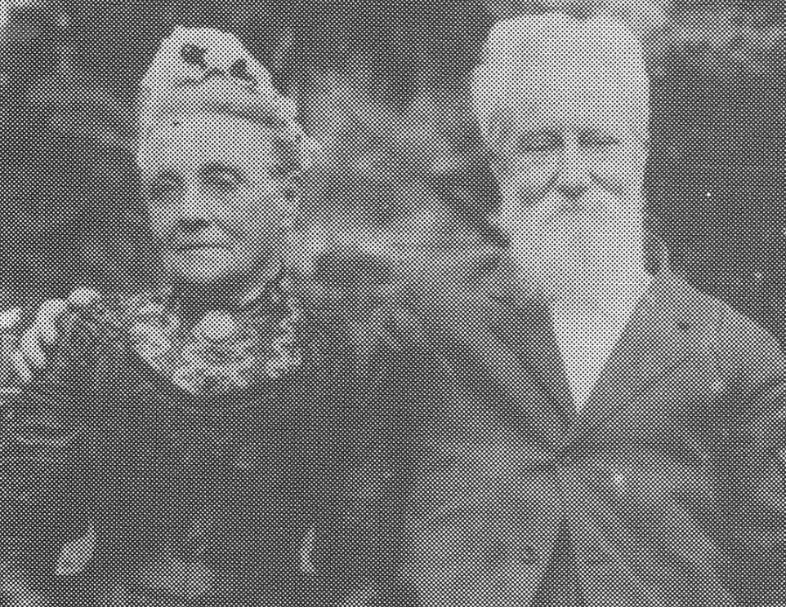

On 6th December 1933 John Seale died at his residence in Malton-road, Beecroft, aged 88 years. He was born in George-street, Sydney, and remembered bullock teams carrying merchandise past his home, and also the first train running to Parramatta.**15**

He was cremated at Rookwood Cemetery.

**Bibliography**

1 NSW Registry of Births Deaths and Marriage; The Sun, Thu 7 Dec 1933

2 NSW Registry of Births Deaths and Marriage [‘Scale’]; The Sydney Morning Herald, Thu 21 Feb 1867

3 New South Wales Government Gazette, Fri 13 Dec 1867

4 The Sydney Morning Herald, Mon 13 Sep 1875; The Sydney Morning Herald, Mon 25 Jun 1888; The Sydney Morning Herald, Sat 26 Mar 1898

5 The Daily Telegraph, Sat 1 Aug 1896

6 The Cumberland Argus and Fruitgrowers Advocate, Sat 30 Jan 1897; The Cumberland Argus and Fruitgrowers Advocate, Sat 16 Oct 1897; The Cumberland Argus and Fruitgrowers Advocate, Sat 23 Oct 1897

7 The Cumberland Argus and Fruitgrowers Advocate, Sat 10 Sep 1898; The Cumberland Argus and Fruitgrowers Advocate, Sat 15 Apr 1899

8 The Sydney Morning Herald, Wed 23 Dec 1903; The Australian Star, Sat 10 Mar 1906

9The Sydney Morning Herald, Wed 13 Feb 1907

10 Nepean Times, Sat 3 Oct 1908; Morning Bulletin (Rockhampton, Qld), Fri 20 Oct 1911; Morning Bulletin, Mon 22 Apr 1912

11 The Sydney Morning Herald, Sat 13 Nov 1909

12 The Daily Telegraph, Mon 7 Feb 1916; The Cumberland Argus and Fruitgrowers Advocate, Sat 30 Dec 1916

13 The Sydney Morning Herald, Thu 27 Sep 1917; The Cumberland Argus and Fruitgrowers Advocate, Sat 29 Sep 1917

14 The Sydney Morning Herald, Mon 6 Mar 1933

15 The Sun, Thu 7 Dec 1933; The Sydney Morning Herald, Fri 8 Dec 1933; Nepean Times, Sat 9 Dec 1933

**NOTE**: Additional information contained within Beecroft Cheltenham History Group website and book ‘Beecroft and Cheltenham, the Shaping of a Sydney Community to 1914’.