## **SEALE, Edward Henry**

Edward Henry Seale was born on 3rd May 1859 in Glebe, son of Joseph (1818-1888) and Susanna (nee Owen; 1823-1875) Seale.**1**

On 1st May 1884, at the Congregational Church, Petersham, Edward, fifth son of Joseph Seale, married Mary Taylor, eldest daughter of Henry and Anne Taylor, of Leichhardt. Mary was born in 1861 in the district of Chippendale.**2**

Children of the marriage were:

Arthur (1885-1931)

Frank (1887-1978)

Eric (1890-1974)

Dora (1892-1971)

Edward Henry (junior) (1895-1978)

In 1896 Edward Seale was living in Leichhardt. The family had moved to Beecroft by 1898.

In 1898 Mrs. Edward Seale, of Beecroft, was reported dangerously ill, but recovered. In 1899 Edward Seale was appointed a sideman of St. John’s Church, Beecroft, with his brother John as auditor.**3**

In December 1901 Edward was clearing and fencing his land facing Malton-road, considered one of the choicest in Beecroft, on the eastern side of the line. In March 1902 Mr. Frederick Mason was erecting a brick residence for Edward Seale on the land, later to be named ‘Boronia’.**4**

In 1918 his son, Edward Henry (junior), would enlist for WW1. He is described as a single man, working as a share farmer. His father, Edward Henry senior, was then living at “Boronia,” Malton-road, Beecroft, and his son Edward junior was also living there.**5**

In 1923 the partnership between Ernest Eloge Abram and Edward Henry Seale jnr., both of Orange, formerly of Beecroft, apiculturists, trading as W. Abram and Son, was in bankruptcy.**6**

On 15th November 1927 Edward Henry Seale, died at his home in Malton-road, Beecroft, aged 68 years. He was survived by his widow, four sons and a daughter.

He was in the railway audit office for more than 40 years, and for many years a warden of St. John’s Church, Beecroft. He was formerly well known as an inter-State cricketer.

He was buried at Rookwood Anglican Cemetery, Section 9 Row 24.**7**

His wife, Mary, died in 1956.

**“Boronia,” Malton-road, Beecroft c.1910**

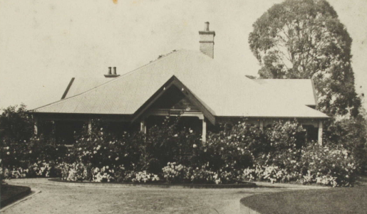

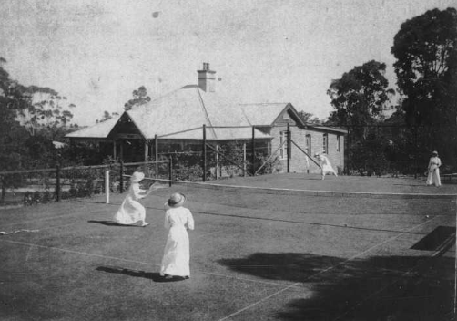

**Edward Henry Seale senior**

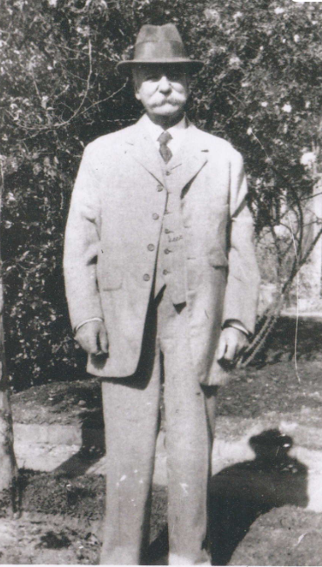

**Bibliography**

1 NSW Registry of Births Deaths and Marriages; The Sun, Wed 16 Nov 1927

2 The Sydney Morning Herald, Mon 4 Aug 1884; NSW Registry of Births Deaths and Marriages

3 The Cumberland Argus and Fruitgrowers Advocate, Sat 16 Jul 1898; The Cumberland Argus and Fruitgrowers Advocate, Sat 15 Apr 1899

4 The Cumberland Argus and Fruitgrowers Advocate, Sat 14 Dec 1901; The Cumberland Argus and Fruitgrowers Advocate, Sat 22 Mar 1902

5 Ancestry.com

6 Government Gazette of the State of NSW, Fri 28 Sep 1923

7 The Sun, Wed 16 Nov 1927; The Age (Melbourne), Thu 17 Nov 1927; The Sydney Morning Herald, Wed 16 Nov 1927

**NOTE**: Additional information contained within Beecroft Cheltenham History Group website and book ‘Beecroft and Cheltenham, the Shaping of a Sydney Community to 1914’.