## **PERDRIAU, Ann Eliza**

Ann/Anne Eliza Perdriau, along with her sons, Albert William, Ernest Charles, Henry (junior) and William Simpson Perdriau, had some association with Beecroft during the 1890’s.

AnnEliza Perdriau (nee Simpson) was born in Newry, Armagh, Ireland, on 14th November 1824, and came to Australia with her parents thirteen years later, on board the ship *Parland*.

On the 20th February 1845 Ann Eliza Simpson, daughter of Ebenezer and Sarah Simpson, of Camden, was married at the Independent Chapel, Pitt-street, Sydney, to Henry Carter Perdriau, of Miller’s Point. They had 13 children – 9 boys and 4 girls.

She resided for 50 years at Balmain. In the early days Balmain was mostly bush, and bushrangers once entered her home. When the gold rush broke out, she, like many others, was left to care for a young family while her husband went off to try in vain to make a fortune for the family.

Henry Carter Perdriau was born on 5th November 1817, at Southwark, Surrey, England, son of Stephen (1768-1820[at Sydney]) and Maria (nee Rowe; 1785-1824) Perdriau.

He was the son of Commander Stephen Perdriau, R.N., who served in the Napoleonic wars, and was on board the *Bellerophon* which conveyed Napoleon Buonaparte to St. Helena.

Henry Carter Perdriau was Mayor of Balmain in 1868, 1873 and 1875.

He was of Huguenot stock, his predecessors becoming shipowners and traders with the West Indies.

He started the first steam ferry in New South Wales, running from Darling Point, Balmain, to Millers Point, Sydney, and continued the enterprise for many years, eventually conducting the steam services connecting Johnstone’s Bay, Stephen Street, and Bald Rock with various points in Sydney, viz., Gas works (Gas Works (Grafton Street), Erskine Street (two wharves), and calling for a time at Annandale and Pyrmont.**1**

**Henry Carter Perdriau**

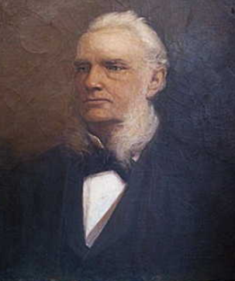 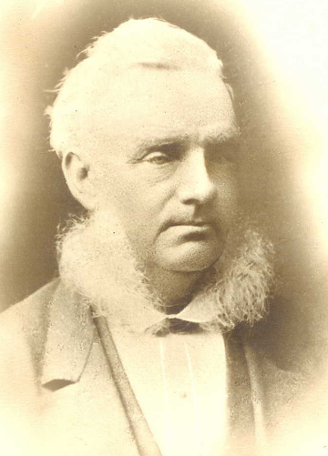

**Family photo**

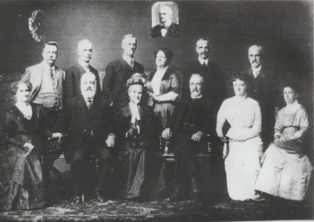

In 1878, Anne’s mother, Sarah Simpson, wife of Ebenezer Simpson, died at Lough Foyle, Waverley, aged 82 years. Anne’s father, farmer of Camden, had died in 1855.**2**

On 21st January 1892, her husband, Henry Carter Perdriau, died at his late residence, Alfred-street, North Shore, aged 75 years. [His brother, George Augustus Perdriau, had died 1876, in Lucknow, India, aged 62 years.]**3**

There are a number of references to “Mrs. Perdriau senior” in Beecroft: in December 1895 attending a meeting for the purpose of arranging the annual St John’s Sunday School picnic; in July 1896 concerning Mrs. Skellet’s death; in Dec 1896 present at the memorial stone ceremony for the new Presbyterian Church at East Carlingford; in March 1898 the killing of 30 of her best fowls by dogs; in September 1898 then planting of trees in the Beecroft public school for Arbor Day; in March 1899 present at the departure of Mr. Gelling.**4**

In April 1899 it was reported that Mrs. Perdriau, senior, was leaving shortly with her son Walter for Melbourne.**5**

On 11th March 1918, ‘Anne Eliza Perdriau, of Balmain, died at the residence of her eldest son, Henry Perdriau, at “San Talmo,” Drummoyne, on Monday, in her 94th year. She retained all her faculties to the last, and never wore spectacles. Mrs. Perdriau had been ailing for some time, but only returned from a visit to her daughter, Mrs. Duesbury, at Wollongong, 10 days before her death.’

‘Mrs. Perdriau took keen interest in all departments of Church life, Dorcas work, and missions, and was for many years an active worker in Balmain and Burwood Presbyterian Churches. She contributed generously to Church and philanthropic objects. During WW1 she knitted socks, mufflers, washers, eye bandages, and kneecaps, and made garments for sick and wounded soldiers and the poor of Belgium.’

‘Mrs. Perdriau had nine sons and four daughters. There are now six sons and three daughters, 46 grandchildren (all the eligibles among whom have enlisted), and 32 great-grandchildren living.’

‘The funeral, which took place at Rookwood, was very largely attended, all her sons and daughters being present: also her surviving brother, Mr. W. H. Simpson, of Waverley.’ She is buried at the Presbyterian denomination, Section 2B, Plot 5675.**6**

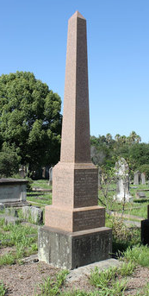

**Bibliography**

1 The Sydney Morning Herald, Fri 21 Feb 1845; Daily Telegraph (Sydney, NSW: 1883 - 1930), Wednesday 13 March 1918, page 10; The Sydney Morning Herald, Thu 22 Oct 1931

2 The Sydney Mail and New South Wales Advertiser, Sat 18 May 1878; New South Wales Government Gazette, Tue 13 Feb 1855

3 The Australian Star, Thu 21 Jan 1892; Evening News, Sat 24 Jun 1876

4 The Cumberland Argus and Fruitgrowers Advocate, Sat 7 Dec 1895; The Cumberland Argus and Fruitgrowers Advocate, Sat 11 Jul 1896; The Cumberland Argus and Fruitgrowers Advocate, Sat 5 Dec 1896; The Cumberland Argus and Fruitgrowers Advocate, Sat 26 Mar 1898; The Cumberland Argus and Fruitgrowers Advocate, Sat 3 Sep 1898; The Cumberland Argus and Fruitgrowers Advocate, Sat 25 Mar 1899

5 The Cumberland Argus and Fruitgrowers Advocate, Sat 1 Apr 1899

6 Sunday Times, Sun 3 Mar 1918; The Daily Telegraph, Wed 13 Mar 1918; Tweed Daily, Fri 22 Mar 1918

**NOTE**: Additional information contained within Beecroft Cheltenham History Group website and book ‘Beecroft and Cheltenham, the Shaping of a Sydney Community to 1914’.