## **PAIN, Arthur Wellesley**

Arthur Wellesley Pain was born on 21st August 1841 at Felmersham, Bedfordshire, England, where the family name had been associated with the village church for hundreds of years.

He came of typical old English farming stock.

His parents were Joseph (1797-1860) and Mary Ann (nee Odell; 1795-1864) Pain.

His early education was received at private schools, entering as a freshman at St. Catherine's College, Cambridge, in 1862. Three years later he took his ordinary degree B.A. first-class, but his health prevented him from continuing the Honours course.

His first curacy was at Holbrook, Suffolk, in 1866, in the diocese of Norwich. Haemorrhage of the lungs compelled him to resign the curacy a year later, and in 1867 he was ordained to the priesthood by the Bishop of Norwich.

On 7th January 1868 he arrived in Sydney, Australia, and was appointed incumbent of Cobbitty, near Camden, where he remained for many years.**1**

He was rural dean of Camden, 1872-1883, which included the oversight of St. Paul's (Cobbitty) with St. Thomas's (Narellan), and Cabramatta; rector of St. John’s, Darlinghurst, in 1883-1902; rural dean of East Sydney, 1885-1902; chaplain to Archbishop Saumarez Smith, 1893-1902; and canon of St. Andrew's Cathedral, Sydney, 1897-1902, in which latter year he was consecrated in St. Andrew's Cathedral, by the Primate and the Bishops of Newcastle, Grafton, and Armidale, as first Bishop of Gippsland [Victoria] (1902-1917).

He took his M.A. degree on the occasion of his visit to England in 1899. Cambridge University conferred upon him, in absentia, the degree of D.D. (jure dignitatis).

In Gippsland he had to face great hardships. He had to undertake long nights journeys on roads that were partly made or not made at all, and on bush tracks. He resigned as Bishop of Gippsland in February 1917 as he felt his health necessitated his resignation, as he was determined not to spend a day in the Gippsland diocese unless he could discharge his duties thoroughly.

He became honorary secretary of the Church Mission Society of Australia and Tasmania, which position he subsequently resigned from through ill-health in February 1920.**2**

On 13th April 1871 ‘at St. Mark's Church, Alexandria [now Darling Point], the Rev. Arthur Wellesley Pain, B.A., of St. Catharine's College, Cambridge, incumbent of at Paul's, Narellan, N.S.W., was married to Annie Bisdee, eldest daughter of George Thorne, Esq., of Claremont, Rose Bay, Sydney.’**3**

Children of the marriage were:

1872 Allan Franklyn [Rev.], at Camden; died 1947

1873 Ernest Maynard [M.D.], at Cobbitty; died 1913

1874 Arthur Clifford, at Cobbitty; died 1918

1878 Mary Allison, at Cobbitty; died 1957

1879 Ethelwynne Theadora, at Cobbitty; died 1976

1881 Annie Rosalie, at Cobbitty; died 1881

1882 Elsie Gertrude, at Cobbitty; died 1968

1885 Margery Bisdee, at Sydney; died 1901

1889 Kenneth Wellesley [Rev.], at Sydney; died 1959**4**

In December 1917, now Bishop Pain, was having alterations done to his residence in Railway Crescent, Beecroft.**5**

On 14th May 1920 Bishop Pain, late Anglican Bishop of Gippsland, died at his residence “Felmersham,” Beecroft, aged 78 years.

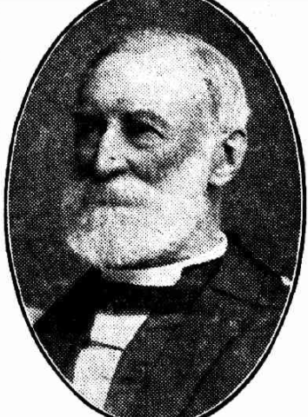 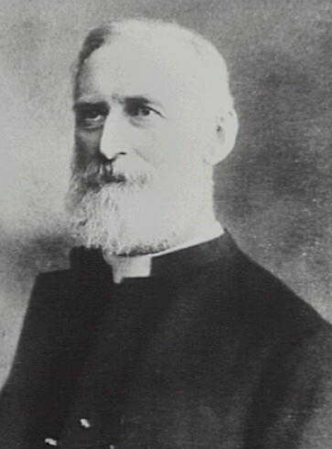

He was survived by his widow and five of nine children— the Rev. Alan Pain, Captain Kenneth W. Pain, M.A., Mrs. T. S. Holt, of Burwood, Mrs. L. Hatfield Hall, wife of Chaplain L. H. Hall, and Mrs. Harry Matthews, whose husband, Dr. Matthews, was in charge of the Chinese contingents in France.

One of the deceased's sons, Gunner Arthur Clifford Pain, a planter of Fiji, was killed on active service on the Western front in 1918.

Another son, Dr. E. Maynard Pain, M.B., Ch.M., died while in charge of the Church Missionary Society's hospitals in Cairo.

The funeral service took place at St. Andrew's Cathedral, after which the cortege left for South Head Cemetery.**6**

On 18th September 1920, Mrs. Pain, widow of the Right Reverend Arthur Wellesley Pain, D.D., passed away at Beecroft, after a very short illness. The interment took place in South Head Cemetery, following upon a service at St. John's Church, Darlinghurst. Mrs. Pain, though in her 77th year, had enjoyed very good health up to a week, preceding her death.**7**

In October 1920 there was an auction sale of the furniture and appointments of drawing and dining rooms, five bedrooms, kitchen and laundry, within Mr. & Mrs. Pain’s home, *Felmersham*, situated on the corner of Railway-crescent and Malton-road, Beecroft.**8**

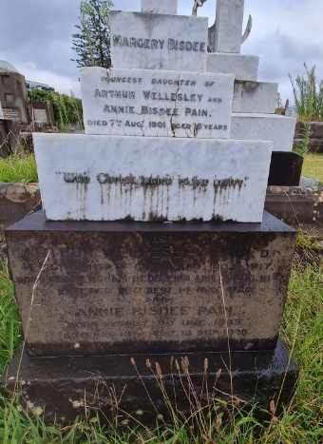 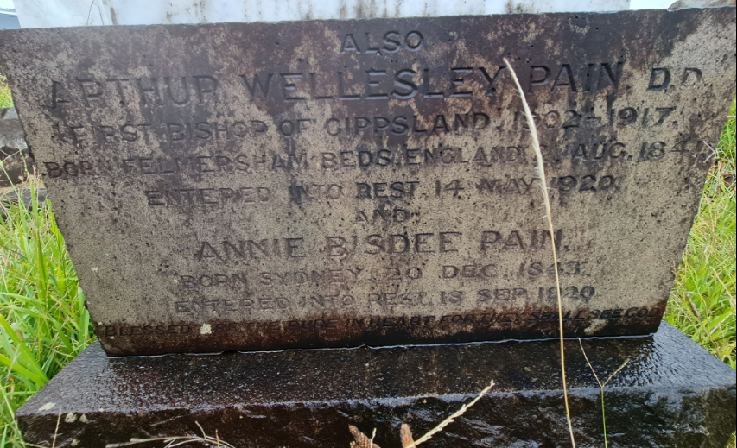

**Bibliography**

1 Sydney Morning Herald (NSW: 1842 - 1954), Saturday 15 May 1920, page 13;

Ancestry.com

2 Evening News (Sydney, NSW: 1869 - 1931), Saturday 21 February 1920, page 6; Daily Telegraph (Sydney, NSW: 1883 - 1930), Saturday 15 May 1920, page 11; Sydney Morning Herald (NSW: 1842 - 1954), Saturday 15 May 1920, page 13

3 Sydney Mail and New South Wales Advertiser (NSW: 1871 - 1912), Saturday 22 April 1871, page 254

4 Ancestry.com; N.S.W. Births Deaths & Marriages

5 Construction and Local Government Journal (Sydney, NSW: 1913 - 1930), Monday 17 December 1917, page 2

6 Sydney Morning Herald (NSW: 1842 - 1954), Saturday 15 May 1920, page 13

7 Nepean Times (Penrith, NSW: 1882 - 1962), Saturday 25 September 1920, page 5

8 Sydney Morning Herald (NSW: 1842 - 1954), Thursday 28 October 1920, page 3