## **OGDEN, Eileen Frances Dorothy**

Eileen Ogden was born on 14th October 1898, at Manly, N.S.W., and was baptised on 16th June 1900 at St. Matthew’s Anglican Church, Manly.

Her parents were Thomas Arthur (1874-1958) & Ann Hannah (nee Watson; 1876-1961) Ogden, who would move to Cheltenham about 1912.

In 1903 T. A. Ogden was a clerk in the Sydney Marine Underwriters and Salvage Association, Limited, and Fire Underwriters Association

Eileen’s siblings were Berenice C. (1906-1906 at Quirindi) and Phyllis Enid Roslyn Ogden (1907- after 1993).**1**

In April 1903, at the age of 4 years, Eileen danced at the Victoria Hall, Manly, when the Juvenile Dramatic and Musical Company produced the extravaganza “The Unhappy Princess.”**2**

Her interest in theatre blossomed over the years.

She started in musical comedies about 1919, firstly in “Hullo Everybody.”

In May 1925 she had a speaking part in the Sydney musical “Good Morning, Dearie.”

In July 1925 she appeared with Gladys Moncrieff in “The Street Singer,” in which she played the part in the third-act of Madame Rossignol.**3**

In October 1926 she was appearing as Ethel Brander, in “Rose Marie,” at Her Majesty's

Theatre, Sydney.

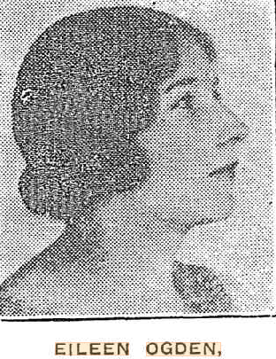

“Rose Marie” broke all records in terms of attendance. Eileen was now very popular.**4**

In October 1927 Eileen was in the stage play “Tweekie.”

‘AS the coy “girlish,” gushing middle-aged flapper, Pansy Trask, of “Tweekie,” Eileen Ogden scores a decided triumph and shows in no uncertain manner her versatility.’

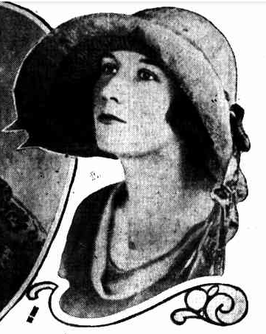

‘Eileen faced her first row of footlights as a show girl and eventually blossomed out of the chorus into a principal when she played Ethel Brandon in “Rose Marie.”

“Tweekie” is enjoying a deserved success, and as a chaser of gloom is advocated to the weary.

“Tweekie” is noticeable for its lilting melodies, bright dancing, and pretty scenery and smart frocking.’

‘Her parents have a large garden at Epping, and she spends her odd moments helping her mother to cultivate prize roses.’**5**

In October 1928 Eileen Ogden was in the play “The Vagabond King.”

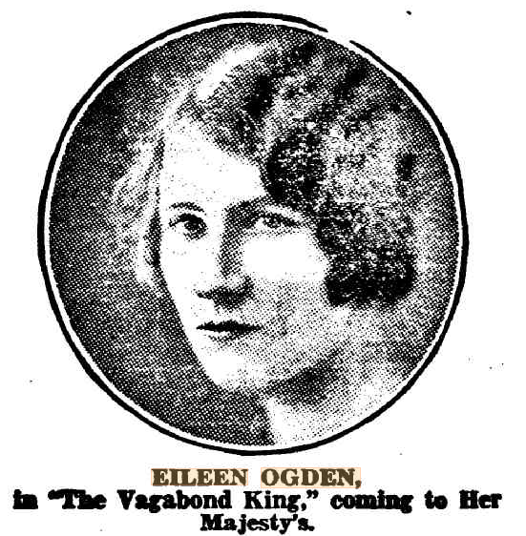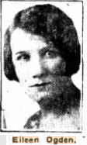

‘Now playing Johanneton in “The Vagabond King,” Eileen Ogden is entitled to a bouquet or two for her present work, and the fine character parts she has played in the past; also she deserves extra greenery for the marathon she puts up nightly in her endeavour to get that 11.10 train to Cheltenham. She's never missed it yet.’**6**

In November 1928 Eileen was playing in Melbourne.

‘She was appearing with Muriel Starr in “The Donovan Affair,” and, at the same time, understudying Eileen Sparks in “The Patsy,” and Rita the vamp in “Hit the Deck.” That week she collected treasury from three theatres.’**7**

In February 1929 ‘she sailed for New Zealand with “The Vagabond King” company to play Mildred Cottell’s role throughout the New Zealand tour, as Mildred has gone to Melbourne to join a new show. Eileen is known as the luckiest understudy on the stage, for without exception she has always played whatever role she has understudied.’**8**

When not on tour she continued to live with her parents: Thomas Arthur Ogden (insurance broker), Annie Ogden, Eileen Frances Dorothy Ogden – “The Willows,” Cheltenham-crescent, Beecroft.**9**

In March 1930 she appeared in the mystery and humorous play entitled "Murder on the Second Floor."

‘In her remarkably clever interpretation of Miss Snell, a fussy maiden lady of uncertain age, Miss Eileen Ogden was worthy of the highest praise, and to her excellent character study must be credited much of the success of the performance.’**10**

In May 1931 she appeared in “The Love Race,”

‘We guarantee you the usual pretty girl, her inevitable nice young man, two or three amiable, cheerful lunatics, as many Incidental people flung in just for fun, and to make extra good measure, and three bags full of that good night-out feeling.

Thanks to quick, slick lines, pleasant melodies, and excellent ballets, the show moves with a whiz. You can't ask for more than that!’**11**

In October 1931 Eileen, of J. C. Williamson, Ltd., sailed to London by the *Orsova* ‘to try her luck over there.’**12**

In April 1932 the T. A. Ogdens, of Cheltenham, received a cable from their daughter, Eileen - “Leaving [for] South Africa April 8 — leading lady to Godfrey Tearle." She has been engaged as principal actress in the company with which Mr. Geoffrey Tearle has just started on a tour of South Africa. Her address was c/o the company, Independent Theatres Trust, Empire Building, Johannesburg.**13**

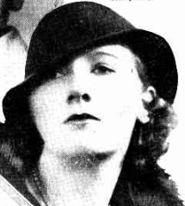

‘A London portrait of Miss EILEEN OGDEN, daughter of Mr. and Mrs. T. A. Ogden, of Cheltenham, who is touring South Africa, playing lead opposite the noted and popular English actor, Mr. Godfrey Tearle, who is known to Sydney audiences through his appearances in British talkies. She opened at Johannesburg, playing the Gladys Cooper part in "Cynara," and the latest mall brought news of her learning parts for "The Faithful Heart" and "Michael and Mary."’**14**

In August 1932 Miss Eileen Frances Dorothy Ogden, 25, artiste, sailed from Durban, South Africa to Southampton, England, on board the ship *Carnarvon Castle*.

She would spend Christmas and New Year ‘as the guest of Lady Darnley, of Puckle Hill, Graves End.’**15**

‘In August 1933 it was reported that Eileen was doing well in England and had taken ‘a charming flat at 13 St. James Place, London.’**16**

In October 1933 it was reported that Eileen had met with considerable success in London, and was now playing in "High Temperature."**17**

In April 1937 she married William D. (‘David’) Williams [born 1900] at Southwark, London.

In 1936 she had met her future husband ‘in the Cochrane production "Anything Goes."18

In January 1950 (or late 1949) Eileen returned to Australia, with her husband David and son David R. A. (‘Rodwell’), aged 12 years. They were on board the P. & O. ship *Chitral*, which departed from London on 23rd November 1949. Her husband is described as an actor, she as a housewife. Their last address in the U.K. was 45 Cottenham Park Road, S.W.2 [London]. They planned to live in Sydney.

During her stay in England she had appeared in films with Flora Robson, Robert Donat, Stanley Lupino, and many other British stars, and also in productions by Leslie Henson, Tom Arnold and C. B. Cochrane.

Her last appearance with Flora Robson was in the film "Holiday Camp," in which she had the role of a hotel receptionist.

She appeared in the film "The Courtneys of Curzon Street" with Anna Neagle, in which she played the role of Lady Iris Colefax. She also appeared in the film "Evergreen," which starred Jessie Matthews.

Mr Williams, a Welsh tenor and actor, generally played in musical comedy but has also in films. He was in the film "The Guinea Pig," and also "The Winslow Boy," with Robert Donat, as one of the barristers, his last film role.

‘Both had appeared in television, and hoped to do some radio work in Australia.’

‘Mr. Williams is disappointed in the lack of television [in Australia], as one of the last parts he played before leaving London was in a television production of "Scrooge".’**19**

In 1958 the family were living at Dee Why and were still there in 1980.**20**

**David & Eileen Williams 1969**

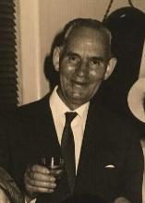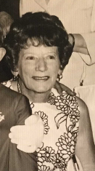

Eileen Williams died on 27th July 1985 and her remains are at the Northern Suburbs Memorial Gardens and Crematorium (RW Wall), North Ryde.**21**

**Bibliography**

1 Ancestry.com; Daily Telegraph (Sydney, NSW: 1883 - 1930), Monday 30 March 1903, page 7

2 Evening News (Sydney, NSW: 1869 - 1931), Saturday 18 April 1903, page 3

3 Sunday Times (Sydney, NSW: 1895 - 1930), Sunday 2 August 1925, page 17; Smith's Weekly (Sydney, NSW: 1919 - 1950), Saturday 2 May 1925, page 10; Labor Daily (Sydney, NSW: 1924 - 1938), Monday 6 July 1925, page 6; Sunday Times (Sydney, NSW: 1895 - 1930), Sunday 2 August 1925, page 17

4 World's News (Sydney, NSW: 1901 - 1955), Saturday 16 October 1926, page 5; Sydney Morning Herald (NSW: 1842 - 1954), Saturday 18 December 1926, page 9

5 Truth (Sydney, NSW: 1894 - 1954), Sunday 30 October 1927, page 11; World's News (Sydney, NSW: 1901 - 1955), Saturday 12 November 1927, page 6; Sun (Sydney, NSW: 1910 - 1954), Sunday 27 November 1927, page 44

6 World's News (Sydney, NSW: 1901 - 1955), Wednesday 24 October 1928, page 11; Truth (Sydney, NSW: 1894 - 1954), Sunday 28 October 1928, page 11

7 Arrow (Sydney, NSW: 1916 - 1933), Friday 23 November 1928, page 15

8 Sun (Sydney, NSW: 1910 - 1954), Sunday 10 February 1929, page 34

9 1930 Electoral Roll

10 Sun (Sydney, NSW: 1910 - 1954), Monday 3 March 1930, page 5; Sydney Morning Herald (NSW: 1842 - 1954), Monday 3 March 1930, page 7

11 Truth (Sydney, NSW: 1894 - 1954), Sunday 17 May 1931, page 7

12 Sun (Sydney, NSW: 1910 - 1954), Thursday 8 October 1931, page 13; Sun (Sydney, NSW: 1910 - 1954), Sunday 3 April 1932, page 24

13 Sun (Sydney, NSW: 1910 - 1954), Sunday 3 April 1932, page 24; Sydney Mail (NSW: 1912 - 1938), Wednesday 6 April 1932, page 9

14 Sun (Sydney, NSW: 1910 - 1954), Sunday 19 June 1932, page 26

15 1932, August - Incoming Passengers to UK; Sun (Sydney, NSW: 1910 - 1954), Sunday 25 December 1932, page 21

16 Daily Telegraph (Sydney, NSW: 1931 - 1954), Saturday 5 August 1933, page 4; Daily Telegraph (Sydney, NSW: 1931 - 1954), Friday 30 September 1932, page 6

17 Sun (Sydney, NSW: 1910 - 1954), Monday 16 October 1933, page 5

18 Herald (Melbourne, Vic.: 1861 - 1954), Monday 2 January 1950

19 Herald (Melbourne, Vic.: 1861 - 1954), Monday 2 January 1950, page 8; Sydney Morning Herald (NSW: 1842 - 1954), Thursday 12 January 1950, page 13

20 1958 Electoral Roll; Ancestry.com

21 N.S.W. Births Deaths & Marriages; Ancestry.com