## **NICHOLAS, William Sydney Mardon**

William S. Nicholas was born in 1863, St. George district, N.S.W., the son of John (1817-1877) and Sarah Price (1841-1894) Mardon.

John and Sarah Mardon, along with their son Edward (1862-1925), would arrive in Australia in December 1863 on the ship *Duncan Dunbar*.

In 1868 Sarah separated from her husband John and had children by W. A. Nicholas from 1869, whom she would marry in 1878. Thus, William Sydney Mardon would become the step-son of William A. Nicholas, who would later run the Commercial Hotel, Bundanoon.**1**

William S. M. Nicholas entered the railway service at Moss Vale in 1882.

Ten years later he became night officer at Harefield (near Junee) and later he was appointed as stationmaster successively to Grong Grong, Bundanoon, Beecroft, and Hawkesbury River (Brooklyn).**2**

He was living at Bundanoon in 1885.

In 1888 he married Lilly Jones.

‘NICHOLAS—JONES.—March 3, 1888, at Trinity Church, Bundanoon, by the Rev. J. H. Mullens, W. S. M. Nicholas, second eldest stepson of W. A. Nicholas, Esq., of Fernmount, Bundanoon, to Lilly Craymer Jones.’**3**

Children of the marriage were:

1889 – Arthur William, district of Berrima (died 1945)

Born 20th July 1891 – Hubert Percy Mardon, district of Narrandera (died 1963)

1893 – Reginald Price Mardon, district of Berrima (died 1971)

1896 – Lilly C. M., district of Moss Vale (died 1940)**4**

In April 1892 Mr. Nicholas was station-master at Beecroft railway station, about to move to Bundanoon where he had previously been the railway night officer. In May he settled in at Bundanoon, as the new station-master.**5**

It is not known how long he was at Beecroft, but probably only for a short time.

In 1910 he was stationed at Brooklyn.

In January 1930 William Nicholas retired after serving 16 years as stationmaster at Croydon, having served 48 years in the Railway Department. He was regarded as one of the most popular officers in the service.**6**

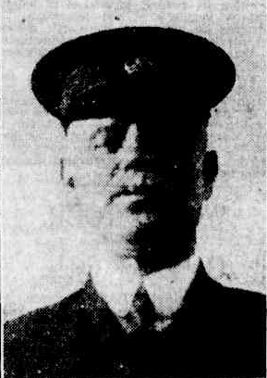

In October 1936 William S. Nicholas died, aged 73 years, in the district of Manly.

While at Croydon he became an active member of the local progress association, and was subsequently awarded the Imperial Service Medal. He was a Freemason for 50 years, being Wor. Master of Lodge Croydon in 1923-24. For many years he was a member of Lodge Victoria, Ashfield.

He was buried at Rookwood Cemetery.

He was survived by Mrs. Nicholas, three sons, and one daughter.**7**

His wife, Lily/Lilly, died in 1940, at Sydney.**8**

**Bibliography**

1 Ancestry.com

2 Daily Advertiser (Wagga Wagga, NSW: 1911 - 1954), Wednesday 21 October 1936, page 4; Sydney Morning Herald (NSW: 1842 - 1954), Tuesday 20 October 1936, page 16

3 Sydney Mail and New South Wales Advertiser (NSW: 1871 - 1912), Saturday 17 March 1888, page 602

4 N.S.W. Births Deaths & Marriages; Ancestry.com

5 Scrutineer (Moss Vale, NSW: 1892), Friday 29 April 1892, page 2; Scrutineer (Moss Vale, NSW: 1892), Friday 13 May 1892, page 2

6 Sydney Morning Herald (NSW: 1842 - 1954), Wednesday 8 January 1930, page 16

7 Daily Advertiser (Wagga Wagga, NSW: 1911 - 1954), Wednesday 21 October 1936, page 4; Sydney Morning Herald (NSW: 1842 - 1954), Tuesday 20 October 1936, page 16

8 N.S.W. Births Deaths & Marriages