## **MURRAY, Andrew**

Andrew Murray was born in Scotland abt. 1854 at Melrose, Roxburghshire, Scotland.

His parents were Andrew (1819-1892) and Euphemia (nee Hall; 1815-1892) Murray.

Andrew Murray (junior) married Isabella Paisley in 1878.

In July 1883 Andrew Murray and his family arrived in Sydney, Australia, aboard the ship *Loch Vennachar* which had departed from Glasgow – Andrew Murray junior, iron-founder, 29; wife Isabella, 27; daughter Isabella, 3.

[Also on board was James H. Murray, mason, 27; wife Isabella, 26; daughter Mary, 8 months. This would be Andrew’s brother, James Henry Murray, born 1856 at Melrose, Roxburghshire.]

Another child to Andrew and Isabella, Euphemia (‘Effie’), was born the following year.

In 1886 Andrew purchased land in Beecroft.

In January 1893 Andrew Murray was one of the founding members of the Horticultural Association for the districts of Hornsby, Thornleigh, Beecroft, Pennant Hills and Carlingford.**1**

In January 1894 it was reported that Mr. Murray of Beecroft, sent to market a few cases of very fine Japanese plums, and had a fine crop of persimmons coming on.**2**

This would seem to have been an interest and not an occupation, as he was an accountant by profession.

In February 1896 he was elected to the committee of the Beecroft Progress Association. The many friends of Mr. Andrew Murray were pleased to see him back again at Beecroft, after a lengthy absence.**3**

In September 1897 Mr. Andrew Murray wrote to the Beecroft Progress Association, regretting his inability to continue as a committee man. This was accepted with regret, and Mr. David McCall was elected to the vacancy. In March 1899 he was available to re-join the committee, replacing Mr. William Abram who was elected vice-president.**4**

In April 1909, Isabella, daughter of Andrew and Isabella Murray, married Dewdney Ellis, of Singleton, at her parent’s home “Corrie”, Beecroft-road, Beecroft.

In 1934 the 25th anniversary of this event took place at “Corrie”.**5**

On 24th February 1917, Mr. Andrew Murray, aged 63, of Hannah-street, Beecroft, who was, with members of his family, on a visit to Narrabeen, collapsed when about to enter the water at Collaroy Beach. He died a few minutes afterwards. Dr. Rygate, of Beecroft, who had been attending deceased for some time, issued a certificate of death. Heart failure was the cause.

‘Mr. Murray, who had been in the employ of Messrs Tucker and Company, of Clarence-street, City, for the past 20 years as chief accountant, was pending the week-end with his daughter, Mrs. I. Ellis, of Beecroft, at Collaroy. Early in the afternoon, with his wife and daughter, he was walking across the beach towards the surf, when he fell back into Mrs. Ellis’s arms, without speaking, and died.

In the Beecroft district Mr. Murray took a prominent part in public matters, and was popular along the northern line.

He leaves a widow and two daughters, Mrs. I. Ellis and Miss Effie Murray, who was to have been married next week.

His employer, Charles Churchill Tucker, announced soon after, that, owing to the sudden and unexpected death of his assistant manager, his business demands would prevent him from pursuing his candidature for King Division at the forthcoming State Elections.’**6**

Andrew and Isabella’s daughter, Isabella Ellis, died at Beecroft on 24th January 1935, and is buried with her parents.

Isabella Murray died on 17th April 1938 ‘widow of the late Andrew Murray, of *Corrie*, 30 Hannah Street, Beecroft, and mother of Isabella (Mrs. D. Ellis, deceased) and Effie (Mrs. R. O. Young).’**7**

**Carlingford Anglican Cemetery Section K 65**

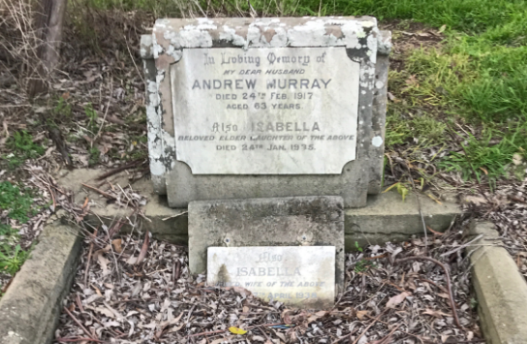

**Bibliography**

1 The Cumberland Argus and Fruitgrowers Advocate, Sat 21 Jan 1893; Ancestry.com

2 The Cumberland Argus and Fruitgrowers Advocate, Sat 13 Jan 1894

3 The Cumberland Argus and Fruitgrowers Advocate, Sat 1 Feb 1896; The Daily Telegraph, Thu 6 Feb 1896

4 The Cumberland Argus and Fruitgrowers Advocate, Sat 18 Sep 1897; The Cumberland Argus and Fruitgrowers Advocate, Sat 18 Mar 1899

5 The Sydney Morning Herald, Sat 5 Jun 1909; The Sydney Morning Herald, Sat 21 Apr 1934

6 The Sun, Sun 25 Feb 1917; The Sydney Morning Herald, Mon 26 Feb 1917; The Cumberland Argus and Fruitgrowers Advocate, Sat 3 Mar 1917; Ancestry.com

7 The Sydney Morning Herald, Mon 18 Apr 1938

**NOTE**: Additional information contained within Beecroft Cheltenham History Group website and book ‘Beecroft and Cheltenham, the Shaping of a Sydney Community to 1914’.