## **MEADMORE, Phyllis Amy (later Hilder)**

**Phyllis Amy Meadmore c1908 in nurse’s uniform. Jesse Hilder**

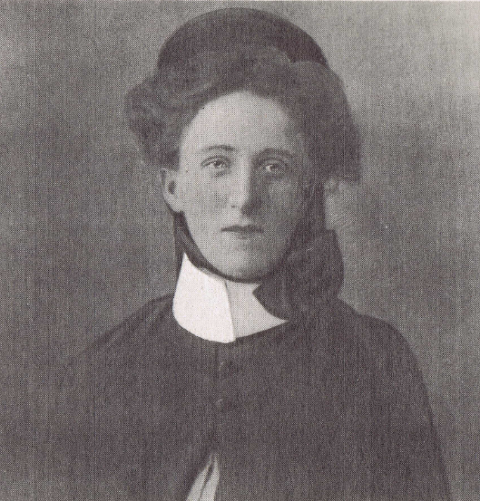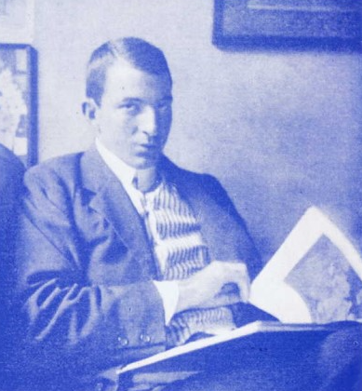

Phyllis was born on 25th November 1886, at “*Mikado*,” Ashfield, the daughter of Clement & Frances Amy (‘Amy’) Meadmore [who would later live at *St. Elmo*, 143 Copeland road, Beecroft].**1**

Phyllis trained as a nurse at Young Hospital. In Young she met, at sketching classes, Jesse Jewhurst Hilder (1881-1916), who arrived in Young in 1908, due to poor health, employed by a bank, later to become a respected watercolour painter.**2**

They married in April 1909 and rented a house in Epping then later moved to Hornsby.

‘In 1909 he married Miss Phyllis Meadmore, of Beecroft. Her faith in his genius and her fear for his health were such that she induced him to leave the bank, with which he had served for eleven years. The bank was generous in its acknowledgement; so, with a new interest in life and high hopes for the future, he gave up his whole time to painting.’

‘Stricken with tuberculosis, and worried financially, he was glad to dispose of anything he produced for a small sum to keep the home going and to procure medical necessities. Nursed by a devoted wife, lie fought every inch of the way, but succumbed to this dread disease on April 10, 1916.’**3**

Their son, Vernon Arthur (‘Bim’), was born in 1909.

Another son, Brett, was born on 27th March 1911.**4**

Jesse J. Hilder died on 10th April 1916, at his residence, in Hornsby.**5**

In 1919 & 1924 Phyllis Amy Hilder, (home duties) was living at 32 Clarke-road, Ivanhoe (Division of Bourke, N.S.W.)**6**

In June 1919 she passed her examination as obstetrics nurse, held by the Australasian Trained Nurses' Association.**7**

In August 1920 there was application on behalf of Vernon & Brett Hilder by their mother, Phyllis Hilder, for increased maintenance from the estate of J. J. Hilder.

‘IN EQUITY.

(Before Mr. Justice Harvey.)

ESTATE OF J. J. HILDER, DECEASED.

Increased Maintenance Asked For.

An application on behalf of Vernon Arthur Hilder, and Brett Hilder, infant children of the late Jesse Jewhurst Hilder, artist, by, their next friend (their mother) Phyllis Hilder, widow of the deceased, was made by Mr. R. K. Manning (instructed by Messrs. Allen, Allen, and Hemsley) that the maintenance provided by the testator's will be increased from £100 to £208 a year. By his will the deceased, who died in April, 1916, appointed his widow and his brother, Robert Tate Hilder, executors and trustees of his estate, which was valued at £611, of which £202/13/ represented the value of certain pictures painted by him. He directed his executors to hold the estate in trust, and to pay £100 a year for the maintenance of his widow and children. In her affidavit, the widow stated that since the death of her husband, two of his pictures had been sold for £307/10/, and that in July, 1918, an agreement had been entered into between the trustees of the estate and Angus and Robertson, Limited, under which the company was to have the right to publish in book form copies of five of the pictures, the executors being under no liability in respect of the publication of the books, and to be paid two-thirds of the net profits arising from the sale. As a result of the publication, the assets of the estate had increased and now amounted to £1800. From

statements received from Angus and Robert-son, Limited, it was expected that a further sum of £200 would be received by them from the publication of the book. She and her co-executor had been advised by experts not to sell the remaining 30 pictures, as in their opinion the selling value of them would continue to increase as time went on. She had been advised that if the pictures were sold at the present time they would realise about £5000. In the circumstances, she asked that the amount of maintenance provided by the will should be Increased. His Honor increased the maintenance as asked.’**8**

Phyllis graduated on 7th June 1928, as a midwife, from Royal Hospital for Women, Sydney. Her residence then was at Bondi.**9**

In 1930 she was living at “Monavale,” Tamarama-street, Bondi; occupation: home duties.**10**

Also in 1930 she is listed as living at Edinburgh-road, Chatswood (later Castlecrag); occupation: home duties.**11**

Her home ‘*Wildflower*’ Castlecrag is said to have been designed and built for her in 1928 by her son Vernon (‘Bim’; 1909-1990) who worked as a carpenter with Walter and Marion Burley Griffin at Castlecrag. **12**

**1933** - Phyllis Amy Hilder (home duties), Brett Hilder (mariner), Vernon Arthur Hilder (etcher) – Edinburgh-road, Chatswood**13**

**1934 -** Phyllis Amy Hilder (home duties), Vernon Arthur Hilder (etcher) – Edinburgh-road, Chatswood; Brett Hilder (mariner) – 16 Raeburn-avenue, Chatswood**14**

**1936 & 1937** - Phyllis Amy Hilder (home duties), Vernon Arthur Hilder (etcher) – Edinburgh-road, Chatswood**15**

In 1938 she again married, to Ernest Browning Kingsnorth (1884-1975).**16**

**1943 & 1949** - Ernest Browning Kingsnorth (jeweller), Phyllis Amy Kingsnorth (home duties) – 185 Edinburgh-road, Castlecrag**17**

Phyllis died on 5th May 1951, at Castlecrag. Probate was granted on 15th February 1952.

Of Hilder’s two sons Vernon Arthur (‘Bim’) Hilder (1909-1990) worked as a carpenter with Walter and Marion Burley Griffin at Castlecrag and went on to become a painter and sculptor. Brett Hilder (1911-1981) became a master mariner before also becoming a painter.**18**

**Bibliography**

1 Sydney Morning Herald (NSW: 1842 - 1954), Thursday, December 2, 1886

2 BCHG website

3 Daily Telegraph (Sydney, NSW: 1883 - 1930), Saturday 2 April 1927, page 20

4 BCHG website; N.S.W. Births, Deaths & Marriages

5 Sydney Morning Herald (NSW: 1842 - 1954), Tuesday 11 April 1916, page 8

6 1919 & 1924 Electoral Rolls

7 Sydney Morning Herald (NSW: 1842 - 1954), Tuesday 17 June 1919, page 4

8 Sydney Morning Herald (NSW: 1842 - 1954), Saturday 28 August 1920, page 9

9 1928 Medical Register

10 1930 Electoral Roll

11 1930 Electoral Roll

12 BCHG website

13 1933 Electoral Roll

14 1934 Electoral Roll

15 1936 & 1937 Electoral Rolls

16 N.S.W. Births Deaths & Marriages

17 1943 & 1949 Electoral Rolls

18 BCHG website

**NOTE**: Additional information contained within Beecroft Cheltenham History Group website.

**Additional references**

[Biography - Jesse Jewhurst Hilder - Australian Dictionary of Biography (anu.edu.au)](https://adb.anu.edu.au/biography/hilder-jesse-jewhurst-6666)

[Jesse Jewhurst Hilder :: biography at :: at Design and Art Australia Online (daao.org.au)](https://www.daao.org.au/bio/jesse-jewhurst-hilder/biography/)

[J. J. Hilder Paintings & Artwork for Sale | J. J. Hilder Art Value Price Guide (invaluable.com)](https://www.invaluable.com/artist/hilder-j-j-1sdc5rmgvq/sold-at-auction-prices/)

[J. J. Hilder - Wikipedia](https://en.wikipedia.org/wiki/J._J._Hilder)