## **MCKAY, John**

John McKay was born on 3rd December 1856, at Floods, Bellie, Moray, Scotland, the son of James & Elspeth (nee Milne) McKay.

**James McKay & 2nd wife Isabella Souter, married 1880 Huntley, Aberdeenshire, Scotland**

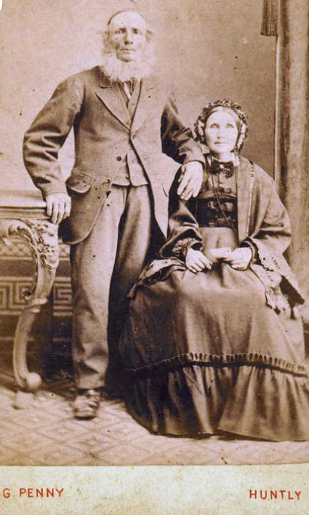

John McKay, carpenter, aged 26 years, came to Australia aboard the ship *Thirlmere*, departing from London and arriving at Melbourne on 31st December 1882.

On 2nd December 1884 John McKay married Charlotte Sarah (‘*Lottie*’) Langworthy, daughter of Arthur & Rosetta Langworthy, in the district of Balmain, Sydney.

Charlotte was born on 8th January 1863, at *First Tower*, Helier, Jersey, Channel Islands.

**Charlotte Sarah Langworthy 1880s**

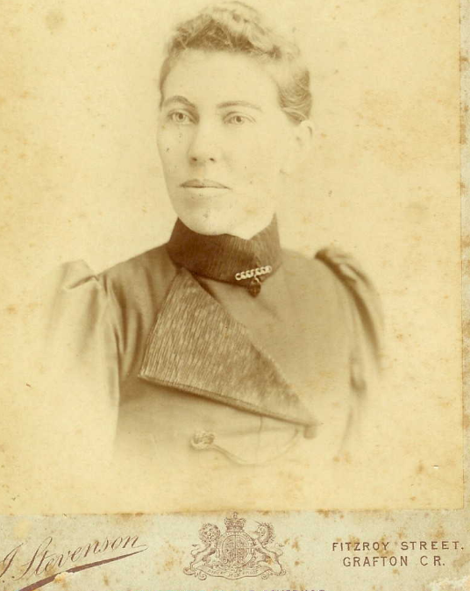

Children of the marriage were:

1. Ada, born 1885, district of Newtown [died 1895 Ulmarra]
2. Charles Stanley, born 1887, district of Newtown [died 1929, district of Ryde]
3. Miriam Alice (Minnie), born 1889, district of Fivedock [died 1895 Ulmarra]

**Photo taken c1890 Newtown**

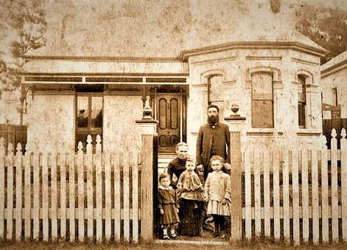

1. Jane Clarice, born 1891, district of Ulmarra (near Grafton, N.S.W.)
2. Edith Constance, born 1893, district of Ulmarra
3. Henry Norman, born 1894, district of Ulmarra
4. Christina Gertrude (Chris), born 1897, district of Ulmarra
5. Rosetta Annie Elspeth (Annie), born 1900, district of Ulmarra
6. Eva Dorothy (Dorothy), born 1903, district of Marrickville
7. Arthur Robert Gordon, born 1905, district of Ashfield1

On 27th December 1895 ‘Ada McKay, aged 11 years, and Miriam ‘Minnie’ McKay, aged 8 years, were drowned at Ulmarra. The two sisters went for a bath in the river at a place where the bank shelved off abruptly. It is thought that the elder sister, in trying to save the younger girl, was dragged in. Mr. John McKay, the father of the girls, is completely broken down, and their mother is in a frantic condition.’**2**

In 1902 John McKay was making improvements to a factory at Ulmarra.**3**

In July 1903 Mr. James (sic) McKay & family, of Marrickville, moved into their recently completed residence in Malton-street, Beecroft, opposite Mr. John Seale's.**4**

In 1905 John McKay ‘the well-known builder,’ commenced the erection of a new house in Malton-street, Beecroft.**5**

In 1907 John McKay was living in Sutherland-road. Mr. Whiteman, a new arrival, was about to build next to Mr. McKay.**6**

In 1908 the tender of Mr. J. McKay, Beecroft, (£131), was accepted for additions to Beecroft School, and teacher’s residence.**7**

In July 1909 the tender of Mr. McKay, Beecroft, was accepted at £1280 for the additions and improvements to the local School of Art; and Mr. L. S. Robertson (the architect) has been authorised to have the contract signed. A little time elapsed before the work started, owing to the difficulty in obtaining a sufficient supply of bricks. In September work had commenced.**8**

In 1910 Mr. McKay was erecting a new brick residence in connection with the butcher's shop at Beecroft.**9**

In February 1917 a roll of honour bearing the names of 21 members of the Presbyterian Church congregation, Beecroft, who have gone to the front was unveiled in the Beecroft church, by Rev. A. M. Ogilvie. The honour board was the handiwork of Mr. J. McKay. In May he was building the school-hall for the Presbyterian Church, Beecroft.

In July 1917 his son, Sergeant Harry (Henry Norman) McKay, apiarist, was wounded in France – he enlisted on 8th August 1915. He returned to Australia on 19th October 1917.**10**

On 19th April 1919 the marriage was solemnised at “The Laurels,” Beecroft, between Nellie, the daughter of Mrs. and the late Mr. Samuel Bonsall, and Harry, the son of Mr. and Mrs. J. McKay, of "Pittscurrie," Sutherland-road, Beecroft. The ceremony took place on the lawn, and was performed by Rev. A. M. Ogilvie, of the Beecroft Presbyterian Church.**11**

**Charlotte McKay, “Huntly”, Beecroft 1930s**

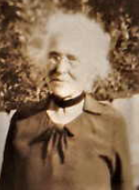

On 23rd May 1939 Mrs Charlotte McKay, wife of Mr. John McKay, died at her residence, Sutherland road, Beecroft, aged 74 years. ‘She had been in failing health for some time and her demise was not unexpected. Deceased was formerly a resident of Ulmarra, but for the past thirty-five years had resided in Sydney. She was survived by her husband and a family of five daughters and two sons, two daughters and a son having predeceased her.’**12**

On 30th April 1947 John McKay died at his residence, 38 Sutherland Road, Beecroft, relict of the late Charlotte and loved father of Clare, Edith, Christina (deceased), Anne, Dorothy, Harry, and Robert, aged 90 years. Privately interred May 1, 1947.**13**

**Bibliography**

1 NSW Registry of Births Deaths & Marriages; Ancestry.com

2 Bathurst Free Press and Mining Journal (NSW), Tue 31 Dec 1895

3 Clarence and Richmond Examiner (Grafton, NSW), Sat 4 Oct 1902

4 Cumberland Argus and Fruitgrowers Advocate, Sat 18 Jul 1903

5 Cumberland Argus and Fruitgrowers Advocate, Sat 17 Jun 1905

6 Cumberland Argus and Fruitgrowers Advocate, Sat 6 Apr 1907

7 Cumberland Argus and Fruitgrowers Advocate, Sat 13 Jun 1908

8 Cumberland Argus and Fruitgrowers Advocate, Sat 17 Jul 1909; Cumberland Argus and Fruitgrowers Advocate, Sat 18 Sep 1909

9 Cumberland Argus and Fruitgrowers Advocate, Sat 4 Jun 1910

10 Cumberland Argus and Fruitgrowers Advocate, Sat 17 Feb 1917; Cumberland Argus and Fruitgrowers Advocate, Sat 12 May 1917; Cumberland Argus and Fruitgrowers Advocate, Sat 14 Jul 1917; Australian War Memorial records

11 Cumberland Argus and Fruitgrowers Advocate, Sat 26 Apr 1919

12 Daily Examiner (Grafton, NSW), Thu 25 May 1939

13 Sydney Morning Herald, Fri 2 May 1947

**NOTE**: Additional information contained within Beecroft Cheltenham History Group book ‘Beecroft and Cheltenham, the Shaping of a Sydney Community to 1914’.