## **MASON, Frederick**

Frederick Mason was born in 1848 at Hinckley, Leicestershire, England, the son of John (1826-1902) and Caroline (nee Bedford; 1825-1895) Mason.

On 26th December 1865 Frederick married Eliza Turner, at St. Mary Church, Bushbury, Staffordshire, England.

Eliza was born in 1845 at Wednesfield, Staffordshire.

Children of the marriage were:

c.1867 – John; died 1949

c.1868 - Sarah Jane

c.1872 – Frederick

c.1874 - Mary

c.1877 - Charles, at Stafford, Staffordshire

c.1879 - Gertrude

There was a 7th child – details not known

1871 Census – Wednesfield, Staffordshire: Frederick Mason, bricklayer, 25; Eliza Mason 25; John Mason, 5; Sarah J. Mason, 3.

They were living next door to Frederick’s father, John, also a bricklayer.

On the other side was David Brazier, a bricklayer’s labourer.

Frederick and his family (wife Eliza; children: John, Sarah, Frederick, Mary, Charles & Gertrude) arrived in Australia in February 1881 aboard the ship *John Elder*, which set sail from Plymouth.

With them was John Mason, 27, builder (Frederick’s brother [1871 a bricklayer]).

Frederick and Eliza settled in Adelaide for a few years, then went to New Zealand for a short time, and then to Beecroft, Sydney where he settled down about 1887. A builder by trade he built cottages there and established one of the best orchards in the district.**1**

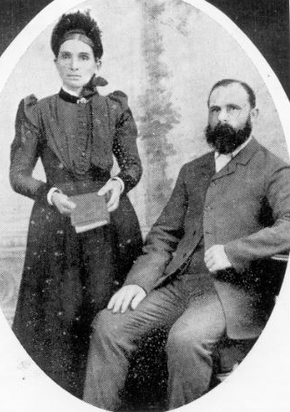

By 1889 Mr. Mason, now in Beecroft, had erected a building and laid out an orchard, and became a resident, and considered a first-class bricklayer.**2**

In 1892 Miss Jean Creagh, music teacher, received pupils for piano and violin at Mrs. F. Mason’s Beecroft residence. The monthly Band of Hope meeting was also held occasionally at Mr. Mason’s residence.**3**

On 6th June 1894 a meeting was held at Mr. Mason’s, at Beecroft, the object of the meeting being to take steps to build a Methodist church. During the previous two years Mr. Mason’s house had been used for services.**4**

In 1895 he was elected to the committee of the Beecroft Progress Association, and was re-elected in 1896.**5**

In October 1895 the foundation stone of a new Wesleyan Church at Beecroft were laid, in the presence of Mrs. Mason of Beecroft.**6**

In May 1896, in the new Wesleyan Church, was the scene of the marriage between Mr. Frederick Thomas Mason, second son of Mr. F. Mason, of Beecroft, and Miss Emma Way, eldest daughter of Mr. John Thomas Way, of Wallace, Mulgoa. The couple were presented with a Bible and hymn book on behalf of the Church trustees, the occasion being the first wedding in the new church.**7**

In July 1896 Frederick was welcomed home, after some months in England, by a gathering at the Wesleyan Church. Later that year it was reported that the orchard of Frederick Mason, of Beecroft, was damaged to the amount of upwards of £100 by a late hailstorm.**8**

In January 1897 Mr. F. T. Mason (the son of Frederick) had a prodigious crop of apricots, peaches and apples this season, but the prices were so low that Mr. Mason found it necessary to dispense with the services of agents and sell the fruit himself in order to make any profit at all.**9**

In May 1898 Mr. Mason has secured the contract for lining the Wesleyan Chapel, Beecroft, and had commenced work. In November it was reported the Mr. Mason was about to have another residence built, the site being in Copeland-street.**10**

Mr. Mason would build many Beecroft houses over the years.

On 21st August 1915 the foundation stone of the new Beecroft Methodist Church was laid by Mrs. Frederick Mason. Many tributes were paid to Mr. and Mrs. Mason for early pioneer work on behalf of the cause at Beecroft, and for their liberal support during the past quarter of a century. Upon the invitation for a liberal collection, Mr. Mason was the first to respond, with a cheque for £50. Several months later, an Esty organ was installed in the new Methodist church at Beecroft at a nett cost of £55, forty pounds of which has been loaned by Mrs. Frederick Mason for two years, free of interest. A monthly subscribing circle was

formed to provide for the repayment of the loan.**11**

On February 19, 1924, at his late residence, “Fiona,” Copeland Road, Beecroft, Mr. Frederick Mason died at the age of seventy-seven years.

His obituary reads as follows: - ‘Born at Hinckley, Leicestershire, England, he was a sturdy type of Englishman. At a comparatively early age, he, with his wife and family, migrated to Australia to seek a more congenial clime. After spending a few years in Adelaide, he was attracted to New Zealand; but not finding the desired haven, he came over to Sydney, and finally settled in Beecroft about 37 years ago.’

‘He was a builder by trade, but when he settled in Beecroft, the possibilities of fruit-growing appealed to him, with the result that he established one of the best orchards in the district. The growth of settlement later provided scope for his energies in the building trade, and a considerable number of cottages stand as monuments of his industry. He was a true pioneer, and by dint of hard work and perseverance, he earned for himself and family a very well deserved and highly respected place in the community. Upright in character and true to his principles, he was a very desirable citizen. He was an ardent supporter of the Methodist Church, in which he always took in active part. It was in his cottage that Methodism was first established in Beecroft over thirty years ago, and some of the old residents can call to mind the good times spent in those services. The growth of settlement demanded the building of a church, and it was largely through the efforts of Mr. and Mrs. Mason that this was accomplished in 1895. His interest in the church continued right to the end, but latterly he was not able to occupy his place in the pew. The cause of Methodism owes much to him for his unceasing efforts, and his name will ever be associated with its establishment in the district.’

The funeral took place at Pennant Hills West Methodist Cemetery [now Cherrybrook United Church Cemetery], and was conducted by Rev. J. W. Collier, assisted by Rev. F. Nixon. A large gathering of relatives and friends assembled at the graveside to pay their last respects, and the large number of beautiful wreaths bore evidence of the esteem in which our dear friend was held. Mr. Mason leaves a widow, three sons and three daughters.’**12**

On 12th June 1927, Eliza Mason, widow of Frederick Mason, died at her residence, Hull-street, Beecroft, aged 82 years.

‘Mrs. Eliza Mason was born in Staffordshire, England, on May 22, 1845, of humble parentage. She married, at the age of twenty, to the late Mr. Frederick Mason. Seven children were born to them, of whom six survive.

Mr. and Mrs. Mason threw open their home for Methodist Church services. Mrs. Mason took an active part in collecting money to build a church, for which the trustees decided to honour her by asking her to lay the foundation stone.’**13**

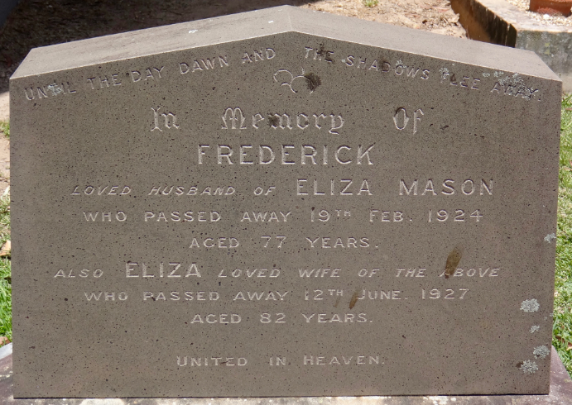

**Bibliography**

1 The Methodist, Sat 22 Mar 1924; The Methodist, Sat 9 Jul 1927; Ancestry.com

2 The Cumberland Argus and Fruitgrowers Advocate, Sat 5 Jan 1889

3 The Cumberland Mercury, Sat 26 Nov 1892; The Cumberland Mercury, Sat 16 Mar 1895

4 The Methodist, Sat 30 Jun 1894

5 The Daily Telegraph, Wed 13 Feb 1895; The Daily Telegraph, Thu 6 Feb 1896

6 The Methodist, Sat 12 Oct 1895

7 The Cumberland Argus and Fruitgrowers Advocate, Sat 9 May 1896

8 The Cumberland Argus and Fruitgrowers Advocate, Sat 23 May 1896; The Cumberland Argus and Fruitgrowers Advocate, Sat 25 Jul 1896; The Cumberland Free Press, Sat 28 Nov 1896

9 The Cumberland Argus and Fruitgrowers Advocate, Sat 16 Jan 1897

10 The Cumberland Argus and Fruitgrowers Advocate, Sat 21 May 1898; The Cumberland Argus and Fruitgrowers Advocate, Sat 12 Nov 1898

11 The Methodist, Sat 28 Aug 1915; The Methodist, Sat 27 Nov 1915

12 The Methodist, Sat 22 Mar 1924

13 The Sydney Morning Herald, Mon 13 Jun 1927; The Methodist, Sat 9 Jul 1927

**NOTE**: Additional information contained within Beecroft Cheltenham History Group website and book ‘Beecroft and Cheltenham, the Shaping of a Sydney Community to 1914’.