## **LYON, John Harry Joseph**

John H. J. Lyon was born in January 1866 (baptised 21st January), at Hounslow Heath, [London Borough], Middlesex, England, the son of John William (1835-1918) and Emma (nee Parker; 1837-1872) Lyon.

[John was the brother of William John Debenham Lyon, who lived in Beecroft]

1871 Census – 3 Woodville Terrace, Isleworth, Middlesex: John W. Lyon, head, ironmonger, Master employing 10 men and 13 boys, born Newington, Surrey, Emma Lyon, 34, born London; Kate C. Lyon, 7, scholar; Emma R. Lyon, scholar; Clementine Lyon, 6, scholar; John H. J. Lyon, 5, scholar; William Lyon, 3; Ernest Lyon, 9 months; and three servants.

Emma, wife of John W. Lyon, died in October 1872, at Brentford, Middlesex. Also a son, Sydney George John Lyon, was born in 1872, and died in 1879. Another son, Archibald John Lyon, born 1869, died 1869, at Hounslow.

1881 Census – 182 & 184 High Street, Heston, Middlesex: Harry J. J. Lyon, 15, scholar, with siblings (father not home) and aunt Mary Ann Graves (nee Lyon), widow, book-keeper.

In 1883 Clementine Marianne Lyon died; and in 1885 Kate Eleanor Lyon died.

On 6th February 1887 John William Lyon, along with his sons John, William and Ernest, arrived in Sydney, Australia, aboard the ship *Cluny Castle*.

The daughter, Emma Rose Lyon, must have come out also as she married Carl F. Liebrand (or Lebrand) in 1891 at Leichhardt. Her father would marry Mary Hancock of Leichhardt in 1892.

In 1892 John Harry Joseph Lyon married Mary Hancock, at Ashfield.

Mary Hancock (nee Wheaton) was a widow, with one child, Mabel.

Mary was born on 10th April 1860, at Charmouth, Dorset, England.

Mary’s parents were John Bowden (1831-1888) & Sarah (nee Loud; 1832-1891) Wheaton.

Mabel Hancock was born on 10th February 1890, at Leichhardt. She was baptised at Leichhardt All Souls Anglican Church on 19th March 1890. Her father’s occupation is listed as ‘gentleman.’

William Hancock was born on 13th October 1851, at Clyst Hydon, Devon, England.

His parents were John (1821-1906) & Maria (nee Burridge; 1822-1889) Hancock.

He married Mary Wheaton in January 1880, at Exeter, Devon. A son, William, was born in 1881 but died in 1889 at Fulham, London. The couple then immigrated to Australia.

William Hancock died on 14th January 1891, aged 39 years, at his residence, Mackenzie-street, Leichhardt. He was the youngest son of John Hancock, of Exeter, Devon, England. **1**

There was only one child to John H. J. & Mary Lyon:

1898, 8th September – Muriel Primrose (‘Primrose’), at *Carrara*, Rose Bay.**2**

In March 1902 Mrs. H. J. Lyon, of Beecroft, left for a trip to England, aboard the “*Ortana*.”**3**

In April 1913, at the invitation of Miss Mabel Lyon, a party of young friends met at “*Tatworth*,” Cheltenham, to bid “au revoir” to Miss Winnie Law, of Beecroft.**4**

In July 1913 a new company, Cheltenham Recreation Club, was registered. Signatures to the registration include John H. Lyon.**5**

On 27th May 1915, at St. John's Church, Beecroft, occurred the marriage of Mabel (daughter of Mrs. J. H. Lyon, of “*Tatworth*,” Cheltenham, and the late William Hancock, of Exeter, England) to Mr. Cuthbert W. Robson, eldest son of Mr. and Mrs. James Robson, of Mosman.

The bride was given away by her step-father, Mr. J. H. Lyon.**6**

**Mabel Hancock Mary Lyon with Mary Robson**

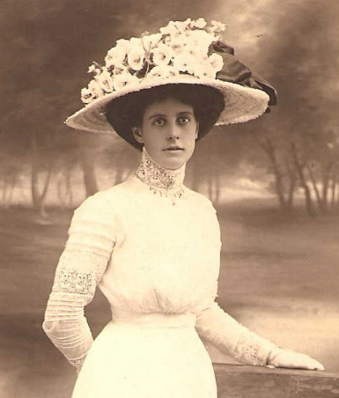 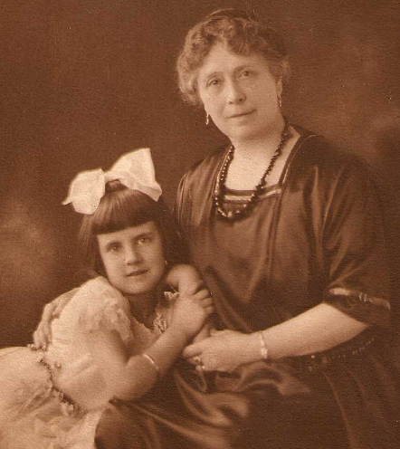

In 1918 John William Lyon, father of J. H. J. Lyon, died at Glen Innes, N.S.W., aged 84 years.

He had lived in the Glen Innes district for many years. He leaves a family of four— Mrs. Lebrand, of Sydney and late of Kent Park, Glen lnnes; Messrs. John, William and Ernest Lyon, of Sydney.**7**

In 1921 “*Tatworth*” was put up for auction.**8**

The family of John H. J. Lyon continued to live at Cheltenham.

On 1st October 1921 at St. Stephen's Church, John W. Buckle, son of Mr. and Mrs. Frank Buckle, of Cremorne, was married to Primrose, daughter of Mr. and Mrs. J. H. Lyon, of Cheltenham.**9**

From 1930 John (accountant) & Mary Lyon were living at 10 The Boulevard, Cheltenham.**10**

On December 24, 1935, Mary, wife of John H. Lyon, of Cheltenham, died, the mother of Mrs. Cuthbert W. Robson, and of Mrs. John W. Buckle. Privately interred.**11**

J. H. Lyon was still living at 10 The Boulevard, Cheltenham in 1949.**12**

On 3rd October 1956 John Harry Joseph Lyon died at Cheltenham.**13**

**Bibliography**

1 N.S.W. Births, Deaths & Marriages; Sydney Morning Herald (NSW: 1842 - 1954), Monday 19 January 1891, page 1; Ancestry.com

2 Sydney Morning Herald (NSW: 1842 - 1954), Saturday 17 September 1898, page 1; N.S.W. Births Deaths & Marriages

3 Daily Telegraph (Sydney, NSW: 1883 - 1930), Saturday 15 March 1902, page 7

4 Cumberland Argus and Fruitgrowers Advocate (Parramatta, NSW: 1888 - 1950), Saturday 5 April 1913, page 8

5 Evening News (Sydney, NSW: 1869 - 1931), Tuesday 1 July 1913, page 4;

6 Cumberland Argus and Fruitgrowers Advocate (Parramatta, NSW: 1888 - 1950), Saturday 5 June 1915, page 3; Sun (Sydney, NSW: 1910 - 1954), Sunday 13 June 1915, page 18

7 N.S.W. Births Deaths & Marriages; Glen Innes Examiner (NSW: 1908 - 1954), Monday 7 October 1918, page 4

8 Daily Telegraph (Sydney, NSW: 1883 - 1930), Saturday 19 February 1921, page 16; Sydney Morning Herald (NSW: 1842 - 1954), Saturday 5 March 1921, page 9; Sun (Sydney, NSW: 1910 - 1954), Sunday 6 March 1921, page 9; Daily Telegraph (Sydney, NSW: 1883 - 1930), Saturday 12 March 1921, page 13; Sun (Sydney, NSW: 1910 - 1954), Thursday 29 September 1921, page 3

9 Daily Telegraph (Sydney, NSW: 1883 - 1930), Tuesday 15 November 1921, page 4

10 Electoral Rolls (various)

11 Sydney Morning Herald (NSW: 1842 - 1954), Friday 27 December 1935, page 6

12 Electoral Roll 1949

13 Ancestry.com