## **LYKKE, Christian Nielsen**

Christian N. Lykke was born in 1851 at Freslev, Denmark, son of Niels (born 1822) & Jensine (nee Nielsdatter; born 1828) Lykke.

His residence in 1855 was Freslev, Morse Sender, Thisted, Denmark.**1**

C. N. Lykke, cabinet-maker, arrived in Australia on 31st December 1877, aboard the ship *Trevelyan*.**2**

On 21st May 1881 he married Ada Jane Wilkinson (born1860), youngest daughter of the late Henry George Wilkinson, at the residence of the bride, Stanley-street, Burwood.**3**

Children of the marriage were:

Henry, born 1882, Sydney

Niels, born 1884, Newtown, Sydney**4**

In September 1881 C. N. Lykke, of 15 Phelps-street, Surry hills advertised ‘WANTED to Rent, a WORKSHOP, for Cabinetmaking, in or near centre of city.’**5**

He became a naturalized citizen on 3rd March 1888.**6**

In November 1901 C. N. Lykke, of Beecroft, then having a house built at Cheltenham, advertised for someone to lay 30,000 bricks.**7**

In May 1902 his house was completed.

The description of the house was as follows:

‘Mr. C. Lykke's recently erected at *Fremblik*, at the junction of Murray-road and the main Beecroft-road, deserves more than passing mention. It is a large eight-roomed house, built of faced bricks of Croydon make, with tiled roof, and gabled, somewhat after the Elizabethan style. The verandahs and gables are finished with ornamental work, which contrasts well with the red brick of the body of the building, and viewed from the road the house presents a neat and picturesque appearance. The interior, too, is quite in keeping with the outward semblance, and evidences a more than ordinary appreciation of the beautiful as well as the useful. There are stained glass windows, of artistic design, a Corinthian arch in the hall, and handsome centre pieces to the ceilings in the chief rooms, and there is much good taste displayed in the way in which the interior is painted and finished. The northerly aspect provides that every room except the kitchen shall receive its due share of sunshine, and the situation of the bathroom, at the end of the back verandah, obviates the dangers arising from the damp incidental to a room used for such purpose. The land embraces an area of four and a half acres part being under orchard, and vegetable garden, and the remainder bush. When the flower gardens are laid out, and the planting of ornamental trees and hedge plants completed, this will be one of the prettiest properties in the district; and Mr. Lykke and his family are very decent folk, genial and homely, and in every way worthy of the recherche [‘exotic’] home which they have built for themselves. At the rear of Mr. Lykke's property, Mr. Wachsmann has acquired a fine block of land on

Boronia Avenue, on which he is preparing to erect two substantial brick residences.’**8**

 Between 1902 and 1904 he was advertising White Leghorn hens for sale.**9**

In November 1904 it was reported that ‘Mr. Lykke has sold his fine residence at [Beecroft-road] Cheltenham, to Mr. Perry, of the Australian Drug Company. Mr. Lykke will be leaving the district shortly, and Mr. Perry will take up his abode in his newly acquired home with the commencement of the New Year.’

At the time Mr. Lykke donated an attractive rosewood palm stand he made, for sale at the opening of the Beecroft School of Arts.**10**

In May 1912 Mr. Lykke advertised for sale a house at West Concord - ‘Bk Cottage, just comp., 4 r., k., Idry., etc, slate roof, 2 verandahs, fibrous ceilings, gas, water, land 50 x 150, 2 mins. Station, Torr. Inspect on job, or N. LYKKE. Russell-street, Strathfield.’**11**

In March 1914 C. N. Lykke advertised for sale a house at Strathfield - ‘Beautiful new D.F. Brick Cottage, 6 rooms and offices, land 44 x 170, 6 mins walk, cheap. Terms. Lykke, *Fremblik*, Russell-st., Strathfield.’**12**

On 31st March, 1946, Christian Nielsen Lykke died at his residence, 10 Railway Avenue, Eastwood, aged 94 years, leaving behind a wife and children, Niels and Henry.

He was buried at Macquarie Park Cemetery – Methodist denomination, Section D, Row S.**13**

On 5th February 1952, his wife, Ada Jane, also died at the Eastwood address, aged 90 years.**14**

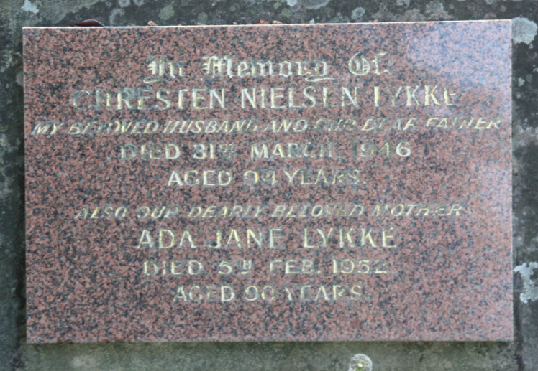

**Bibliography**

1 NSW Births Deaths & Marriages; Sydney Morning Herald (NSW: 1842 - 1954), Thursday 7 February 1952, page 26; Ancestry.com

2 Sydney Morning Herald (NSW: 1842 - 1954), Saturday 5th January 1878; Ancestry.com

3 Sydney Daily Telegraph (NSW: 1879 -1883), Wednesday 8 June 1881, page 2

4 NSW Births Deaths & Marriages; Ancestry.com

5 Sydney Morning Herald (NSW: 1842 - 1954), Monday 19 September 1881, page 10

6 Ancestry.com

7 Daily Telegraph (Sydney, NSW: 1883 - 1930), Thursday 7 November 1901, page 3

8 Cumberland Argus and Fruitgrowers Advocate (Parramatta, NSW: 1888 - 1950), Saturday 24 May 1902, page 11

9 Daily Telegraph (Sydney, NSW: 1883 - 1930), Wednesday 29 October 1902, page 4; Daily Telegraph (Sydney, NSW: 1883 - 1930), Wednesday 2 September 1903, page 4; Daily Telegraph (Sydney, NSW: 1883 - 1930), Saturday 21 May 1904, page 3

10 Cumberland Argus and Fruitgrowers Advocate (Parramatta, NSW: 1888 - 1950), Saturday 3 December 1904, page 10; Cumberland Argus and Fruitgrowers Advocate (Parramatta, NSW: 1888 - 1950), Saturday 17 December 1904, page 10

11 Sydney Morning Herald (NSW: 1842 - 1954), Friday 17 May 1912, page 3

12 Sydney Morning Herald (NSW: 1842 - 1954), Friday 13 March 1914, page 2

13 Sydney Morning Herald (NSW: 1842 - 1954), Tuesday 2 April 1946, page 14; Ancestry.com

14 Sydney Morning Herald (NSW: 1842 - 1954), Thursday 7 February 1952, page 26