## **KNAPP, Edward James Howes (junior)**

Edward was born on 30th December 1835, in Sydney, the son of Edward James Howes Knapp & his wife Rosina (nee Aarons) whose marriage is registered for 1841 but likely took place in 1834.

‘When Mr. Knapp was born in what was then a fashionable suburb of Sydney, but which is now represented by that maze of buildings surrounding Goulburn-street, the city had neither gas nor water, nor a sewerage system; and the Tank Stream ran its open course almost to King-street.’

‘Mr. E. J. H. Knapp's own memories do not recall quite such scenes as these; but he has a distinct recollection of catching sand mullet and whiting one day from the parapet of the old bridge In Hunter-street, in company with a playmate, Miss Myra Felton, who subsequently acquired some local distinction as a portrait painter.’

‘He [Edward Knapp junior] can tell you, too much of the exciting days of the coaches, the bushrangers, and the gold fever. Of this latter period, in particular, he has many amusingly interesting memories. "I remember seeing Sir Alfred Stephen," he says, "buying some fish at a fish shop near the foot of George-street, and carefully explaining that he had to do it himself, because his servants had all cleared out to the diggings. Why, no one could get a domestic servant in those days, or if one did, she was off again before you could turn round. I have known a digger, fresh come to town, go up to a maid washing the steps or sweeping the footway, and exhibiting to her a fistful of notes, just yank her off, and got spliced without more ado - and the family not know of it till they found the breakfast not materialising. The cove was full of ships lying idle, no crews to move them - every man jack of them off to the diggings. An extraordinary time it was, and many extraordinary things happened while it lasted."**1**

‘The first great remembrance of my [Edward Knapp junior] association with him [W. C. Wentworth] is one of pride to me [1853]. It was the day after the [N.S.W. Legislative] Council had passed a resolution in favour of a constitution for the colony. “W. C. Wentworth came into my father's (Edward Knapp senior] office, and said to him: “Edward, I want somebody who can write out for us the petition to the Queen to grant the Constitution.” And father said he would be glad to do what he could. Said Wentworth: “No, this youngster - pointing to me - has Just won a prize for copper-plate writing, hasn't he?” “Yes” said my father. “Well, then, let him see what he can do with It," said Wentworth. And I did it," says Mr. Knapp proudly; "and the petition in my hand-writing was presented to the Queen. I won't say it was that which won approval for it," he adds with a humorous twinkle, "but everybody knows the result of it; and so, there you are."**2**

In 1856 he was elected a member of the Philosophical Society. He was then living at 34 Elizabeth-street, Sydney.**3**

He qualified as a surveyor in February, 1858, and in June was appointed a Licensed Surveyor.**4**

Edward Knapp wrote of his experiences (in 1924, in the third person – “Bits from Beecroft.

By a Bush Ranger.”) [circa 1860], when Allaster Grant MacLean was Surveyor-General (August 1859 – September 1862):

‘It Is 65 or more years ago since a young licensed surveyor was instructed by the then Surveyor-General, W. Allerton [Allaster Grant] Maclean (an Austral-Scot), to survey the (then called) Lane-Cove-road, right through to Parramatta (the place where the eels "sit" down); as well as a number of branch roads, leading to Ryde, Parramatta, and between that river and the Hawkesbury.

His field book shows just about 60 huts and w. b. houses, all the distance from St. Leonard's (as The Shore was then called) to Parramatta, about 17 miles, via the Crow's Nest. After passing the Green Gate Pub, (kept by one, Waterhouse) [Lane Cove], the road was then but a little better than numerous cart tracks through the dense scrub. The only cleared lands were those won from the bush by sturdy pioneers, in the guise of orchardists.’**5**

During Maclean’s tenure as Surveyor-General, Edward Knapp’s survey of the outer and inner Domain was the first "contour survey" prepared in these parts, and he holds a letter of thanks from the then Surveyor-General, A. G. McLean, in respect of It. He also prepared the contour survey of the islands in Port Jackson, and surveyed the whole foreshores of the City of Sydney.**6**

In March 1863 he qualified as the first Licensed Surveyor under the "Real Property Act," Surveys. His certificate is dated 23rd November 1863.**7**

On 12th October 1875, his father died, at his residence, "The Cottage," Braidwood. He was the surveyor of all of W. C. Wentworth's properties; his son, Edward junior, later succeeded to the position.**8**

In 1887 Edward junior was a member of the New South Wales Commission for the Melbourne International Exhibition. Also, that year, he stood for the Paddington election in the interests of free trade and local option; however, he was unsuccessful.**9**

In 1890 he was honorary secretary of the committee of the Lithgow Colliery Disaster Relief Fund.**10**

In 1897 a letter to the Press stated that ‘A barrack on modern journalism is the letter writer bore. He is a sort of editor-in-chief without portfolio who presses his opinion into your morning paper on every topic which the time casts uppermost. A particularly aggravated type is "Edward J. H. Knapp," whose perpetual platitudes glut the columns of the Herald.’**11**

In January 1899 Edward Knapp attempted suicide with a razor.

‘Constable Linegar, of No. 3 Station, was on duty in Kellett-street, Darlinghurst, at about twenty minutes past 2 o'clock this morning, he saw a man, dressed only in his pyjamas, emerge from a house at the corner of Bayswater-road. On approaching to make inquiries he found that his throat was cut, and that blood was streaming freely from the wound.

In answer to the questions put to him by the officer, the other stated that his name was Edward J. H. Knapp. Linegar procured a cab immediately, and drove Knapp to Sydney Hospital, where Dr. Throsby attended to his injury. It was found that a large wound 3½ in. long and 1in. deep had been made in the left side of the neck. The windpipe and the carotid artery had not been severed, but the latter had only escaped by a hair's breadth. Mr. Knapp was so weak, however, from the tremendous loss of blood which he had sustained that his recovery was looked upon as being doubtful. He was admitted to one of the wards for treatment as an urgent case. The patient, who is a civil engineer and surveyor, and a Justice of the Peace, resides at the house where the rash attempt at self-destruction was made, [at] no. 2 Kellett -street, Darlinghurst. He is a single man, 62 years of age, and lives with his mother and sister. Of late he is said to have been under medical treatment for some internal complaint, Dr. Angel Money having been attending him. He has been despondent, but his relatives have had no reason to suspect that he contemplated taking his life. In answer to Constable Linegar's questions while on the way to the hospital, Knapp said that trouble had driven him to it, and that he had tried to end it with a razor. The blood-stained razor was afterwards found in his bedroom by the police. It is believed that after inflicting the first gash, the unfortunate man's nerve failed him, and he sought the street in order to obtain medical assistance. Knapp has for many years been well known in Sydney as a temperance worker. He was also up till recently the secretary of the Local Option League and a prolific writer of letters to the daily press. His name was recently announced as that of the gentleman who, in all probability, would be appointed to the vacant Governorship of Norfolk Island.’

‘Edward Knapp was also known as “Alphabetical” Knapp, supposedly the greatest newspaper letter writer in the province.’

‘For many years he has been honorary secretary of the Local Option League, and he has also been a frequent contributor to the newspapers on temperance, and many other subjects. His letters on the other subjects, as a rule, excited only derision, but that did not mitigate in the slightest degree his itch for writing. Although he was a bit of a crank, yet it never occurred to any of the folks that laughed, or to anybody else who knew him, that he would ever be guilty of an attempt to take his own life.’

‘When he leaves the institution, he will of course be charged at the police court for trying to take his life, and to him that will be a very sad trial. What was the cause of the temporary insanity that resulted in his suicidal act has not been stated, but it is probable that it had relation to his profession. Perhaps business has been as bad with him as with many other professional men in Sydney, and being incapable of getting clients, whatever his ability or energy may have been, and having a mother and sisters depending upon him, he sunk into a state of despair.’

‘The attempted suicide of E. J. H. Knapp, the Apostle of Temperance in this country, came as a great shock to the prohibition party. It is said that poor Knapp was made too melancholy for this life by pursuing his inevitable "letters to the editor." E. J. H. Knapp, W. E. Abbot, and William Afflick have almost a monopoly of the "open column " space in the N.S.W. Press.’

‘Mr. Knapp, who recently made an attempt on his own life, and after treatment in the hospital was discharged, has again come under public notice, and he is now an inmate of Callan Park asylum.’**12**

On 12th August 1900, Edward’s sister, Emily Eliza Ellen Knapp, third daughter of the late Edward James Howes and Rosina Knapp, died aged 53 years, late of Braidwood (death recorded for district of Leichhardt].**13**

In due course Mr. Knapp recovered from the injuries of his attempted suicide and was released from the asylum.

In 1916, it was reported: ‘in reference to his [Edward Knapp’s] services on behalf of the Local Option League of New South Wales, now the Alliance, he had been elected as secretary for about 15 years unopposed. Instead of pay going into his pocket, pay was constantly coming out of it; besides the valuable time he gave to help to keep the league from being stranded.’**14**

On 28th July 1916 his mother, Mrs E. J. Knapp, of “Havant”, Oaks-avenue, Neutral Bay, died at the age of 101 years, of heart failure. She was interred at Rookwood, Church of England section. In October of that year Edward was still living at 21 Oaks Avenue, Neutral Bay, having just written a newspaper article entitled “Caucus and City Council in Camera.”**15**

In January 1919, now living at “Havant,” Beecroft, Edward Knapp (C.E., L.S., J.P.) proposed to the Hornsby Council that “if they will sink six holes equidistant in front of my gunyah, putting a good layer of large bones (broken large) and have them trenched 3 feet deep, providing fenders, I will plant three jacarandas and three kurrajong plants, and moreover look after their growth carefully.” Several councillors thought the council might undertake the supply of the trees, and let Mr. Knapp do the rest. It was, however, decided to reply that permission would be given for the trees to be planted subject to the usual conditions.**16**

In October 1919 ‘Mr. E. J. Knapp, of Beecroft, appeared at Hornsby Court this week on a charge of preventing the removal of nightsoil. Defendant, who appeared well over 90 years of age, defended his own case, contending that, so long as he paid for the service, he could retain the soil for garden purposes. The P.M. said that if everyone took that view it would be no use the council proclaiming scavenging areas. After hearing the views of defendant and the health inspector the P.M. suggested that defendant agree to abide by the provisions of the Act, which he agreed to do, and the P.M. merely awarded costs. The old man was in rather a reminiscent mood and told the P.M. that he owned land in Hornsby when it wasn't worth £5 per acre— at a time when there were only about 200 houses between Hornsby and Milson's Point. He also mentioned that his mother lived to be over 100 and he was out after the century.**17**

In 1922 he attended a ceremony at Vaucluse House to commemorate William Charles Wentworth.

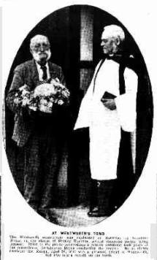

[‘At Wentworth’s Tomb. The Wentworth anniversary was celebrated on Saturday at Vaucluse House, on the shores of Sydney Harbour, several thousand people being present. Prior to the public proceedings a private ceremony took place at the mausoleum, Archdeacon Boyce conducting the ceremony. He is shown receiving Mr. Knapp, aged 90, who was a personal friend of Wentworth, and who laid a wreath on the tomb.’]

MR. E. J. H. KNAPP, whose picture with that of Archdeacon Boyce appears on this page, was a persona] friend of Wentworth. Writing from Beecroft he says that, at the request of the Vaucluse Park trustees and the Mitchell Library, he is getting together all the memoranda he can find for an account of “Wentworth and his Works.” His card on the wreath he placed on the tomb said it was in remembrance of “The Australian Patriot — the Father of Freedom, our first free Constitution, and our free press; and founder of the University.”’18

In 1923 he wrote of his failing sight being restored, following a sort of prayer circle organised by him. ‘Mr. Knapp asked about 50 Christians, of various denominations, resident in various States, to pray for him, with this result: “A month or two ago, going on to our verandah early one morning, I clearly saw the gates, fence, and cottage immediately opposite, and going to our post-box (on the building line) I looked down Beecroft Road, and clearly saw the chemist 's shop, nearly a third of a mile away. Since then, my sight has daily become stronger, and I can see as clearly and as distinctly as ever I could.”**19**

In 1924 Edward J. H. Knapp, “Havant,” Beecroft, submitted a poem, dated April 25th, 1924, commemorating Anzac Day.**20**

In 1924, in his newspaper published memories, Edward Knapp spoke of Dr. Lang and Archdeacon Cowper, and Bishop Polding ("men," he says, "who were all broader than their creeds"), of Dalley, and Stuart, and Robertson, and Parkes. But of all the names which figure in his memories, that of William Charles Wentworth, the intimate friend of his father, and whom he knew himself for many years, holds the greatest place, the most affectionate regard.

"I can see him now," he says, "as clearly as if he were before me. A tall, gaunt man, over six feet in height, with shoulders too big for his body, not by any means a shapely figure. He would come stooping into my father's office; he always walked with a stoop, and generally with his arms folded behind his back and talk to him [Edward Knapp senior] of many things."

Mr. Knapp's estimate of Wentworth is that "he was a gentleman all out, a splendid fellow to get on with, gentle as a lamb, if you took him the right way; but if you rubbed him up, look out! He could call a spade a spade, too - and even more than that when the fit took him. But I never knew him do an unworthy act, and I know of many a good one that he did by stealth." Indeed, Mr. Knapp has excellent personal authority for his statement, for he himself was the recipient of many a proof of it. One in particular he recalls. "One day," he says, "when father was away surveying somewhere, Wentworth came in to the office. “Where's your father?” he asked. I told him. “Huh,” he grunted; “it's a pity. I wanted him to make a survey of the Helensburgh coalfields.” Then he turned to me suddenly. “Couldn't you do it?” he asked. I was young then; and, though I had qualified, I had no outfit of my own; so I said that I could not. “Huh,” he grunted again; “I thought you were a competent surveyor.” “So I am,” I said; - “but I haven't the kit, and I can't ask father for it - he's done enough for me. I'm saving for it now.” "What would such a kit cost?" he asked. The question took me aback. I didn't really know, but I hazarded, “About £50, I think.” “Huh,” he ejaculated, and departed without more ado. Half an hour later his clerk came over with a note for me. I opened It, and out tumbled a cheque for £100 and a note: “Get your kit and make the survey. If you like, you can repay me when you've made enough to do so.” I got the outfit completed at once, went away, and made the survey of the coalfields - the first big job I ever had - cleared £600 over It, and sent Wentworth back the £100 within a year. “That was Wentworth!"

‘Yes, I knew him and all his ways. My father was the surveyor of all his properties, and, when my father had to give it up, I succeeded him in the position. A big chap - a splendid chap in every way!"’**21**

In October 1924, Edward Knapp junior’s death at Beecroft was erroneously reported.

‘Through a curious coincidence, an announcement, intended as an ‘in memoriam’ notice of   the late Edward J. H. Knapp, senior, and printed as a death notice in our issue of October 21 led to a confusion of the name of deceased with his son, Mr. Edward J. H. Knapp, of Beecroft. His son is, as a matter of fact, in good health at the age of 90 years.’

‘Like Mark Twain, the late Edward J. H. Knapp, oldest surveyor in Australia, was once able to say that reports of his death were greatly exaggerated.’

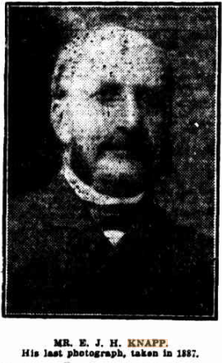**22**

On 10th October 1927, at the Church of England Home of Peace, Addison-road, Marrickville, occurred the death of Edward’s sister, (Miss) Fanny Mary A. Knapp, daughter of Rosena/Rosina and the late Lieutenant Edward J. H. Knapp, Royal Engineers. She was interred at St. Andrew's (C. E.) God's Acre, Cooper-street, Braidwood.**23**

On 11th June 1930, Edward’s brother, Alfred Knapp, died. By then Edward had moved from Beecroft and was living with his sister, Kate Maddrell, at ‘*Bedervale*,’ Braidwood.**24**

On 2nd January 1931 Edward Knapp junior passed away at the age of 95 years, at ‘*Bedervale*,’ Braidwood, where he had been residing for some little time with his sister, Mrs. R. J. C. Maddrell, senior.

‘Until two or three years ago, when the weight of years commenced to tell Its tale, the late Mr. Knapp was a man of wonderful vitality. His mentality, too, was astonishing. Up till then he was a prolific writer to the newspapers; his articles disclosing a knowledge of many subjects quite beyond the scope of many contributors to the press. In former years he was a frequent contributor to the 'Dispatch,' especially during the war period, when his well-informed articles created a deal of attention. The funeral took place on Saturday, the remains of the deceased gentleman being interred in St Andrew's cemetery.’

‘Mr. Knapp's sister, Mrs. R. J. C. Maddrell, of *Bedervale*, Braidwood, is still living.’**25**

**Grave of Edward J. H. Knapp junior (with other family members)**

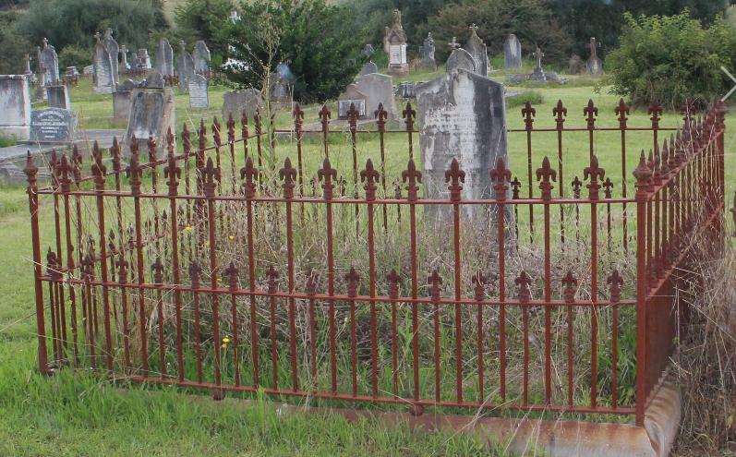 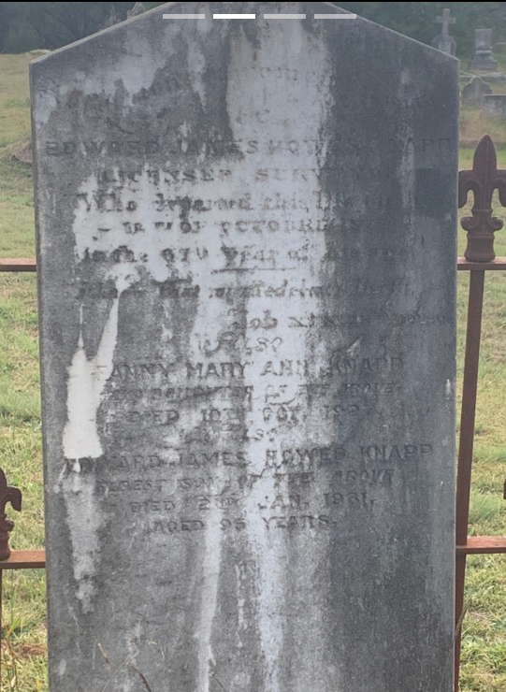

**Bibliography (Edward Knapp junior)**

1 NSW Registry Births Deaths & Marriages; Sydney Morning Herald, Sat 3 May 1924; Gosford Times and Wyong District Advocate (NSW), Thu 22 May 1924

2 Sydney Morning Herald, Sat 3 May 1924

3 Sydney Morning Herald, Sat 14 Jun 1856

4 New South Wales Government Gazette, Fri 11 Jun 1858

5 Northern Times (Newcastle), Wed 17 Aug 1859; Sydney Morning Herald, Wed 5 Aug 1863; Cumberland Argus and Fruitgrowers Advocate, Sat 8 Mar 1924

6 Sydney Morning Herald, Sat 3 May 1924

7 Sydney Morning Herald, Tue 3 Mar 1863; Sydney Morning Herald, Sat 3 May 1924

8 Sydney Morning Herald, Thu 14 Oct 1875; Sydney Morning Herald, Sat 3 May 1924; Goulburn Evening Penny Post (NSW), Wed 7 Jan 1931

9 Sydney Morning Herald, Wed 17 Aug 1887; Sydney Mail and New South Wales Advertiser, Sat 31 Dec 1887; Queanbeyan Age (NSW), Sat 14 Jan 1888

10 Evening News (Sydney), Thu 12 Jun 1890

11 Queanbeyan Observer (NSW), Thu 22 Apr 1897

12 Evening News (Sydney), Tue 31 Jan 1899; Daily Telegraph (Sydney), Wed 1 Feb 1899; Catholic Press (Sydney), Sat 4 Feb 1899; Clarence and Richmond Examiner (Grafton, NSW), Sat 4 Feb 1899; Warialda Watchman (NSW), Thu 16 Feb 1899; Armidale Express and New England General Advertiser (NSW), Fri 7 Apr 1899

13 Sydney Morning Herald, Wed 15 Aug 1900

14 Daily Telegraph (Sydney), Sat 22 Jul 1916

15 Sun (Sydney, NSW), Tue 1 Aug 1916; Watchman (Sydney), Thu 19 Oct 1916

16 Cumberland Argus and Fruitgrowers Advocate, Sat 25 Jan 1919

17 Cumberland Argus and Fruitgrowers Advocate, Sat 18 Oct 1919

18 Sydney Mail, Wed 1 Nov 1922

19 Richmond River Express and Casino Kyogle Advertiser (NSW), Wed 11 Jul 1923

20 Armidale Chronicle (NSW), Sat 3 May 1924

21 Sydney Morning Herald, Sat 3 May 1924

22 Sydney Morning Herald, Tue 21 Oct 1924; Sydney Morning Herald, Fri 24 Oct 1924; Sydney Mail (NSW), Wed 14 Jan 1931

23 Yass Courier (NSW), Thu 8 Dec 1927

24 Biz (Fairfield, NSW), Fri 13 Jun 1930

25 Braidwood Review and District Advocate (NSW), Tue 6 Jan 1931; Goulburn Evening Penny Post (NSW), Wed 7 Jan 1931