## **JOHNSON, Algernon Sidney Melville**

Algernon S. M. Johnson was born on 2nd February 1878, at Parramatta, the son of George Charles & Mary Johnson.**1**

He joined the Public Service on 5th December 1892, serving in the Mental Hospitals Department.**2**

By mid-1909, prior to his marriage, Algernon was living at Cheltenham, having lived previously at Goulburn. In July 1909 he asked Hornsby Council to reduce the levels of Beecroft-road, in front of his house, due to poor drainage. The Council recommended that the drains be put in good order there.**3**

On 15th November 1909, at St. Saviour's Cathedral, Goulburn, Algernon Sidney M., second son of Mr. and Mrs. G. C. Johnson, of Summer Hill, was married to Emelie [also Emily]; born 1883] Margaret, younger daughter of Mr. and Mrs. Alexander J. W. Manson, of Belmont, Goulburn. Alexander Manson at one time owned Bellmont Orchard, Goulburn.**4**

Children of the marriage were:

Valerie Dorrington (1912-1999), born Ryde district

Nancy Marion Melville (1914-1991), born Ryde district

Lawrence Alexander Sidney (1925-1997, AM), born Ryde district**5**

Algernon Johnson continued to live at Cheltenham for the remainder of his life.

In July 1924 his father died in the district of Mosman.

‘Mr. G. C. Johnson, the well-known Pressman, passed peacefully away at his late residence, "Okorito," Brierly [Brierley] street, Watersleigh[?], at 1.30 yesterday morning after a long and honorable career, having reached the advanced age of eighty-eight years.

Better known by the pen name of "Paul Twyford,"Mr. Johnson was a prolific writer, and was held in affectionate esteem by a very wide circle with whom he was unacquainted with personally, his pen proving equally facile in either verse or prose. Not the least valuable of his labors was the collecting of a volume of fact and legend concerning that romantic personality Margaret Catchpole. Declining years militated against the late author supervising its publication, but the valuable manuscript is in the safe keeping of the Mitchell Library.’**6**

On 23rd October 1933, at his residence, "Glen Gavin," 178 Beecroft Road, Cheltenham, Algernon Sidney Melville, died aged 55 years, having served as accountant and later an inspector in the Mental Hospitals Department.

‘He was a foundation member and director of the Cheltenham Recreation Club, honorary auditor of St Andrew's Church of England Church and Sunday School, Cheltenham, of which he was also an active worker since its foundation. He was also the vice-president and honorary auditor of Cheltenham Cricket Club, and honorary auditor of the Beecroft and Cheltenham Red Cross Society.

In his earlier days, he was well known in Goulburn, being a member of the Goulburn Liedertafel and 1st Australian Light Horse. Mr. Johnson is survived by a widow, two daughters, Valerie and Nancy, and one son, Lawrence.’**7**

Emily died in 1964 and is buried with her husband at Macquarie Park Cemetery, Church of England Section, Row F5, Grave 0056. The grave of their son, Lawrence, is alongside.**8**

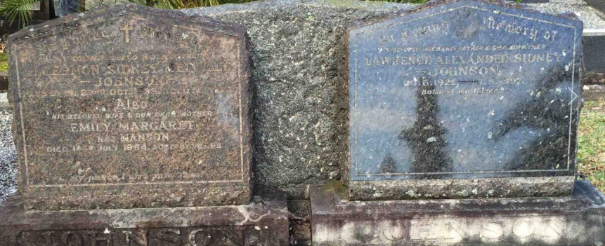

**Bibliography**

1 Ancestry.com

2 N.S.W. Public Service Lists

3 Cumberland Argus and Fruitgrowers Advocate (Parramatta, NSW: 1888 - 1950), Saturday 17 July 1909, page 5; Cumberland Argus and Fruitgrowers Advocate (Parramatta, NSW: 1888 - 1950), Saturday 7 August 1909, page 10

4 Sydney Morning Herald (NSW: 1842 - 1954), Saturday 4 December 1909, page 12

5NSW Births Deaths & Marriages; Ancestry.com

6 Hawkesbury Herald (Windsor, NSW: 1902 - 1945), Thursday 31 July 1924, page 4

7 Daily Telegraph (Sydney, NSW: 1931 - 1954), Tuesday 24 October 1933, page 8; Sydney Morning Herald (NSW: 1842 - 1954), Friday 27 October 1933, page 15; Goulburn Evening Penny Post (NSW: 1881 - 1940), Friday 27 October 1933, page 2

8 Ancestry.com