## **HULL, James Prior & Jemima M.**

**James Prior Hull**

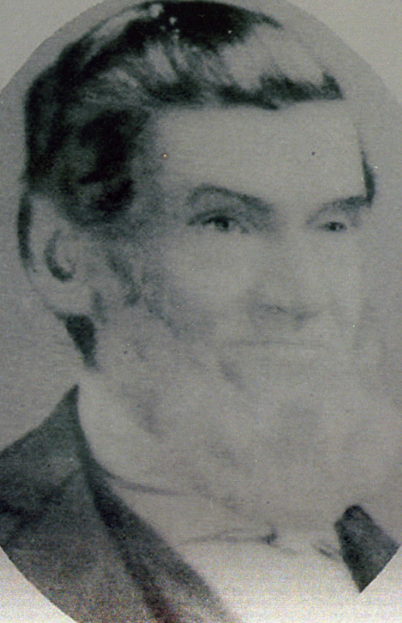

James Prior Hull was born on 29th July 1818, at Stepney, London, Middlesex, England. He was baptised at St. Dunstan and All Saints Church of England, Stepney High Street, Stepney, London, on 23rd August 1818.

His parents are Thomas (then a chandler, 1785-1854) & Sophia (nee Moyse; 1788-1860) Hull.

On 5th August 1839 at St. Anne Church of England, Limehouse, London, James Prior Hull, painter, of Limehouse, son of Thomas, married Eliza Foster Alexander, spinster of Limehouse, daughter of John Alexander (dead). Both signed their names on the certificate.

James and Eliza arrived in Sydney, Australia, as assisted immigrants on 7th January 1840, on board the vessel *Alfred*. His occupation is given as painter.

In 1847 he owned 2 lots of land at Bathurst, each of 2 roods.

In May 1848 James, then living at Summer Hill, Sydney, purchased another small plot of land at Bathurst for £10.

The first child, Charles Arthur Hull (1849-1921), was born 1st November 1849, at Guyong, N.S.W. (near Bathurst).

The family returned to England in 1851.

Their 2nd child, Emily, was born at sea, off the coast of Brazil, in 1851.

Back in England he entered into business, however it would not prosper.

Their 3rd child, James William, was born in London, on 23rd April 1852.

On the death of his wife Eliza shortly afterwards, he married Jemima Margaret Forster, at Newington, Kent, England, on 8th March 1843.

There would be 8 children from the marriage.

The 1st child was Alice Clara, born on 23rd June 1853, London.

The family journeyed back to Australia in 1856.

Gold fever had hastened his return, and he headed for the Turon, but was unsuccessful on the field, and so returned to Sydney and worked as a carpenter for the then high wage of £1 a day. Having made some money he returned to Molong where he worked on the Commissioner’s House. After that he erected an inn at Sheppard’s [or Shepherd’s] Creek, opened the hotel himself and ran it for a while.

The following children were:

Walter John, born 6th March 1857, at Shepherd’s Creek, Wellington, N.S.W.

Frederick, born 19th August 1858, Orange (died 1860)

Grace Maria, born 2nd March 1860, Orange

Lucy Rose, born 4th February, Molong

Ada Mary, born 4th August 1863, Molong

Clara Louise, born 1865, Molong

Amy Claudia, born 3rd August 1867, Molong

[After 1857] he went to Murga (on the stagecoach line from Orange to Forbes) to erect a hotel there in order to cope with the traffic to the Forbes gold field, but circumstances dictated that the hotel be erected on Boree Creek [now Cudal].

He obtained a position with Mr. [Robert Johnstone] Barton [maternal grandfather of Andrew Barton ‘Banjo’ Paterson], the original owner of Boree Station [near Molong, N.S.W.].

In 1858 he purchased a small plot of land at Orange. In 1860 he purchased a small plot of land at West Molong. He erected old St. John’s and the R. C. Church in Molong.

About 1880 James left Molong and went in for contracting for the erection of public schools in all parts of the State, from Sydney to Bourke and from the Queensland border down to Molong, schools at Burraga, Liverpool, Obley, Green Grove, and Meranburn.

On assisting his son, James, contractor for the Molong Town Hall, he suffered his first seizure of paralysis. He gradually recovered but suffered from subsequent attacks. When building a school on the Darling a big flood occurred and he sought a place of refuge, the experience staying forever in his memory.**1**

In October 1889 the Hulls, James having retired, were living in Beecroft, having bought two allotments of land at the corner of Beecroft Road and Kirkham Street.**2**

In 1889, the first known Wesleyan Methodist service in Beecroft was conducted by the Rev. James Carruthers, the Ryde Circuit Minister, in the home of James and Jemima Hull. Many years later, it was reported by the Methodist Minister: ‘During my time services were held at Beecroft, but the opening of an Anglican Church crowded us out, as the lady at whose place we met no longer felt free to give us the room. She was an Anglican, and her minister objected to her helping the Methodists any longer.’

The lead for establishing an Anglican church in Beecroft came from Jemima Margaret Hull.

The first Church of England service at Beecroft was held at Mrs. Hull’s residence on November 16th, 1890, Mrs. Hull having kindly placed a room at the disposal of the Rev. G. McIntosh for the purpose.

In January 1891, at a meeting held at Mrs. Hull’s residence, Beecroft, it was resolved that a Progress Association be established, to be known as the Beecroft Progress Association. ‘Also, that a public MEETING be called, and is hereby called, to take place at Mrs. Hull’s Residence on WEDNESDAY NEXT, 4th February, at 7.45 p.m. sharp. Business To elect Officers and Committee, adopt Rules and Regulations, and to transact such other business as will place the Association on a working basis at once. H. RAWES WHITTELL, Hon. Sec.’**3**

On 6th June 1891 a public meeting was held at Mrs. Hull’s for the Beecroft Progress Association, the topic of discussion being the selection of a site for a Public School.**4**

In February 1891 St. John’s Church of England Church-School, Beecroft, was opened. Jemima Hull offered a white cloth for the newly installed communion table. In 1892 the Church was licensed and Jemima Hull arranged for the purchase of a stone font at a cost of £5 3s, half of which was met by children attending the Sunday school, Mrs. Hull contributing a large proportion of the remainder.**5**

In December 1895 it was reported that ‘Mrs. J. P. Hull, a much-esteemed lady resident of this district for some considerable time, left to take up her residence in Marrickville this week. Mrs. Hull was a very energetic worker in church matters and will be greatly missed.’**6**

On 16th August 1902 Mrs. J. P. Hull, formerly of Beecroft, died at her home, 17 Joseph-street, Ashfield.**7**

On 27th October 1906 James Prior Hull, aged 88 years, died at his residence, Bridge-street, Epping. He left a family of three sons and four daughters, the sons being Arthur and James of Molong, Walter of Wagga district, one of the daughters being a State school teacher, and two others who conduct a ladies school at ‘Linwood’ College, Petersham.**8**

He was buried at Carlingford Anglican Cemetery, Section B5.69.

**Bibliography**

1 Molong Express and Western District Advertiser, Sat 3 Nov 1906; Ancestry.com

2 Beecroft and Cheltenham: The Shaping of a Sydney Community to 1914, page 213-214; The Cumberland Argus and Fruitgrowers Advocate, Sat 13 Jul 1907; Methodist (Sydney, NSW), Sat 9 Aug 1913

3 The Sydney Morning Herald, Sat 31 Jan 1891

4 The Sydney Morning Herald, Sat 6 Jun 1891

5 Beecroft and Cheltenham the Shaping of a Sydney Community to 1914, page 215, 217

6 The Cumberland Argus and Fruitgrowers Advocate, Sat 7 Dec 1895

7 The Cumberland Argus and Fruitgrowers Advocate, Wed 20 Aug 1902, The Sydney Mail and New South Wales Advertiser, Sat 23 Aug 1902

8 Molong Express and Western District Advertiser, Sat 3 Nov 1906; NSW Registry of Births Deaths and Marriages

**NOTE**: Additional information contained within Beecroft Cheltenham History Group website and book ‘Beecroft and Cheltenham, the Shaping of a Sydney Community to 1914’.