## **HOLCOMBE, Harry Octavius**

Harry Octavius Holcombe was born on 1st January 1856, London Middlesex, England. He was baptised on 29th November 1857, at St. Pancras, London. His parents were Philip George (1813-1893) and Eliza (nee Jones; born 1819) Holcombe.

In 1871, Harry then attending school, was living with his parents and siblings at Marylebone, London, his father being a master harp manufacturer.

Harry left England when aged 24 years (1880) carrying a letter of introduction to Robert Tooth of the brewing company in Sydney. Tooth gave Holcombe a position and he became private secretary to Robert Tooth, remaining with the company all his working life.**1**

In November 1882 Harry Holcombe was boating with friends in Sydney Harbour when the boat capsized, and he had a narrow escape.**2**

In December 1883 he was a contestant in a Public Elocution contest at Woollahra Literary Institute.**3**

In March 1884 he was elected as to the office of Hon. Secretary of the Kent Brewery Amateur Coursing Club.**4**

On 7th May 1884 Harry, son of Phillip George Holcombe, of Berners-street, London, was married at the Presbyterian Church, Campbell-street, Balmain, to Violet Isabel Young, eldest daughter of George Edward Young, of Balmain.

In June 1885, at “Bernesville, Orange-street, Randwick, a son was born. This child, Phillip George Edward (Phil), died at his parents’ home in Randwick, on 11th November 1886, of diphtheria. Another child, Hilda Annie, was born in 1887 at Randwick.**5**

In May 1886 he was a committee member of the Randwick Literary and Debating Society.**6**

In July 1888 he was elected vice-president of the Woollahra Literary and Debating Society.**7**

In January 1889 he was appointed Honorary Secretary of the Randwick Ratepayers Association.**8**

On 24th April 1894 he sold his property, “Bernsville”, Orange-street, Randwick by public auction, ‘on account of his departure to the country’ [Beecroft].**9**

In November 1894 Harry Holcombe attended a public meeting at Mr. Stobo’s store, Beecroft, concerning ‘The Fate of Beecroft under Local Government’. He thanked Mr. Whittle for the trouble he had gone to in bringing about the meeting.**10**

In February 1895 he was elected as Treasurer of the Beecroft Progress Association, and in February 1896 was re-elected Treasurer.**11**

In August 1896 he was also elected Vice-president of the Beecroft Kennedya Tennis Club. In August good progress was being made with Mr. Holcombe’s new residence in Copeland-street.**12**

In January 1897 he was elected President of the Beecroft Progress Association. **13**

In October 1897, Harry, aged 42, suffered a leg fracture in an office at Tooth’s [Kent] Brewery, George-street west. In December 1897 he was appointed a Magistrate.**14**

In 1898 he was appointed a trustee of the Beecroft Recreation Reserve.**15**

In January 1899 Harry Holcombe became a committee member of the Beecroft Progress Association, Mr. B. R. Gelling becoming president.**16**

In April 1900 Harry was elected the people’s churchwarden at St John’s, Beecroft. He hosted a juvenile evening party, with about 50 children attending, at his home, “Highwick”, Beecroft, in November of that year.**17**

In January 1902 he sailed for London with his wife and daughter. The residents of Beecroft presented him with a case of pipes and wished him bon voyage. The Beecroft Progress Association granted him a leave of absence for six months.**18**

In December 1902 he was appointed an office bearer of the Kent Brewery Ambulance Corps.**19**

In May 1908 he was gazetted a trustee of an additional nine perches to the Village Green, Beecroft.**20**

In Nov 1912 a weatherboard cottage in Copeland Street was being constructed, under the name of his wife, Violet.**21**

On 2nd April, 1913, at St. John’s Church of England, Beecroft, Hilda Annie, only daughter of Mr. & Mrs. H. O. Holcombe, “Highwick”, Beecroft, was married to Eric Brangwin, second son of Mr. and Mrs. Melbourne Green, Beecroft.**22**

In September 1915 Harry had let for a term his ‘fine villa home’ in Copeland-road, the tenant being Mr. B. J. Ball, of Mosman, and a former resident of Beecroft. Mr. and Mrs. Holcombe were going to live at Manly for some time.**23**

In June 1916 a cottage in Hornsby was being constructed for H. O. Holcombe, of Copeland street.**24**

In July 1916 Harry was elected president of the Beecroft Bowling Club.**25**

In August 1920 it was gazetted that Harry Octavius Holcombe had land in the municipality of Manly of 18 ¼ perches, including premises “Glenalva,” No. 28 Cliff-street.**26**

In April 1924 a dinner was held by the management and staff of Tooth and Co. Ltd. to mark his resignation after 44 years of service.**27**

In July 1926 he was elected as a vice-president of the Beecroft Bowling and Recreation Club.**28**

In January 1928 he advertised for a housekeeper. He and his wife were the only occupants of the home.**29**

In December he dropped out of the New South Wales bowling contingent for the New Zealand tour, due to heavy rain affecting the greens.**30**

In November 1930 Mr. and Mrs. Holcombe attended a party at Killara to celebrate the 80th birthday of Mrs. Melbourne Green, whose son had married Mr. and Mrs. Holcombe’s daughter.**31**

In June 1933 a trust, H. O. Holcombe Family Trust Ltd., was set up, with a capital of £500 to acquire lands, buildings, etc., with governing director being Harry Holcombe.**32**

In May 1934 Mr. and Mrs. Holcombe, of Beecroft, celebrated their golden wedding anniversary at their daughter and son-in-law’s home in Killara. Among the many guests were five of the bridesmaids who had attended Mrs. Holcombe at her wedding fifty years previously. The Beecroft Croquet Club sent flowers.**33**

In June 1941 the construction of two brick cottages on Beecroft Road, Beecroft, were approved, the owner being Harry Holcombe, of Copeland-street, Beecroft. Whether these were to be part of the trust is uncertain.**34**

On 11th September 1943, at his home, “Highwick,” 88 Beecroft Road, Beecroft, Harry Octavius Holcombe, husband of Violet and father of Hilda (Green), died aged 87 years.**35**

On 29th March 1947, at her residence, “Highwick”, 88 Beecroft Road, Beecroft, Violet Isabel Holcombe, widow of Harry Octavius Holcombe, died, aged 80 years. A service was held in St. John’s Church of England, Beecroft.**36**

He was buried at Macquarie Park Cemetery, Anglican denomination, Section H, Row 15.

The family grave contains the remains of Harry Octavius Holcombe, died 11th September 1943, aged 87 years; Violet Isabel Holcombe, died 29th March 1947, aged 80 years; infant son Philip George Edward Holcombe, Eric Brangwin Green, died 24th September 1958, aged 74 years; Hilda Annie Green, died 28th July 1972, aged 85 years.

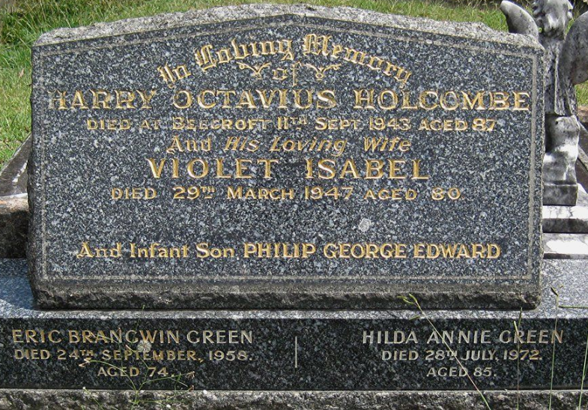

**Bibliography**

1 Hornsby Shire Historical Society, Pioneers of Hornsby Shire, Sydney, 1979, pp. 65­-70; Ancestry.com

2 Morning Herald and Miners’ Advocate, Fri 10 Nov 1882

3 Evening News, Sat 8 Dec 1883

4 The Sydney Mail and New South Wales Advertiser, Sat 22 Mar 1884

5 The Sydney Morning Herald, Mon 19 May 1884; The Sydney Morning Herald, Wed 28 May 1884; The Sydney Mail and New South Wales Advertiser, Sat 4 Jul 1885; The Sydney Morning Herald, Sat 13 Nov 1886

6 The Sydney Morning Herald, Fri 7 May 1886; The Sydney Morning Herald, Mon 6 Sep 1886

7 The Sydney Morning Herald, Sat 21 Jul 1888

8 Evening News, Tue 22 Jan 1889

9 The Sydney Morning Herald, Wed 18 Apr 1894

10 The Cumberland Argus and Fruitgrowers Advocate, Sat 24 Nov 1894

11 The Cumberland Argus and Fruitgrowers Advocate, Sat 9 Feb 1895; The Daily Telegraph, Sat 9 Feb 1895; The Daily Telegraph, Thu 6 Feb 1896

12 The Daily Telegraph, Sat 1 Aug 1896; The Cumberland Argus and Fruitgrowers Advocate, Sat 29 Aug 1896

13 The Cumberland Argus and Fruitgrowers Advocate, Sat 30 Jan 1897

14 The Australian Star, Tue 12 Oct 1897; Ancestry.com

15 The Cumberland Argus and Fruitgrowers Advocate, Sat 1 Jan 1898; The Sydney Morning Herald, Thu 13 Jan 1898

16 The Daily Telegraph, Tue 31 Jan 1899

17 The Cumberland Argus and Fruitgrowers Advocate, Sat 28 Apr 1900; The Cumberland Argus and Fruitgrowers Advocate, Sat 3 Nov 1900

18 Evening News, Sat 25 Jan 1902; The Sydney Morning Herald, Thu 13 Feb 1902; The Cumberland Argus and Fruitgrowers Advocate, Sat 3 May 1902

19 The Sydney Morning Herald, Mon 8 Dec 1902

20 The Cumberland Argus and Fruitgrowers Advocate, Sat 23 May 1908

21 Construction: Weekly Supplement to Building, Mon 18 Nov 1912

22 The Sydney Morning Herald, Sat 26 Apr 1913

23 The Cumberland Argus and Fruitgrowers Advocate, Sat 18 Sep 1915

24 Construction and Local Government Journal, Fri 30 Jun 1916

25 The Cumberland Argus and Fruitgrowers Advocate, Sat 29 Jul 1916

26 Government Gazette of the State of New South Wales, 20 Aug 1920

27 The Daily Telegraph, Sat 5 Apr 1924

28 The Daily Telegraph, Sat 31 Jul 1926

29 The Sydney Morning Herald, Sat 14 Jan 1928

30 The Daily Telegraph, Mon 17 Dec 1928

31 The Sydney Morning Herald, Wed 12 Nov 1930

32 Daily Commercial News and Shipping Line, Sat 1 Jul 1933

33 The Sydney Morning Herald, Thu 17 May 1934

34 Construction (Sydney), 4 Jun 1941

35 The Sydney Morning Herald, Mon 13 Sep 1943

36 The Sydney Morning Herald, Mon 31 Mar 1947

**NOTE**: Additional information contained within Beecroft Cheltenham History Group website and book ‘Beecroft and Cheltenham, the Shaping of a Sydney Community to 1914’.