## **HERRING, Leslie George**

[‘Leslie’ occasionally spelt as ‘Lesley’]

Leslie George Herring was born on 21st February 1846, at Balmain, Sydney, and baptised on 26th April 1846 at St. John’s, Ashfield.

His parents were Joseph (1813-1899) and Emily Ann (nee Potts; 1829-1892) Herring.

In 1873 Leslie Herring married Kate Emily Tucker, in Sydney.

‘HERRING—TUCKER—September 18, at St. John's Church, Darlinghurst, by the Rev. Thomas Hayden, Leslie Herring, to Kate Emily, second daughter of James Cawley Tucker.’

Kate was born in 1852, in Sydney.

She was the sister of Charles Churchill Tucker, also a long-term resident of Beecroft.**1**

Children of the marriage were:

12th July 1874 – Mabel Kate, Milson’s Point, Sydney [died 1942]

1st September 1875 – Leslie Guy, Milson’s Point, Sydney [died 13th July 1876]

29th December 1876 - Edgar Maule, Milson’s Point, Sydney [died 1976]

17th February 1878 - Albert Everard [died 1967]

20th June 1879 - Nigel Reep, at St. Leonards, Sydney [died 1953]

[The name ‘Reep’ comes from the maiden name of Kate’s mother] **2**

In April 1891 the Beecroft Nursery, advertised ‘Clean, Healthy, and Well-grown ORANGE, LEMON, and SUMMER FRUIT. All Apples worked on blight-proof stocks. ORNAMENTAL TREES, SHRUBS, and Flowering Plants. Also, a choice lot of Vegetable and Flower Seeds.’

The nursery was managed by G. B. Moran who had previously owned Waratah Nursery at Pennant Hills, however Leslie Herring and G. B. Moran each had a ½ share in the Beecroft Nursery.

By January 1893 the nursery was flourishing, with some 34 acres of orchard land under cultivation. There were large numbers of well-selected and carefully imported stock trees, from San Francisco, Japan, and other countries. They also planted poplars and other trees in the streets. Mr. Moran lived at Pennant Hills; Mr. Herring lived at Hunter’s Hill.**3**

In July 1893 Mr. Herring, through his manager, Mr. Moran, sent from the Beecroft orchard, ten cases of lemons to San Francisco, per the S.S. *Miowera*, as a trial shipment.4

In August 1894 it was reported that ‘This grand estate [Beecroft Nursery], the property of Mr. Leslie Herring, is now well worth a visit, and the enthusiastic manager, G. B. Moran, is very pleased to see visitors.**5**

In November 1896 it was reported that ‘Mr. L. Herring, of Hunter’s Hill, is about to erect a commodious residence on his well-known orchard property at Beecroft.’**6**

In October 1897 Kate E. Herring refers to her address as “*Sheen,*” Beecroft. It would no doubt refer to an earlier residence as the new house, also named “*Sheen*,” was not completed until February 1899.

Also that month, at a Beecroft Progress Association meeting, ‘Mr. Green mentioned the desirability of beautifying the station grounds, by having the vacant lands thereat trenched, fenced in and planted with ornamental trees and shrubs. Mr. Hogan had brought the matter under his notice and had informed him that Mr. Leslie Herring was willing to contribute towards such an improvement.’**7**

In February 1899 it was reported that ‘Mr. Leslie Herring, formerly a resident of Hunter’s Hill, entered into the occupation of his new and handsome villa residence in Hannah Street, Beecroft, last week. It is of the early English type of house, and is generally regarded as the prettiest place in Beecroft.’

‘Mr. H. B. Colton, who some few years ago left Hunter’s Hill, has returned, and now occupies the residence recently vacated by Mr. Leslie Herring, in Joubert-street.’**8**

In August 1900 **‘**A garden fete was held at “*Sheen*,” Hannah Street, Beecroft, the grounds of Mr. Leslie Herring, in aid of the Indian Famine Relief Fund.’**9**

In April 1901Mr. Joseph Lovell, disposed of his well-known orchard property, dwelling, etc., to Mr. Leslie Herring.**10**

In March 1903 Leslie Herring, of Beecroft, became a new telephone subscriber [Tel. 48 Epping].**11**

In April 1903, Walcot Way, a labourer, 25 years of age, son of Mr. John Thomas Way, orchard manager for Mr. Leslie Herring, of “Sheen,” Beecroft, committed suicide opposite the Beecroft railway station.**12**

**HERRING’S ORCHARD, BEECROFT**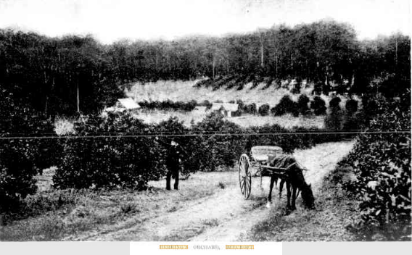

In July 1907 Leslie Herring exported 20 cases of oranges to London, as an experimental shipment. He topped the list of local growers at 8s 3d per case.**13**

On 25th September 1907 ‘at Tangoa, New Hebrides, Maurice, son of the late A. E. Witts, of Rosemount, Monaro, and Mrs. Witts, Drummoyne, was married to Mabel Kate, only daughter of Lesley Herring, *Sheen*, Beecroft.’**14**

In May 1908 Mrs. Herring advertised for a ‘thorough General Servant, 2 in family, another maid kept.’

In February 1909, she advertised for a ‘thorough General [Servant], 3 in family, housemaid kept.’

In May 1910, she advertised for a ‘young Girl, train as H. and P. Maid.’

In August 1911, another advertisement for a ‘Cook and laundress, OR General Servant, housemaid kept. Wages 16s.’

Another advertisement in November 1912 – ‘reliable Lady Help, for small family, for Wyong.’**15**

In August 1913 a garden fete in aid of the funds of the Ministering Children’s League and the Beecroft branch of the Harbour Lights Guild, was held in the grounds of Mrs. L. Herring’s residence, who was president of the Beecroft branch.**16**

Leslie George Herring died on 12th September 1913, aged 67 years, at Dr. McCormack’s private hospital at Darlinghurst, after being operated on for an internal trouble.

‘His illness came on rather suddenly, and his death was quite unexpected by his friends. The funeral took place at Waverley Cemetery. He left a wife and three sons and a daughter. ‘The sons are farmers in the Batlow district, and the daughter is Mrs. Witt[s]. The late Mr. Herring resided at “Sheen,” Hannah-street, Beecroft. He had an extensive orchard property in Beecroft.’

‘Mr. Herring held the position of secretary to the firm of Mort and Co, and about the time that an amalgamation was effected and the present firm of Goldsbrough, Mort, and Co., was established he left the firm, although he continued to be identified with the Mort interests. Under the terms of the will of the late Mr. T. S. Mort, Mr. Herring was appointed a trustee of the estate, and in that capacity his business acumen was of great service. At the time of his death he was on the directorate of the New South Wales Fresh Food and Ice Company Ltd., Mort’s Dock and Engineering Company Ltd., Tooth and Co. Ltd., the Australian Alliance Assurance Company, the Permanent Trustee Company Ltd., and the Bodalla Estate.’**17**

In December 1913 probate was granted of the will of L. G. Herring.

‘The testator appointed the Permanent Trustee Company, Limited, trustees and executors of his estate, the whole of which he bequeathed to his widow and children, the widow (Kate Emily Herring) to receive the income for life; after her decease, the estate to be divided equally among all the children. Directions were given the trustees with respect to the sale and conversion of the estate, and the carrying on of the orchard at Beecroft.

The net value of the estate was sworn at £23,499 15s.’**18**

In June 1914 two allotments of Herring’s Estate were sold for £424.**19**

On 3rd February 1918, Kate Emily Herring, of *Sheen*, Beecroft, widow of L. G. Herring, died at a private hospital.**20**

**Waverley Cemetery, Plot: W-19-CE-SP-6086**

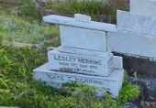

In April 1919 a subdivision sale of portion of the Herring Estate, Beecroft, was held by Richardson and Wrench, Ltd.

‘On Saturday, April 12th, Messrs. Richardson and WRENCH WILL OFFER ON BEHALF OF THE TRUSTEES FOR POSITIVE SALE, THE PICK OF Beecroft, known as the Herring estate, fronting Hannah, York, and Malton-streets., situate opposite “Sheen,” the residence of the late Mr. Leslie Herring, also one of the picked sites of Beecroft of 2 acres, fronting Garret-road, handy to the station, and a choice building site, between Beecroft and Cheltenham.’**21**

In September 1919, Acting under instructions received from The Permanent Trustee Coy. of N. S. WALES, Trustees, in the Estate of Mrs. Kate Emily Herring, deceased, will sell by Public Auction, at Batlow, on Sept. 6th, 1919, Lot 5, consisting of about 66ft frontage to road, depth about 188ft. 8 1/2 ins. containing 1 rood, 5 ½ perches. Torrens title.**22**

In October 1919, by order of the Permanent Trustee Company of New South Wales, Limited, in the late L. G. Herring’s Settlement, BEECROFT, SHEEN SUBDIVISION, the following was auctioned:

‘16 Building Lots, Each 66 feet.

Frontages to Hannah and York streets, and Malton-road, by depths of 280 ½ feet, together with ***Sheen***, an attractive Home of modern and convenient design, built of brick, shingle roof, containing 9 rooms, 2 bathrooms, kitchen, pantry, storeroom, hot water service, detached laundry, 3-stall stable, man’s room, and small bedroom, garage. The position is a corner one.

The Property will be offered as a whole, or with less area, and if not disposed of, then in Subdivision as above.’**23**

In January 1922, By order of the Permanent Trustee Co. of N.S.W., Limited, in the Estate of Kate Emily Herring, deceased, the following was auctioned:

‘CRONULLA SITES.

1st. – Lot 29, Dunmore Heights Estate, 52ft 11in to Kurranalla Beach-road, by 178ft 4in along Cawarra-road.

2nd. – Lot 24, Five Ways Estate, 53ft 4in Port Hacking-road (Port Hacking), by 215ft to 231ft.

3rd. – Lot 18, Charley’s Corner Estate, 40ft to Willarong-road, by 288ft.

4th. – Lot 50, Sturt Estate, 56ft 7in to Sturt-road, depth 213ft to 217ft.

5th. – Lots 41 and 42, Sturt Estate, 132ft to Locksley-street, by 165ft along Sturt-road.

6th. – Lots 43 and 44, Sturt Estate, 151ft to Locksley-street, by 162ft, width at rear 107ft 8n.

7th. – Lot 42, Cronulla Beach Hotel Estate, 60ft to Gosport-street, by 180ft.’**24**

In October 1922, under instructions from The Permanent Trustee Company of N.S.W., Limited, as Trustees in the estate and Settlement of the late Lesley George Herring, the following was auctioned:

‘BEECROFT.

Large Home Areas, convenient to Station, comprising 14 Lots.

In area about 2 ½ acres each, including W.B. cottage, “Sunningdale,” on portion 730.

Deep, rich, well worked soil, sheltered and shaded, fronting Malton, Hull and Albert Roads.’**25**

In May 1924 the bungalow villa, formerly the residence of Mr. Leslie Herring, at Beecroft, was secured for a second Twilight Home, a hostel for aged gentle-women. [The first Twilight Home was at Mosman.]

‘The original home has undergone some notable extension, a two-storey addition at the rear, a cottage wing, giving a closed verandah entrance and exit to all other parts of the composite building, which contains 15 bedrooms, 4 sitting and recreation rooms, together with adequate bathrooms, pantries, kitchens, and other rooms. Mr. W. M. Nixon was the architect for the remodelling, and Mr. George Lennon the contractor.

The original cost was £2500, and the additions will run into £1600.’**26**

**Batlow Cemetery – Nigel Reep Herring, died 16th June 1953**

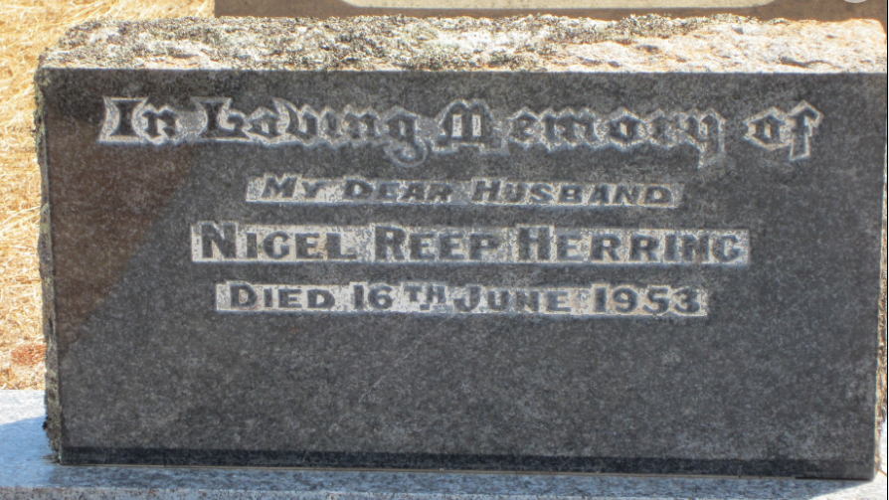

**Batlow Cemetery – Edgar Maule Herring, died 23rd August 1976**

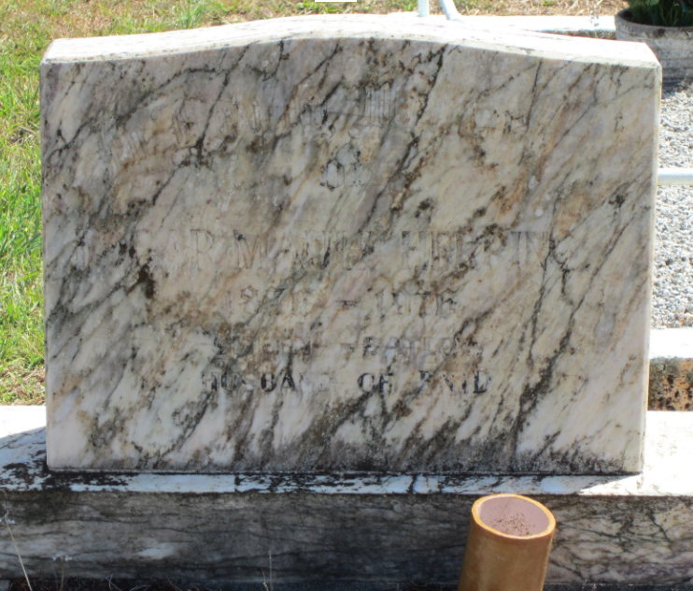

**Batlow Cemetery – Albert Everard Herring, died 13th April 1967, Plot: CE A4**

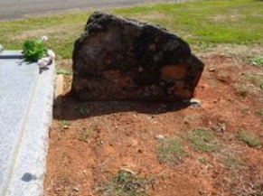

**Bibliography**

1 Sydney Mail and New South Wales Advertiser (NSW: 1871 - 1912), Saturday 4 October 1873, page 453; Ancestry.com

2 Ancestry.com; N.S.W. Births Deaths & Marriages, various newspapers

3 Windsor and Richmond Gazette, Sat 18 Apr 1891; The Cumberland Mercury, Sat 14 Jan 1893

4 The Cumberland Argus and Fruitgrowers Advocate, Sat 15 Jul 1893

5 The Cumberland Argus and Fruitgrowers Advocate, Sat 18 Aug 1894

6 The Cumberland Argus and Fruitgrowers Advocate, Sat 21 Nov 1896

7 The Daily Telegraph, Sat 9 Oct 1897; The Cumberland Argus and Fruitgrowers Advocate, Sat 16 Oct 1897

8 The Cumberland Argus and Fruitgrowers Advocate, Sat 4 Feb 1899; The Cumberland Argus and Fruitgrowers Advocate, Sat 2 Dec 1899

9 The Cumberland Argus and Fruitgrowers Advocate, Sat 4 Aug 1900

10 The Cumberland Argus and Fruitgrowers Advocate, Sat 20 Apr 1901

11 Evening News, Mon 16 Mar 1903; The Sydney Morning Herald, Fri 15 Nov 1912

12 The Cumberland Argus and Fruitgrowers Advocate, Sat 25 Apr 1903

13 The Cumberland Argus and Fruitgrowers Advocate, Sat 6 Jul 1907; The Cumberland Argus and Fruitgrowers Advocate, Sat 21 Sep 1907

14 The Sydney Morning Herald, Mon 28 Oct 1907

15 The Cumberland Argus and Fruitgrowers Advocate, Sat 30 May 1908; The Cumberland Argus and Fruitgrowers Advocate, Sat 20 Feb 1909; The Sydney Morning Herald, Sat 14 May 1910; The Cumberland Argus and Fruitgrowers Advocate, Sat 12 Aug 1911; The Sydney Morning Herald, Fri 15 Nov 1912

16 The Cumberland Argus and Fruitgrowers Advocate, Sat 9 Aug 1913

17 The Sydney Morning Herald, Mon 15 Sep 1913

18 The Daily Telegraph, Fri 5 Dec 1913

19 The Sydney Morning Herald, Sat 20 Jun 1914

20 The Sun, Wed 13 Feb 1918

21 The Daily Telegraph, Sat 8 Mar 1919; The Cumberland Argus and Fruitgrowers Advocate, Sat 29 Mar 1919

22 The Tumut and Adelong Times, Thu 28 Aug 1919

23 The Sydney Morning Herald, Sat 13 Sep 1919

24 The Sydney Morning Herald, Sat 7 Jan 1922

25 The Daily Telegraph, Sat 9 Sep 1922

26 The Daily Telegraph, Fri 9 May 1924

**NOTE**: Additional information contained within Beecroft Cheltenham History Group website and book ‘Beecroft and Cheltenham, the Shaping of a Sydney Community to 1914’.