## **GREEN, Melbourne**

Melbourne Green was born on 12th September 1851, at 1b Upper Gloucester Place, Chelsea, London, the son of Henry (1805-1857) and Catherine Ann (nee Heath; 1812-1908) Green.

The family arrived in Port Phillip Bay, Melbourne, on 20th October 1852, on board the ship *Nepaul* which had departed from London.

On 16th February 1881 Melbourne, youngest son of the late Henry Green, of Melbourne, married Margaret Kate Palmer, eldest daughter of Benjamin Palmer, Clifton, Upper William-street, at the Congregational Church. Pitt-street, Sydney.**1**

Children of the marriage were:

Melbourne Outtrim Shirley (1881-1899), nicknamed ‘Shirley,’ born on 31st December 1881, at their residence, Liberty-street, Stanmore.

Eric Brangwin Douglas (1884-1958)

Dorothy Kate L. (1885-1886)

Emma W. K. (1887-1887)

Neville Palmer (1888-1952)

Clarice Heath Palmer (1890-1899)

Gerald L. (1891-1891)**2**

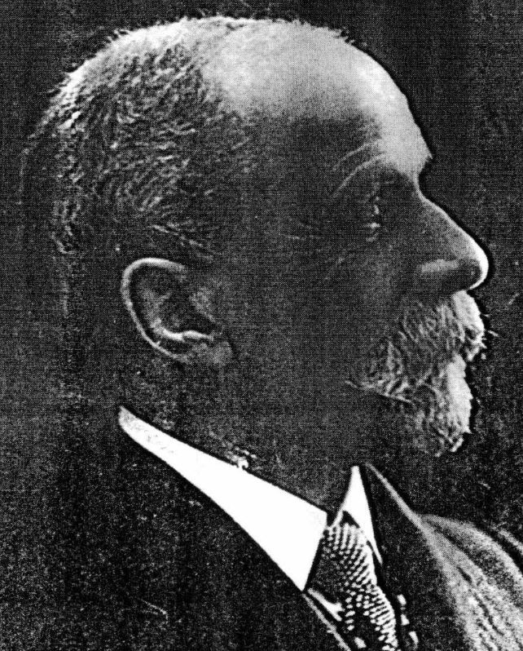

Melbourne Green was an accountant, later chief accountant, of the Water & Sewerage Board Department.

In January 1894 the residence of Melbourne Green, in Holt-street, Petersham, was robbed of a large amount of jewellery.**3**

The family relocated to Beecroft around 1895.

**Clarice Green’s birthday c1896 with Beecroft Railway Station in background**

**Clarice standing in centre, Melbourne Green standing on left**

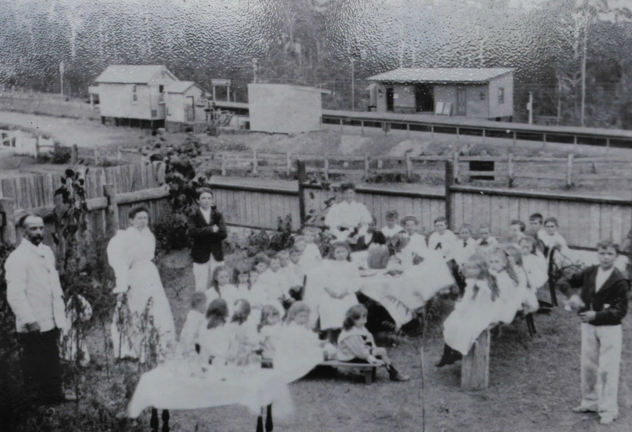

In May 1896 he was elected to the committee of the Beecroft Progress Association, and in 1897 was elected honorary treasurer of that association. In late 1898 he resigned the treasurer-ship to become vice-president.**4**

In April 1897 he was appointed minister’s warden of St. John’s Church of England in Beecroft. In September he was appointed, along with the President of the Beecroft Progress Association, H. O. Holcombe, to act as Beecroft representatives on the Carlingford School Board.**5**

In October 1897, at the Beecroft Progress Association meeting, he mentioned the desirability of beautifying the station grounds, by having the vacant lands trenched, fenced in and planted with ornamental trees and shrubs. He, and Joseph Lovell, were appointed as a sub-committee to approach the Railway Commissioners for their sanction and to carry out the necessary arrangements with regard to subscriptions. In October 1898, with the establishment of the gardens, he was actively involved in tending the plants.**6**

In October 1897 he was appointed a magistrate by the Chief Secretary’s Office.**7**

In February 1899 Melbourne Green and his family left Beecroft for Croydon, which was heard with much regret. Their residence was then occupied by the owner, Mr. McLaughlan.**8**

Several weeks later Melbourne’s eldest son, Shirley [Melbourne Outtrim S. Green], died.

In July 1899 the family returned to Beecroft for some weeks, living in Mr. George Sargent’s house.**9**

On Dec 8th, 1899, at her parent’s residence, “Tara,” Elwin-street, Croydon, occurred the death of Clarice Heath Palmer, dearly beloved daughter of Melbourne and Margaret Kate Green, aged 9 years.**10**

In July 1901 the family again returned to live in Beecroft at Mr. Sargent’s house in Copeland-street. In September 1902 they moved into Mr. H. O. Holcombe’s residence, with Mr. Holcombe to occupy the residence previously vacated by Mr. T. Skellett.**11**

In May 1903 the family occupied “Healthfield,” Beecroft, and, at the invitation of Mrs. Green, the house and grounds were opened to give the parishioners an opportunity of meeting the new rector, Rev. J. Young, who succeeded the Rev. G. McIntosh. Mrs. Green was president of the Beecroft League (the Women’s Liberal League, dealing with matters of women’s suffrage).**12**

In September 1905 Melbourne Green resigned his position as a member of the committee of the Beecroft School of Arts.**13**

In 1912 Melbourne Green purchased the cottage used as the police station from William Abram, giving the policeman notice to quit the premises. In December he called a tender for brick additions to the building in Railway Crescent [also referred to as the Thornleigh road], which he named ‘Shirley’ after his deceased son. In 1916 he applied to Hornsby Council to lop the tops off the blue gums in Railway Crescent, as to encourage a thicker growth.**14**

In April 1913 the Beecroft Bowling and Recreation Club was formed, with Melbourne Green being on the Committee. That month, his second son, Eric Brangwin Green, married Annie Holcombe, only daughter of Mr. and Mrs. H. O. Holcombe, of “Highwick,” Beecroft.**15**

On 26th August 1928 Melbourne Green died at Epping, aged 77 years, and was buried at Gore Hill cemetery. It is mentioned that he was a director of the N.S.W. Mont de Plete Deposit and Investment Co, Ltd., and a keen bowler of both Beecroft and North Sydney Bowling Clubs. He was survived by a widow and two sons. In the Supreme Court, Probate Jurisdiction, he is recorded as being a retired accountant, of Epping.**16**

In November 1930 his widow Kate celebrated her 80th birthday at the Killara home of her son Eric. She was born in George-street, Sydney, in 1850, and had many vivid memories of those early days.**17**

On 6th December 1935 Margaret Kate Green died at her residence, 15 High-street, Epping, aged 85 years, widow of Melbourne Green, and a daughter of the late Mr. Benjamin Palmer, a former Mayor of Sydney. She was an ardent supporter of the Pitt-street Congregational Church for many years. She lived at Epping and Beecroft, for a long period, and took a keen interest in many charities, including the Twilight Home, Beecroft. Early in the century she was actively associated with the movement for the introduction of women’s suffrage.

She is survived by two sons and seven grandchildren.**18**

**Bibliography**

1 Evening News, Sat 26 Feb 1881; Ancestry.com

2 NSW Registry of Births Deaths and Marriages; The Sydney Morning Herald, Thu 5 Jan 1882; Ancestry.com

3 NSW Police Gazette and Weekly Record of Crime, Wed 31 Jan 1894

4 The Cumberland Argus and Fruitgrowers Advocate, Sat 2 May 1896; The Cumberland Argus and Fruitgrowers Advocate, Sat 20 Aug 1898

5 The Cumberland Argus and Fruitgrowers Advocate, Sat 24 Apr 1897; The Cumberland Argus and Fruitgrowers Advocate, Sat 18 Sep 1897

6 The Cumberland Argus and Fruitgrowers Advocate, Sat 16 Oct 1897; The Cumberland Argus and Fruitgrowers Advocate, Sat 29 Oct 1898

7 NSW Government Gazette, Fri 29 Oct 1897

8 The Cumberland Argus and Fruitgrowers Advocate, Wed 1 Feb 1899; The Cumberland Argus and Fruitgrowers Advocate, Sat 25 Feb 1899

9 The Cumberland Argus and Fruitgrowers Advocate, Sat 11 Mar 1899; The Cumberland Argus and Fruitgrowers Advocate, Sat 1 Jul 1899

10 The Daily Telegraph, Sat 9 Dec 1899

11 The Cumberland Argus and Fruitgrowers Advocate, Sat 13 Jul 1901; The Cumberland Argus and Fruitgrowers Advocate, Sat 6 Sep 1902

12 The Cumberland Argus and Fruitgrowers Advocate, Sat 2 May 1903; The Sydney Morning Herald, Wed 20 May 1903

13 The Cumberland Argus and Fruitgrowers Advocate, Sat 16 Sep 1905

14 The Cumberland Argus and Fruitgrowers Advocate, Sat 27 Jul 1912; Construction: Weekly Supplement to Building, Mon 16 Dec 1912; The Cumberland Argus and Fruitgrowers Advocate, Wed 6 Dec 1916

15 The Cumberland Argus and Fruitgrowers Advocate, Sat 19 Apr 1913; The Sydney Morning Herald, Sat 26 Apr 1913

16 The Daily Telegraph, Mon 27 Aug 1928; The Sun, Tue 28 Aug 1928; Government Gazette of the State of NSW, 24 May 1929

17 The Sydney Morning Herald, Wed 12 Nov 1930

18 The Sydney Morning Herald, Sat 7 Dec 1935; The Sydney Morning Herald, Fri 13 Dec 1935

**NOTE**: Additional information contained within Beecroft Cheltenham History Group website and book ‘Beecroft and Cheltenham, the Shaping of a Sydney Community to 1914’.