## **DEY, Robert**

**Robert Dey Elizabeth Johnston Dey Robert Dey senior**

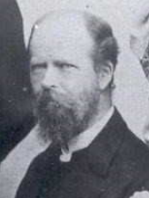 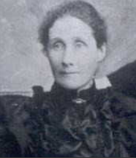 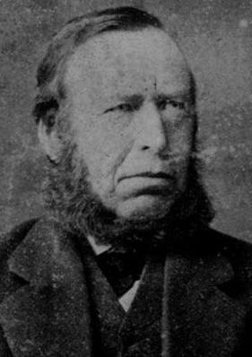

Robert Dey’s parents were Robert (1814-1897) and Elizabeth (nee Dunbar; 1824-1850) Dey.

‘Dr Dey was born in Inverurie, Aberdeenshire, Scotland, on August 4, 1848.

He went to school at Banffshire at the age of four and continued there until October, 1867, when he obtained a scholarship in connection with the theological Hall of Congregational Churches (Scotland), which entitled him to attend the Edinburgh University for four years.

Entering the Edinburgh University in November 1867, Dr Dey remained there during the sessions of 1867-68 to 1870-71, when he took a full course of study for the M. A. degree, obtaining distinction in moral philosophy and English literature.

He passed the Master of Arts examination in mathematics and philosophy, but when reading up for the examination in classics to complete his course for the M. A. degree there occurred the first breakdown in his health, which prevented his sitting for the examination and eventually necessitated his coming to Australia.

He also studied for four years in the Theological Hall of the Congregational Churches in Edinburgh under Dr Lindsay Alexander and Dr Cowan. On the completion of his course at the Theological Hall he accepted a call to the Congregational Church at Nairn. Dr Alexander travelled all the way from Edinburgh to Nairn to take part in his ordination on August 18 1871.’**1**

On 3rd April 1874, the Rev. Robert Dey, minister of the Congregational Church. Nairn, was married to Elizabeth Johnston Dewar, third daughter of the Rev. David Dewar, minister of the Free Church of Scotland.

Elizabeth was born on 23rd January 1852, at Fochabers, Moray, Scotland, daughter of David (1796-1885) and Charlotte (nee Johnston; 1817-1899) Dewar.**2**

Children of the marriage were:

1875 - Robert [died 1918]

1876 – Charlotte Johnston [died 1960]

1878 – Herbert [died 1878]

1879 - David Dewar [died 1957]

1882 – Elma Victoria [died 1885]

1884 – Ethel Dunbar [died 1954]

1886 – Lindsay Alexander [died 1973]

1888 – John Dewar [died 1953]

1891 – William Dunbar [died 1892]**3**

‘After seven happy and successful years of ministry at Nairn during which he had been invited to churches in Glasgow and various parts of Scotland he eventually accepted a call to Glasgow and went there as pastor of Bethany Church in April 1878. The change from the beautiful bright, clear atmosphere of Nairn to the moist humid atmosphere of Glasgow proved too heavy a strain on his health especially as it meant the oversight of a congregation of 500 members, and of a Sunday school of more than 1000 scholars together with the direction of a mission at some distance from the main church.

On October 1, 1880, he left London for Melbourne on a year's leave of absence from his congregation but when he arrived In Melbourne he was strongly advised by Dr Bird, a great medical authority in those days, to give up the idea of returning to Scotland. He cabled his resignation and accepted a call to the Victoria-parade Congregational Church, Melbourne.

After two years' service there he accepted a call to the church at Marrickville, entering upon his ministry there in 1882. Whilst at Marrickville the church was enlarged to double its size and the membership increased threefold.

At the beginning of July, 1888, he acceded to an urgent call, and became home secretary of the Congregational Union of NSW. This position he held until October 1894 when he resigned that post and also the editorship of the “Australian Independent," the organ of the Congregational body, which he had held for eight or nine years. About the year 1892 he purchased the "Australian Christian World,” eight years after it had been started by the Rev J. D. Hennessy, and it was edited by the late Dr Forsyth on his behalf, while he remained secretary of the Congregational Union. In 1894 he took over the editorship of the paper himself. After purchasing the "Australian Christian World" he took over and amalgamated with it the following journals: "The Protestant Standard" (Sydney), "The Australian Weekly" (Melbourne), "The Christian Colonist (Adelaide), and lately "The Southern Cross" (Melbourne). The paper in 1887, before Dr Dey's ownership had taken over the "Evangelical Standard" (Brisbane).**4**

On the celebration of his 82nd birthday in 1930 he said "My life hobby has been literary work and reading. I have always been a consistent worker, not into the early hours that some men boast of, for I never toiled after 10 p.m., but I invariably did all that I was expected to do at the time and rested properly as each day's task was thrown behind."**5**

Dr. Dey commenced his residency at Cheltenham about 1902.**6**

His house in Cheltenham-road, Cheltenham, was named ‘Strathsprey,’ after the region around the strath of the River Spey, Scotland.

In December 1914, ‘Robert Dey, of Cheltenham, wrote to Hornsby Council, asking that an additional street light might be erected at the corner of Boronia Avenue and Cheltenham-road. It was an exceedingly dark spot just there, and as there was considerable traffic along Boronia Avenue from Cheltenham-road, it was very desirable that there should be a lamp at the junction of the two streets.’**7**

In 1923 ‘the University of Edinburgh - his Alma Mater - and the McGill University of Toronto, Canada, conferred upon him the honorary degree of Doctor in Divinity. For the past 21 years Dr. Dey had resided at Cheltenham. He was honorary pastor of the church there for a considerable time.’**8**

On 6th June 1934, at Strathsprey, Cheltenham Road, Cheltenham, occurred the death of Elizabeth Johnston, wife of the Rev. Dr. Robert Dey, aged 82 years.

On 18th June a service of remembrance and thanksgiving for the life and work of the late Mrs. Robert Dey was held in the Cheltenham Congregational Church.

On 23rd September a stained-class window installed in memory of the late Mrs. Robert Dey, was unveiled and dedicated in the Cheltenham Congregational Church.**9**

On 31st July 1936, Robert Dey, of Cheltenham Road, Cheltenham, died at St. Luke's Private Hospital. He died the day after his return from a visit to North Queensland.

‘His wife died two years ago, and his eldest son in 1918. He is survived by three sons - Mr. David Dewar Dey [of Epping], of Robert Dey, Son, and Company, Dr. Lindsay Dey, of North Sydney, Mr. John Dewar Dey, of Parramatta and two daughters - Mrs. F. S. Stuckey, of Mosman, and Mrs. A. H. Hinton, of Chatswood.’

‘The Rev. Robert Dey, D.D., occupied a prominent position in the councils of the Congregational Church for more than 60 years. He would have celebrated his 88th birthday next Tuesday.’

‘Dr. Dey was a forceful and eloquent preacher, but he was better known as the editor of the "Australian Christian World" for more than 30 years. In this capacity, and by his extensive travelling, he kept in touch with religious leaders throughout Australia, and he exercised a great influence in Church circles. Few men were better known and respected.

He was a keen advocate of Church union, and as a tribute to his work in this connection, representatives of the various Churches will participate in the funeral services today. There will be a service at the Pitt-street Congregational Church at 10.30 a.m., after which the cortege will move to the Congregational Cemetery, Rookwood.’**10**

In April 1937 ‘Dr. Robert Dey, who died last year, was for nine years honorary pastor of the Cheltenham Congregational Church. On Sunday a memorial window was unveiled by Dr. Lindsay Dey, one of his sons. The window, depicting "The Good Shepherd," was a companion of one erected previously in memory of Mrs. Dey.

Dr. Robert Dey had a record of over 60 years in the ministry, and for a lengthy period edited the "Australian Christian World."**11**

**Rookwood General Cemetery; Plot: Independent; Old Ground; North-East Boundary**

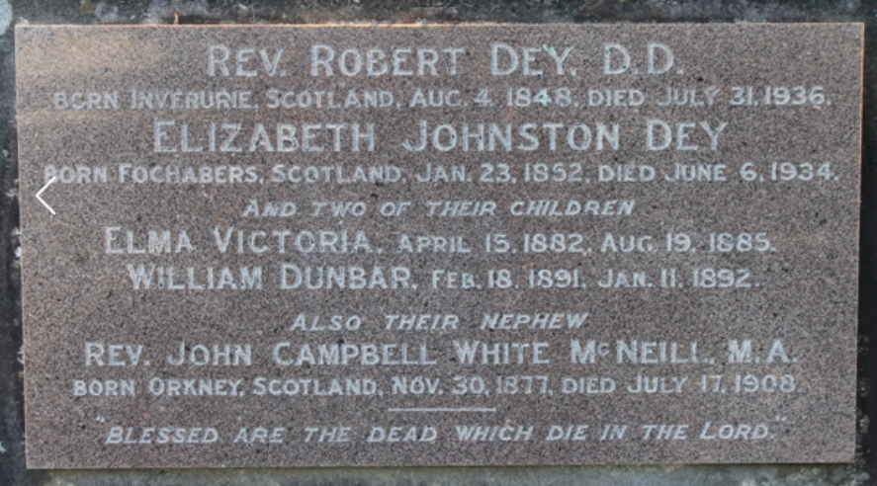

**Bibliography**

1 Sydney Morning Herald (NSW: 1842 - 1954), Tuesday 5 August 1930, page 10; Ancestry.com

2 Daily Telegraph (Sydney, NSW: 1883 - 1930), Thursday 3 April 1924, page 4; Ancestry.com

3 Ancestry.com

4 Sydney Morning Herald (NSW: 1842 - 1954), Tuesday 5 August 1930, page 10

5 Sydney Morning Herald (NSW: 1842 - 1954), Tuesday 5 August 1930, page 10

6 Sydney Morning Herald (NSW: 1842 - 1954), Saturday 1 August 1936, page 14

7 Cumberland Argus and Fruitgrowers Advocate (Parramatta, NSW: 1888 - 1950), Saturday 19 December 1914, page 8

8 Sydney Morning Herald (NSW: 1842 - 1954), Saturday 1 August 1936, page 14

9 Daily Telegraph (Sydney, NSW: 1931 - 1954), Saturday 9 June 1934, page 6; Sydney Morning Herald (NSW: 1842 - 1954), Monday 18 June 1934, page 15; Sun (Sydney, NSW: 1910 - 1954), Friday 21 September 1934, page 14

10 Riverine Grazier (Hay, NSW: 1873 - 1954), Friday 31 July 1936, page 2; Wingham Chronicle and Manning River Observer (NSW: 1898 - 1954), Friday 31 July 1936, page 4; Daily Telegraph (Sydney, NSW: 1931 - 1954), Saturday 1 August 1936, page 10; Sydney Morning Herald (NSW: 1842 - 1954), Saturday 1 August 1936, page 14

11 Daily Examiner (Grafton, NSW: 1915 - 1954), Thursday 8 April 1937, page 4