## **CREAGH, Sarah Anne**

The story begins with the death of Sarah Ann[e] Creagh, who died on 23rd June 1915, at her residence ‘*Westgarth*,’ Copeland-street, Beecroft, where she had lived for some years following the death of her husband, Rev. Stephen Mark Creagh in 1902. She was buried in the Congregational section of Rookwood Cemetery. Her surviving issue consisted of four daughters and three sons.

‘Mrs. Creagh, widow of the late Rev. S. M. Creagh, of the London Missionary Society, died recently, at her home at Beecroft, in her 86th year [85 years 11 months]. The greater part of Mrs. Creagh's active life was spent in missionary duties in the Loyalty Islands [now part of New Caledonia], where she carried on a most successful work. Mrs. Creagh first settled in the Loyalty Islands in the year 1858, and after 28 years' service in conjunction with her late husband she retired to Sydney in 1886, and spent the remainder of her days with some of the members of her family residing there. She, however, never ceased her missionary activities.’**1**

On 16th February 1858 Sarah Anne Buzacott, only daughter of the Rev. Aaron Buzacott, Senior Missionary and Principal of the Native Theological College, Roratonga, South Sea, [now in the Cook Islands] was married to the Rev. Stephen Mark Creagh, in Sydney.

Sarah had been born in Roratonga, but in 1851 was living with her parents, Aaron & Sarah V. Buzacott, in Islington, London, England.

Stephen Mark Creagh was born on 9th September 1826 at Plymouth, Devon, England.**2**

In May 1902 the Committee of the British and Foreign Bible Society offered the position of honorary life governor of the Society to the Rev. S. M. Creagh, a retired missionary in Sydney of the London Missionary Society, in recognition of the great services which he has rendered in the translation of the Bible.

That year he had completed the revision of the Mare Bible, in which work he was greatly assisted by Mrs. Creagh. In recognition of her services, the British and Foreign Bible Society conferred upon Mrs. Creagh the unique distinction of a life governor of that society.**3**

On 8th October 1902 at his residence, ‘*Avarus*’, Redmyre-road, Strathfield, Rev. Stephen Mark Creagh, of the London Missionary Society, died, aged 76 years. He was buried in the Congregational section of Rookwood Cemetery. Watego, a native of the Loyalty Islands, was also in attendance at the funeral service.**4**

Rev. Creagh had been appointed in 1853 to the Loyalty Group, and during his long residence in the islands was chiefly engaged in a translation and publication of the Scriptures in the native languages of Polynesia. After retiring from active missionary work in 1886, he continued his literary work, and at the time of his death was still engaged in revising proofs of the Mare Bible, forwarded to him by each mail from London, by the Bible Society.**5**

**Gravestone of Stephen & Sarah Anne Creagh Sarah Ann Creagh at daughter Mrs. Rayner’s house6**

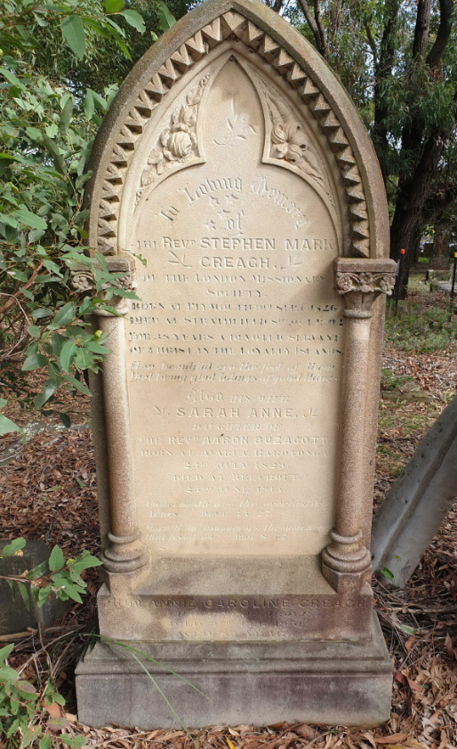 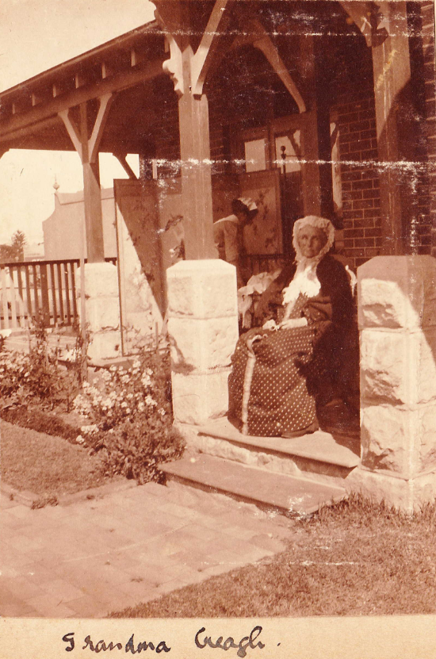

**Stephen Mark Creagh**

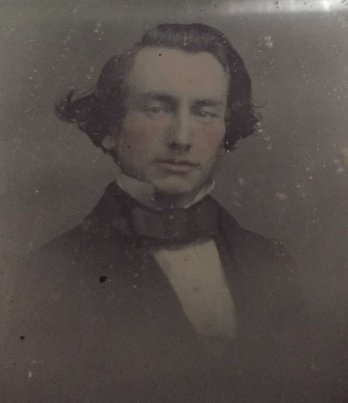

**Bibliography**

1 Albury Banner and Wodonga Express (NSW: 1871 - 1938), Friday 2 July 1915, page 30; Sydney Morning Herald (NSW: 1842 - 1954), Thursday 24 June 1915, page 8; Cumberland Argus and Fruitgrowers Advocate (Parramatta, NSW: 1888 - 1950), Wednesday 30 June 1915, page 3

2 Sydney Morning Herald (NSW: 1842 - 1954), Thursday 18 February 1858, page 1; Ancestry.com

3 Watchman (Sydney, NSW: 1902 - 1926), Saturday 31 May 1902, page 4; Australian Town and Country Journal (Sydney, NSW: 1870 - 1919), Wednesday 15 October 1902, page 11; Sydney Morning Herald (NSW: 1842 - 1954), Friday 25 June 1915, page 4

4 Sydney Morning Herald (NSW: 1842 - 1954), Thursday 9 October 1902, page 1; Sydney Morning Herald (NSW: 1842 - 1954), Friday 10 October 1902, page 10; Sydney Morning Herald (NSW: 1842 - 1954), Saturday 11 October 1902, page 11

5 Australian Town and Country Journal (Sydney, NSW: 1870 - 1919), Wednesday 15 October 1902, page 11

6 Ancestry.com photos