## **COPELAND, Henry**

Henry Copeland was born at Brandsburton, Hull, Yorkshire, England, and baptised on 6th June, 1839 at Holy Trinity, Kingston upon Hull, Yorkshire.

He was educated at Trinity House School, Hull.

‘He qualified as a navigator at 15, failed to get into the navy and joined the merchant service. He was in a Russian port when the Crimean war broke out, saw action in the Baltic and then sailed for America. At 18 he reached Williamstown, Victoria, where he deserted and carried his swag to Ballarat.’**1**

‘He settled in Australia in 1857, going there as a mining lad and from that humble position he worked his way up to take an active part in the government of the colony in which he settled.’**2**

He later returned to England (perhaps due to some financial difficulties he was facing in Ballarat) and ‘on the 20th [April 1863], at St. Leonard’s church, Malton, Mr. Henry Copeland, of Ballarat, Colony of Victoria, Australia, [was married] to Hannah, youngest daughter of Mr. James Beecroft, cooper, Malton.’**3**

Henry, with his new wife, returned to Ballarat.

Children of this first marriage (there was no issue to his 2nd marriage) were:

1865 – Henry Beecroft (born 9th Dec 1864), Ballarat, Victoria (died 1930)

1867 – Ada Laura, Ballarat, Victoria (married William A. Lutherborrow 1907)

1868 – Rachel Lillian, Ballarat, Victoria (married 1904 Frank Norris)

1871 – Hilda Victoria, Ballarat, Victoria (died 1872)

In January 1872 the family moved from Victoria to N.S.W.

Further additions to the family were:

1873 - Alfred Dale, Paddington, N.S.W. (died 1879)

1874 – Ethel, Sydney N.S.W. (died 1874)

1876 – Harold Woden, Sydney, N.S.W. (died 1949)

1877 – Rachel, Newtown, N.S.W. (died 1877)

1878 – William Arthur, Newtown, N.S.W. (died 1878)**4**

On 7th August, 1879, Hannah, the wife of Henry Copeland, died at her residence, ‘Yarraville,’ Newtown.**5**

On 16th September 1880, at Dawson-street Congregational Church, Henry Copeland, M.P., Sydney, married Mary Beecroft, sister of his late wife Hannah, of New Malton, Yorkshire, England. **6**

In early 1887, as Minister for Lands, Henry was heavily involved in the management of auction sales of large areas of land, including Beecroft - named by Mr. Henry Copeland after his wives’ maiden name. He named, also, several streets in the District: — ‘Copeland’, after his own name; ‘Hannah’, after his first wife; ‘Mary’ after his second wife; ‘Malton’, after their birthplace in England.**7**

By 1900 Henry Copeland, Agent-General for N.S.W., was installed in office in London, in succession to Sir Julian Salomons.**8**

On 19th March 1904, Henry’s wife Mary died at her residence in Burren-street, Newtown, after a long illness. Henry had recently obtained six months’ leave of absence to return home from London.**9**

Back in London by June 1904 Henry underwent an operation for a throat infection, however several days later he died on 23rd June.

He was a member of the Mining Board of New South Wales, 1B74-77; member of the Legislative Assembly, 1877-1900, when he was appointed Agent-General; Minister for Works, 1883; Minister for Lands, 1886-87; member of Public Works Committee, 1888-91; Minister for Lands, 1891-94; Chairman of Land Trustees of Trades Hall, Sydney; President of Harbour Islands and Ku-ring-gai Chase Trusts; gazetted Honourable, 1896; a frequent contributor to the press, and has published several pamphlets; took an active and prominent part in connection with Australian Federation.

During his Parliamentary life he held office in three Administrations. He represented the Commonwealth on the Pacific Cable Board, the Advisory Committee of the Imperial Institute and the International Telegraph Conference. He was a staunch defender in the Press of Australian interests.

‘In his address he was of a blunt disposition, accustomed to speak his mind, a master of his own conviction, a straight goer, and an honest man.’

At the time of his death he had become very stout; he was over 18 stone in weight. His eldest daughter was with him during his illness and at his death.**10**

The deceased was buried on the 26th June, 1904, at Teddington cemetery, near London.**11**

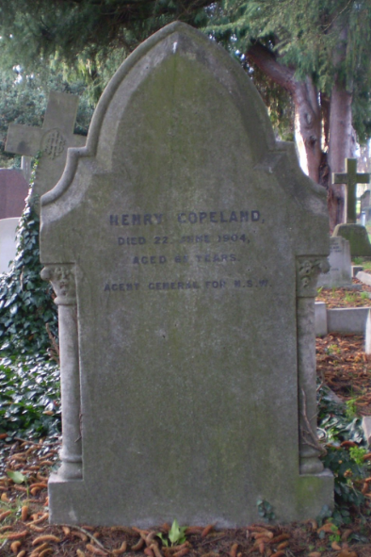

**Bibliography**

1 Ancestry.com

2 Zeehan and Dundas Herald (Tas.: 1890 - 1922), Saturday 25 June 1904, page 3; Telegraph (Brisbane, Qld.: 1872 - 1947), Saturday 30 July 1904, page 13

3 The Malton Gazette, Saturday 25 April 1863

4 Victoria Births Deaths & Marriages; NSW Births Deaths & Marriages

5 Sydney Mail and New South Wales Advertiser (NSW: 1871 - 1912), Saturday 16 August 1879, page 245

6 Ballarat Star (Vic.: 1865 - 1924), Friday 17 September 1880, page 2

7 Yass Courier (NSW: 1857 - 1929), Friday 7 January 1887, page 4; Gosford Times and Wyong District Advocate (NSW: 1906 - 1954), Thursday 25 January 1917, page 13

8 The Cumberland Argus and Fruitgrowers Advocate, Sat 19 May 1900

9 Australian Town and Country Journal (Sydney, NSW: 1870 - 1919), Wednesday 23 March 1904, page 9

10 Zeehan and Dundas Herald (Tas.: 1890 - 1922), Saturday 25 June 1904, page 3; Examiner (Launceston, Tas.: 1900 - 1954), Saturday 25 June 1904, page 4; Democrat (Perth, WA: 1904 - 1905), Saturday 2 July 1904, page 7; Telegraph (Brisbane, Qld.: 1872 - 1947), Saturday 30 July 1904, page 13

11 Democrat (Perth, WA: 1904 - 1905), Saturday 2 July 1904, page 7