## **COLQUHOUN, William Henry**

William Henry Colquhoun was born late 1856, in Leeds, Yorkshire, England, the son of Henry & Jane Colquhoun.

In 1861 the family was living in Chancery Lane, New Malton, Yorkshire.

It is not presently known when he arrived in Australia but probably about 1878 (see below).

William married Annie Watts in 1881, district of Sydney.

Annie was born in 1859, in the district of Port Macquarie, the daughter of Charles & Mary Watts.

Children of the marriage were:

Colin, born 1882; Vera, born 1883; and William, born 1884, all in the district of Newtown.**1**

On 14th February 1884, Anne, the wife of W. H. Colquhoun, Railway Department, died at 12 Baltic-street, North Kingston, Newtown.**2**

In January 1900 William’s mother, Jane, aged 72 years, died at Surrey Hills, near Melbourne.**3**

In May 1900 William Colquhoun was residing in [Alfred] Cox’s cottage, at Beecroft, and was about to move to the residence owned by Mr. Walter Perdriau and previously occupied by Mr. McCarthy. In September 1900 Mr. Bills and family occupied the cottage of Mr. Cox, previously occupied by Mr. Colquhoun. On the return of Mr. Perdriau and family in mid-1901 Mr. Colquhoun would have to vacate the premises. The 1901 Census has him living in Copeland-street – 2 males & 2 females.**4**

William Henry Colquhoun, aged 45 years, died at his residence in Beecroft on 9th January 1903.

William Colquhoun was an officer of long service in the Railway Department. After being connected with one of the leading lines of railway in Scotland, he joined the New South Wales service about 1878 as a junior clerk to Mr. Reid, the then traffic manager. His capabilities as a railway man soon gained Mr. Colquhoun promotion, and he gradually rose to the position of chief clerk in the traffic manager's department. This post he held with honour, not only in Mr Reid's time, but also during the years that Mr. Kirkcaldie was traffic manager. Mr Colquhoun was subsequently transferred to the office of the Commissioners for special duty - the preparation of statistical returns. The deceased also occasionally acted as secretary to the Commissioners. Mr Colquhoun, although not in robust health, was able to attend to his duties until within a few days of his death, which was due to heart failure. The respect in which Mr Colquhoun was held in the railway service was fully evinced by the large gathering of officers and ex-officers who attended the funeral. The cortege moved from the late residence of the deceased officer at Beecroft and proceeded to Strathfield railway station, where the funeral train was joined en route to Rookwood cemetery. The chief mourner was Mr. Colin Colquhoun, son of the deceased. Mr Colquhoun's remains were laid to rest in the Church of England portion of the cemetery (along with his wife Annie).**5**

An inscription was erected by the Staff of N.S.W. Railway – ‘An esteemed Officer who served the State with zeal and integrity for 24 years.’

Followed by Math. 25 v. 23 (Obelisk).**6**

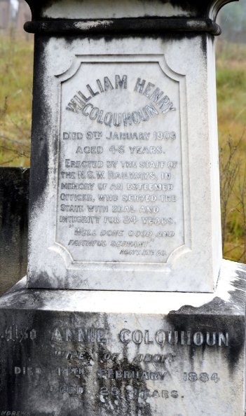

**Bibliography**

1 NSW Registry of Births Deaths and Marriages; Ancestry.com

2 Evening News, Thu 14 Feb 1884; Sydney Morning Herald, Sat 16 Feb 1884

3 Argus (Melbourne, Vic.), Thu 11 Jan 1900

4 Cumberland Argus and Fruitgrowers Advocate, Sat 19 May 1900; Cumberland Argus and Fruitgrowers Advocate, Sat 8 Sep 1900; Cumberland Argus and Fruitgrowers Advocate, Sat 27 Jul 1901; 1901 Census

5 Daily Telegraph (Sydney, NSW), Sat 10 Jan 1903; Sydney Morning Herald, Mon 12 Jan 1903

6 Ancestry.com