## **CHORLEY, William**

William Chorley was born in 1860 at the small settlement of Brompton Ralph, Somerset, about 5 miles north of the town of Wiveliscombe, Somerset, to James and Sarah Chorley.

William was baptised on 21st March 1860 in the parish of Fitzhead, county of Somerset [Fitzhead is about 2 miles east of Wiveliscombe].

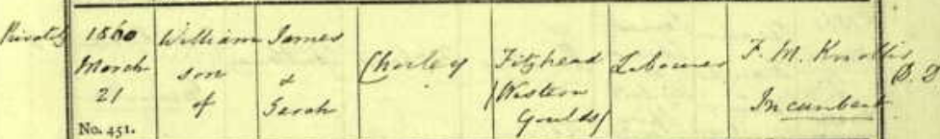

**1861 English Census – Petsford Hill, Brompton Ralph, Somerset:**



**1871 English Census – Holloways, Brompton Ralph, Somerset:**

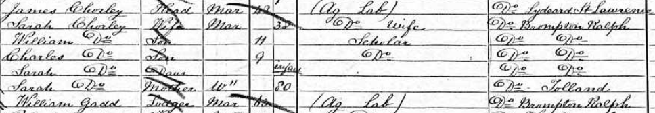

**1881 English Census – 20 Fairview Place, Cheltenham, Gloucestershire:**

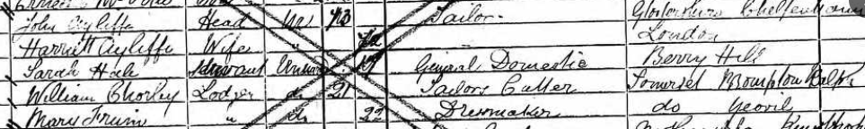

He married Lily Virginia Alder in 1881, at the Baptist Chapel, King Stanley, Gloucestershire. Lily was born in January 1862, at Stroud, Gloucestershire, daughter of Charles (1838-1901) and Anne (nee Lusty; 1838-1927) Alder.

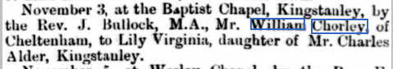

After their marriage the couple lived in Magenta Place, Cheltenham.

Their first child, Edith Bertha Amery Chorley was on 10th August 1882, at 3 Courtney-villas, Cheltenham, England

In 1883 the family sailed to Australia, arriving at Melbourne on 5th June, aboard the ship *British Yeoman* - William Chorley, 21, traveller; Lily V. Chorley 20, wife; Edith B. A. Chorley, infant.

Further children followed:

2nd July 1884 – Henry James Alder, at Canterbury [died 1956]

1886 - William Charles, at Canterbury, Sydney [died 1951]

1889 – Mabel Lily, at Burwood [died 1988]

14th November 1891 – Ada Maud, at Ryde [died 1979]

20th October 1893 – Alice Annie, at Ryde [died 1967]

1896 – Lily May, at Ryde [died 1988]

1899 - Beatrice Sarah Elizabeth Anne, at Ryde [died 1985]

1902 - Sarah, at Ryde [died 1902]

1903 – Ethel Florence, at Ryde [died 1995]**1**

He bought large parcels of land in 1887 around Beecroft, and moved from Strathfield to Beecroft about 1890.

In January 1890 ‘TENDERS are invited for Weatherboard Cottage at Beecroft, for W. Chorley. Esq. Plans, &c., and particulars at the office of H.B. THOMPSON, Architect, 30, Castlereagh-street.’**1a**

In March 1891 William was elected a member of the Carlingford Progress Association.**1b**

In November 1895 he put forward a motion at the Beecroft Progress Association meeting “that the Secretary write to the Railway Commissioners requesting them to accelerate the 6.30 p.m. train from Sydney.”**2**

In January 1896 he was elected to be on the committee of the Beecroft Progress Association. In June he advertised “I have opened a Tailoring Business in connection with my present well-known establishment, and with the object of making it a success have secured as Cutter, the services of Mr. J. F. Dibbs, late Murray Bros., Parramatta, Hagon’s, Sydney, and W. Chorley, Sydney, tailor by special appointment to the late Governor, Sir R. Duff, and the present Governor, His Excellency, Viscount Hampden’.**3**

In October 1897 he was advertising for a man who understood fruit garden and milk, with permanency for a good man. His address was both Beecroft, and 313 George-street, Sydney.**4**

In October 1898 the new railway platform, within the vicinity of Mr. Chorley’s residence at Beecroft, was declared open. It was christened “Cheltenham”, the name being chosen by Mr. Chorley in remembrance of his English home. Mrs. Chorley and members of her family had the new platform gaily decorated with flags, including the royal standard, the Union Jack, and the Australian flag. It was also artistically adorned with ferns and native flowers.

‘Despite the early hour at which the interesting little ceremony was enacted — 8 a.m. — and the short notice given, there was a fairly large gathering of local and “along the line” residents as Chief-Commissioner Oliver stepped from the train and formally declared the new railway platform open, at the same time christening it “Cheltenham” as a bottle of good sparkling champagne was smashed.’**4a**

In November 1898, an unwelcome visitor in the form of a large black snake, had invaded his aviary on the back verandah. The gardener promptly shot the reptile.

Also, that month the first consignment of fruit was despatched from the new railway platform at Cheltenham and sent to Sydney. It consisted of a dozen cases of choice apricots and plums, the produce of Mr. W. Chorley’s orchard “Mount Pleasant”.**5**

In April 1899 it was reported that ‘Mr. C. Bennett, who has been a resident of Blacktown for upwards of eleven years, has secured for a term that very handsome villa residence in Welham-street, Beecroft, belonging to Mr. Chorley, of Cheltenham. Until recently this desirable residence was occupied by Mrs. Perdriau, and has only been vacated by her about a week. Mr. Chorley was fortunate in securing a permanent tenant so soon.**5a**

In September 1899 the Department of Works complied with Mr. W. Chorley’s application for the repair of the road leading from the Pennant Hills-road to the railway station. Mr. Chorley was also advised that the main road between Cheltenham and Carlingford would be formed at once. He also advertised for a horse suitable for plough and orchard work.**6**

In January 1900 Mr. Chorley was elected vice-president of the Beecroft Progress Association, and in January 1901 was elected President for the ensuring year.**7**

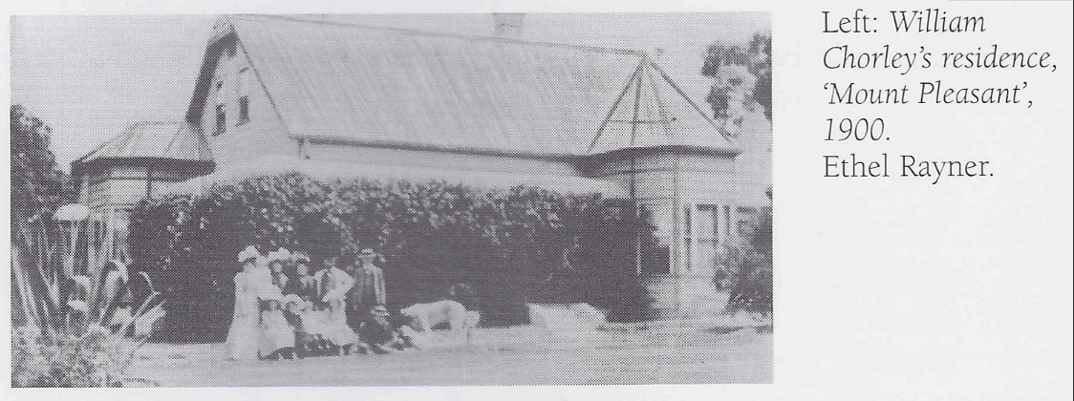

In May 1901 Mr. Chorley, of Cheltenham, was created a magistrate of the territory. In November he was at the unveiling of the Willis Memorial at Beecroft, being chairman of the committee.**8**

In January 1902 he was elected to the committee of the Beecroft Progress Association. In March he advertised for tenders required for concrete and asphalt cricket pitches at Cheltenham.**9**

In 1903 he was again president of the Beecroft Progress Association, and involved in a fund for relief of drought sufferers. He was also associated with entertainment in the Beecroft public school in aid of the picnic lunch.**10**

On 20th February 1904 Mr. Chorley’s daughter, Edith Amery, was married at St. John’s Church, Beecroft, to George Jennings Graham.**11**

**William & Lily Chorley - 1904 Wedding**

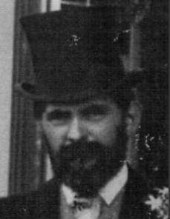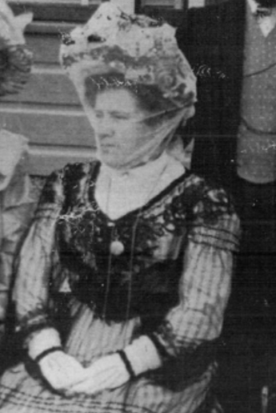

In March 1907 he offered his grounds at “Mount Pleasant,” Cheltenham, for the purpose of the annual picnic in connection with the Beecroft Public School, as he had on previous occasions. In October Mrs. Chorley advertised for a middle-aged woman as mother’s help.**12**

In 1908 he is referred to as Master Tailor, 313 George-street, Sydney.

On 19th September 1908 the foundation stone of the Beecroft Presbyterian Church was laid by Mrs. Chorley.**13**

In November 1908 Richardson and Wrench, auctioneer, offered the Mount Pleasant Estate [Subdivision 1], Cheltenham, opposite the railway station. The total amount realised upon the sale of the Mount Pleasant Estate [10 allotments] by auction and private sale was £1308, prices ranging from 25s to £3.10s per foot.**14**

On 6th March 1909 a wedding took place in the new Presbyterian Church at Beecroft, of Miss Amy Fowler, of Chepstow, England, and Mr. Henry Chorley, jun., of “*Mount Pleasant*,” Cheltenham.

Henry was the eldest son of Mr. and Mrs. W. Chorley, *Mount Pleasant*, Cheltenham; Amy was the only daughter of Mr. and Mrs. J. W. Fowler, 17 Welch-street, Chepstow, Monmouthshire, England. Several years previously, when the bridegroom was travelling in England, he made the acquaintance of Miss Fowler, and they formed a deep attachment. The six bridesmaids were the Misses Chorley, sisters of the bridegroom. Mr. Will Chorley was best man. The reception was held at “*Mount Pleasant*.” The speaker [Mr. Chorley, senior] was very pleased with his son’s conduct and with the step he had taken, and that day he had given him an interest in his city business. ‘He trusted that the young couple would have the same experience in matrimony as he had had, for though 28 years married, he had always got on happily with his wife, and if he had time his over again, would make the same selection.’

‘Rev. Mr. Ogilvie proposed the health of the parents of the bridegroom. Mr. Chorley had lived a career that any man might be proud of. He had, by industry and ability, worked up one of the largest businesses in Sydney in his profession. Mrs. Chorley’s kindness and hospitality were well known, and he was very grateful to her for her assistance in the work of the church, a gratitude which was felt not only by himself but by the whole congregation. Mr. Chorley, replying, said that when he came into the district some 19 or 20 years ago, there were only about six or eight houses there, and the train service consisted of two regular trains per day. He and his good wife had always taken a pleasure in trying to make the district go ahead, and in assisting in the social and religious work of the district.’**15**

In October 1909 the annual picnic in connection with Beecroft Public School was held on Mr. Chorley’s ground at Cheltenham, attracting between 200 and 300 adults and children. The youngsters were kept busy with races and games.**16**

In April 1910 five allotments of the Mount Pleasant Estate, Cheltenham, were sold for £656. In June another three portions of the Mount Pleasant Estate, Cheltenham, were sold for £367.

In July 1911 an allotment, being portion of the Mount Pleasant Estate, was sold for £181 5s.**17**

A cottage erected by him in 1910 was a first for the district, built with camerated concrete, patented by a Sydney man in 1905. This was of aerated concrete, an early form of besser block.**18**

On 17th February 1912, at the Presbyterian Church, Beecroft, occurred the wedding of Mr. W. Chorley, jun., son of Mr. Wm. Chorley, of Mt. Pleasant, Cheltenham, to Miss Osborne, only daughter of Mr. and Mrs. L. O. Osborne, of Beecroft.**19**

In March 1913 Mr. and Mrs. Chorley were about to take a trip to England. In August was the announcement that Miss Mabel Chorley, daughter of William Chorley, was to be married in the Presbyterian Church, Beecroft, early in September, to Mr. Hugh Millar, of Queensland.**20**

In 1914, at the annual meeting of the Beecroft Progress Association, he was not re-elected as a delegate to the committee, of which he had been a part for some years, owing to its being understood that he was about to take a long vacation in England.**21**

In January 1915, on an early Monday morning, ‘a very enthusiastic crowd of 80 to 100 friends assembled on the wharf at Palm Beach, Barrenjoey, to bid farewell to Mr. W. Chorley and Mrs. Chorley and their daughters, of “*Mount Pleasant*,” Cheltenham. The family had been staying over the holidays at “*The Rest*,” which is their pretty seaside residence facing the ocean, and situated at Palm Beach. At “*The Rest*” friends were right royally entertained and receive the Chorley family’s usually abundant hospitality. Croquet tournaments were played, surf parties and plenty of music were indulged in, and altogether the holidays were delightfully spent. There was great rejoicing when Mr. Chorley’s private launch came alongside the wharf, which was overcrowded with sincere friends.’**22**

In August 1917 a concert arranged by the Misses Chorley, of “*Mount Pleasant*,” Cheltenham, was held in the Beecroft School of Arts in aid of France’s Day. Miss May Chorley contributed a number of violin selections in admirable style, and her sister, Miss Ada Chorley, was no less successful in her songs. Miss Alice Chorley sang “Love’s Echo,” and as an encore “Down in the Forest.” A supper cloth, worked by Mrs. Chorley, was drawn for in the interval.**23**

On 19th January 1918 the 2nd subdivision of the Mount Pleasant Estate, was auctioned by Hardie and Gorman, comprising 47 building sites with large frontages and depths, while seven choice sites on the first division were also submitted. Thirty allotments, from 35s to £7 12s 6d per foot, were sold with total sales of £8741.**24**

In April 1921 was advertised for sale in Cheltenham, by William Chorley’s son Henry, a ‘New Brick and Stone Bungalow, right opposite station, 5 large rooms, large reception hall, bathroom and heater, linen press, kitchen, pantry, laundry, large sleeping-out verandah back and front, motor entrance, gardens laid out, paths and drive concrete; land 68 x 157; price £2375. Henry Chorley, Boulevard, Cheltenham; or 313 George-street, Sydney.**25**

In July 1921 William and Lily would take an overseas voyage, stopping off at various places - Honolulu, Hawaii; Washington U.S.A.; Ketchikan, Alaska, U.S.A.; Vancouver, British Columbia, Canada. From Washington they returned to Sydney.

William Chorley’s physical appearance would be described as: Complexion: dark; Eye Colour: Blue; Hair Colour: Gray; Height: 5 feet 6 inches.

Lily Chorley’s physical appearance would be described as: Complexion: Freckled; Eye Colour: Green; Hair Colour: Brown; Height: 5 feet 1 inch.**25a**

In August 1922 was announced the engagement of Ada, daughter of Mr. and Mrs. W. Chorley, of *Mount Pleasant*, Cheltenham, with Joseph A. Allison, of Rosalie, Brisbane, Queensland.**26**

In September 1923, at Epping, at a meeting of the Joint Committee of Northern District Progress Associations, Mr. W. Chorley unanimously elected a life member of the Association as a mark of recognition of his services in the days when the movement was only in its infancy.**27**

On 19th January 1924, at the Congregational Church, Pitt Street, Albert Edwards, son of Mr. and Mrs. R. Tulloch, of Thornleigh, was married to Alice Annie, daughter of Mr. and Mrs. W. Chorley, “*Mt. Pleasant*,” Cheltenham.

In February 1924, Hardie and Gorman, auctioneers, reported the sale of 19 allotments of the third subdivision of the Mount Pleasant Estate, Cheltenham. Prices ranged from £3/5/- to £7 a foot, and sales aggregated £7396/15/-.

In August was announced the engagement of Miss Beatrice Chorley, daughter of Mr. and Mrs. W. Chorley, Mount Pleasant, Cheltenham, to Mr. James Hillhouse, youngest son of Mr. and Mrs. W. Hillhouse, Clayfield, Queensland (late of Fiji). They were married on 29th December at the Pitt Street Congregational Church, Sydney.

On 25th October, to augment the building fund of the Epping Congregational Church, Mr. and Mrs. Chorley held a garden party at their home, *Mount Pleasant*, Cheltenham.**28**

In April 1927 ‘the foundation stone of a Congregational Church at Cheltenham was laid, primarily due through the generosity of two Cheltenham residents, Mr. and Mrs. W. Chorley, and to Mr. Chorley was entrusted the duty of laying the stone. In May last Mrs. Chorley gave the site, a valuable one on the main road, together with £500, and her husband followed with a straight-out gift of £1500. Although the balance of £2750 required to meet the cost of the projected project, 59ft. by 38ft. in internal measurement, was not immediately forthcoming from others, it was decided in December to commence operations, in the confidence that support would not be wanting. This confidence was not misplaced, for the last £200 was subscribed at Saturday’s ceremony.’**29**

On 26th April, 1928, at her residence , Mount Pleasant, Cheltenham, occurred the death of Lily Virginia, wife of William Chorley, and mother of Harry, William, Charles, May, Ethel, Mrs. Graham, Mrs. Millar, Mrs. Allison, Mrs. Tulloch, and Mrs. Hillhouse, in her 67th year. Probate of the will was granted to William Chorley, Henry James Chorley and Lily May Chorley, all of *Mount Pleasant*, Cheltenham.**30**

In October 1929 was announced the engagement of Miss Ethel Chorley, youngest daughter of Mr. W. Chorley, of “Mount Pleasant,” Cheltenham, to Mr. C. W. Rayner, of the Malay States, son of Mr. G. Rayner and the late Mrs. Rayner, of Porepunkah, Victoria.**31**

In September 1932 Henry Chorley, of 52 Cheltenham-avenue, advertised a land sale at Cheltenham, close to the station.**32**

On 22nd April 1935, at his residence, “*Mount Pleasant*,” Cheltenham, occurred the death of William Chorley, aged 75 years, father of Edith, Henry, William, Mabel, Ada, Alice, May, Beatrice, and Ethel. The funeral service was conducted at the Congregational Church, Cheltenham, thence to Congregational Cemetery, Northern Suburbs [Macquarie Park Cemetery, Congregational, Section A, Row 2].

‘Mr. William Chorley, whose death took place on Monday at Cheltenham, was a pioneer of that district, where he took up land about 46 years ago, and named it Cheltenham, after his native town in England. He was also one of the first to build a home at Palm Beach. He was associated with all local enterprises at Cheltenham and was a prominent member of the Congregational Church of which he was a generous supporter for many years. The founder and principal of the well-known business of W. Chorley and Co., Ltd. He had been associated with the business life of the city for more than half a century. He was 75 years of age. He is survived by two sons and seven daughters.’**33**

Probate of his will was granted to Henry James Alder Chorley, of 313 George-street, Sydney and the Permanent Trustee Company of New South Wales Limited.

In September 1938, another seven allotments of the Chorley Estate were sold, prices £5/10/- to £7/10/- per foot, total sales £2,897/5/-.**34**

**Bibliography**

1 Ancestry.com; N.S.W. Births, Deaths & Marriages

1a Sydney Morning Herald (NSW: 1842 - 1954), Tuesday 14 January 1890, page 12

1b The Cumberland Argus and Fruitgrowers Advocate, Sat 28 Mar 1891

2 The Cumberland Argus and Fruitgrowers Advocate, Sat 2 Nov 1895

3 The Cumberland Argus and Fruitgrowers Advocate, Sat 1 Feb 1896; The Cumberland Argus and Fruitgrowers Advocate, Sat 27 Jun 1896

4 The Cumberland Argus and Fruitgrowers Advocate, Sat 23 Oct 1897

4a The Cumberland Argus and Fruitgrowers Advocate, Sat 15 Oct 1898

5 The Cumberland Argus and Fruitgrowers Advocate, Sat 5 Nov 1898; The Cumberland Argus and Fruitgrowers Advocate, Sat 26 Nov 1898

5a Cumberland Argus and Fruitgrowers Advocate (Parramatta, NSW: 1888 - 1950), Saturday 15 April 1899, page 12

6 The Cumberland Argus and Fruitgrowers Advocate, Sat 9 Sep 1899

7 The Cumberland Argus and Fruitgrowers Advocate, Sat 23 Jun 1900; The Cumberland Argus and Fruitgrowers Advocate, Sat 2 Feb 1901

8 The Cumberland Argus and Fruitgrowers Advocate, Sat 18 May 1901; The Cumberland Argus and Fruitgrowers Advocate, Sat 30 Nov 1901

9 The Cumberland Argus and Fruitgrowers Advocate, Sat 18 Jan 1902; The Cumberland Argus and Fruitgrowers Advocate, Sat 8 Mar 1902

10 The Cumberland Argus and Fruitgrowers Advocate, Sat 21 Mar 1903

11 The Sydney Mail and NSW Advertiser, Wed 23 Mar 1904

12 The Cumberland Argus and Fruitgrowers Advocate, Sat 30 Mar 1907; The Daily Telegraph, Thu 24 Oct 1907

13 The Sydney Morning Herald, Sat 26 Sep 1908

14 The Daily Telegraph, Sat 21 Nov 1908

15 The Cumberland Argus and Fruitgrowers Advocate, Sat 13 Mar 1909

16 The Sydney Morning Herald, Mon 19 Apr 1909; The Cumberland Argus and Fruitgrowers Advocate, Sat 30 Oct 1909

17 The Sydney Morning Herald, Sat 9 Apr 1910; Sunday Times, Sun 12 Jun 1910; The Sun, Sat 15 Jul 1911

18 Cumberland Argus and Fruitgrowers Advocate, Sat 3 Dec 1910

19 The Cumberland Argus and Fruitgrowers Advocate, Sat 17 Feb 1912

20 The Cumberland Argus and Fruitgrowers Advocate, Sat 22 Mar 1913; The Cumberland Argus and Fruitgrowers Advocate, Sat 2 Aug 1913

21 The Cumberland Argus and Fruitgrowers Advocate, Sat 6 Jun 1914

22 The Cumberland Argus and Fruitgrowers Advocate, Wed 13 Jan 1915

23 The Cumberland Argus and Fruitgrowers Advocate, Sat 18 Aug 1917

24 The Daily Telegraph, Sat 29 Dec 1917; The Cumberland Argus and Fruitgrowers Advocate, Wed 30 Jan 1918

25 The Sydney Morning Herald, Wed 13 Apr 1921

25a Ancestry.com

26 Sunday Times, Sun 27 Aug 1922

27 The Cumberland Argus and Fruitgrowers Advocate, Sat 15 Sep 1923

28 The Daily Telegraph, Sat 1 Mar 1924; The Daily Telegraph, Mon 25 Feb 1924; Sunday Times, Sun 31 Aug 1924; The Sydney Morning Herald, Thu 6 Nov 1924

29 The Cumberland Argus and Fruitgrowers Advocate, Thu 14 Apr 1927

30 The Sydney Morning Herald, Fri 27 Apr 1928; Government Gazette of the State of New South Wales, Fri 19 Oct 1928

31 The Sun, Sun 20 Oct 1929

32 The Sydney Morning Herald, Sat 24 Sep 1932

33 The Daily Telegraph, Tue 23 Apr 1935; The Sydney Morning Herald, Tue 23 Apr 1935; The Sydney Morning Herald, Wed 24 Apr 1935; Warwick Daily News (QLD), Wed 24 Apr 1935

34 Government Gazette of the State of New South Wales, Fri 19 Jul 1935; The Sydney Morning Herald, Sat 24 Sep 1938

**NOTE**: Additional information contained within Beecroft Cheltenham History Group website and book ‘Beecroft and Cheltenham, the Shaping of a Sydney Community to 1914’.