## **CADDY, Winifred Catherine**

Winifred Caddy was born 7th November 1884 in the district of Woollahra, the daughter of James Caddy & his wife Catherine (Kate) Caddy (nee Reeve).1

Her only sibling was James Pascoe Caddy, born 1882, who served in WWI where he became a Major and was mentioned in despatches and was awarded the Military Cross.2

[In December 1932 he would give an account of his service at Gallipoli for “Reveille” which was included in the book “The RSL Book of World War I”, published in 2015 by HarperCollins Publishers.]

From 1904 to 1907 Winifred Caddy studied art at the Sydney Technical College.3

Winfred studied under Alfred Coffey. A landscape artist working in watercolour, she exhibited with the Royal Art Society of New South Wales, the Australian Watercolour Institute and the Society of Women Painters.4

About 1907 the family moved from Waverley to Beecroft. In 1913 they were living at Railway Crescent (also named Thornleigh road, now Wongala Crescent), Beecroft, namely: James Caddy (draper), Catherine Caddy (home duties), Winifred Catherine Caddy (home duties).5

In 1916 Winifred Caddy was exhibiting her art at the annual exhibition in Sydney of the Society of Women Painters.6

In 1919, again at the Women Painters' Exhibition in the Queen Victoria Buildings, she sold one painting at £4/4/- and another at £5/5/-.7

In 1924 she was a committee member of the Society of Women Painters.8

In 1926 Winifred, along with other women artists, donated a picture each for the benefit of Sydney Hospital.9

A photo of Winfred Caddy about this time

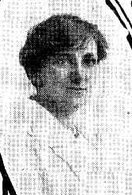

In May 1929 both her mother, Catherine, and then her father, James, of ‘Korung,’ Malton-road, Beecroft, died. The value of James’ estate was £10,589.

That year the Society of Women Painters was almost disbanded due to low finances, however it was decided to continue, and Winifred Caddy became honorary secretary.10

In 1930 Winifred was living at ‘Korung,’ 11 Malton-road, Beecroft. By 1933 she had moved to 5 York-road, Beecroft, but by 1943 had moved back to 11 Malton-road, Beecroft, where she remained until the 1960’s.11

Winifred continued her association with the Society of Women Painters, and would exhibit her paintings at their annual exhibitions. In 1934 the society had their 24th annual exhibition, and Winifred was still honorary secretary.12

In February 1935 Winifred took a voyage to England where she remained until October of that year.13

‘DURING Miss Winifred Caddy's stay in Eastbourne, England, the King and Queen and the two little Princesses went there for a holiday.

Miss Caddy went to the church service which the Royal Family attended, and watched the princesses play on the sands. Princess Elizabeth preferred riding on the South Downs, and Princess Margaret Rose liked to play on the beach, the result being that one day they would ride and the next day they would spend on the beach.

Miss Caddy, who is one of the best-known members of the Society of Women Painters, told this and other interesting experiences of her recent trip abroad to the members of the Art Circle of the Lyceum Club yesterday afternoon.

Once, when she was sketching In England, Miss Caddy saw what she thought was a cloud approaching, only to discover that it was the ill-fated German Zeppelin, Hindenburg, which was skirting the English coast on its way to America. The front of the Zeppelin caught the light, and this made it resemble an Immense silver cigar.

Miss Caddy spent much of her time painting on the Thames embankment, and was often questioned by children. When she asked them where they thought she came from, they never once answered Australia, but guessed America and New Zealand. One child asked if her home was China! Australia was connected in their minds only with sheep and kangaroos.’14

By 1968 she had moved to Mowll Village, Galston and was still there in 1977.15

In 1980 she was living at 10 Edward-street, Gordon.16

Winifred Caddy died in 1981.17

**Winifred Caddy Paintings**

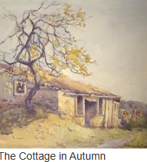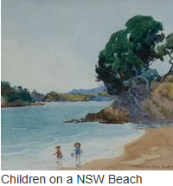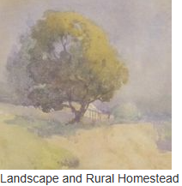

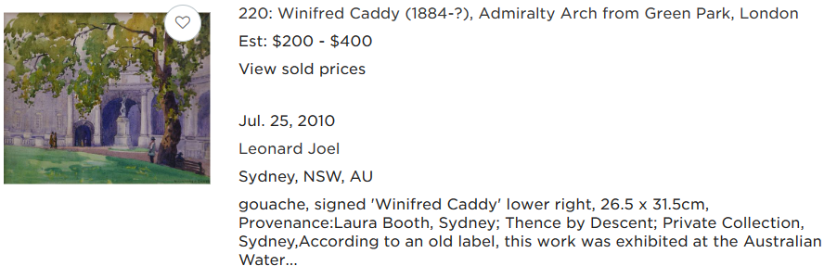

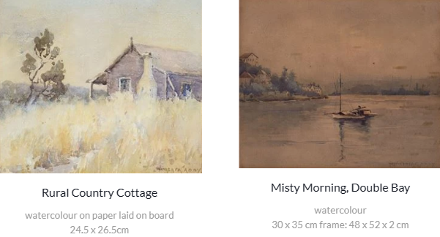

**Bibliography**

1 Sydney Morning Herald (NSW: 1842 - 1954), Saturday 8 November 1884, page 1

2 AWM Records

3 Sydney Morning Herald (NSW: 1842 - 1954), Friday 6 January 1905, page 3; Sydney Morning Herald (NSW: 1842 - 1954), Friday 18 January 1907, page 3; Sydney Morning Herald (NSW: 1842 - 1954), Saturday 11 January 1908, page 14

4 Australia and New Zealand Art Sales Digest

5 1913 Electoral Roll

6 Cumberland Argus and Fruitgrowers Advocate (Parramatta, NSW: 1888 - 1950), Saturday 18 March 1916, page 12

7 Sunday Times, Sun 23 Nov 1919

8 The Sydney Morning Herald, Sat 20 Sep 1924

9 The Daily Telegraph, Thu 18 Nov 1926

10 The Sun, Sat 26 Oct 1929

11 1930 Electoral Roll; 1933, 1935, 1936 & 1937 Electoral Rolls; 1943, 1949, 1954, 1958 & 1963 Electoral Rolls

12 The Daily Telegraph, Sat 5 May 1934

13 Sydney Morning Herald (NSW: 1842 - 1954), Tuesday 5 February 1935, page 4; Outward Passenger Lists

14 The Sun, Thu 8 Jul 1937

15 1968, 1972 & 1977 Electoral Rolls

16 1980 Electoral Roll

17 NSW Births Deaths & Marriages

Further Information:

Campbell, Jean. *Australian Watercolour Painters: 1780 to the Present Day.* Craftsman House, Sydney, 1989. Page 293

[Find New Zealand Artists](http://findnzartists.org.nz/artist/2383/)

[Australian Prints + Printmaking](http://www.printsandprintmaking.gov.au/artists/17381/)

**NOTE**: Additional information contained within Beecroft Cheltenham History Group website and book ‘Beecroft and Cheltenham, the Shaping of a Sydney Community to 1914’.