## **BLACK, Alwyn Rufus**

Alwyn Rufus Black was born 1886, at Glenorie, N.S. W., where he attended Glenorie Public School, the son of Henry George & Emma Black.

He enlisted in the A.I.F. in July 1915. At the time his father lived at “Kia-Ora,” Beecroft-road, Beecroft, N.S.W.

Alwyn lived in Glenorie and worked as a selector. He was single, aged 29 years, height 5 5 ¾”, weight 151lbs. He was placed in the 25th Battalion and embarked for overseas duties aboard the *Mootan* on 12th April 1916.**1**

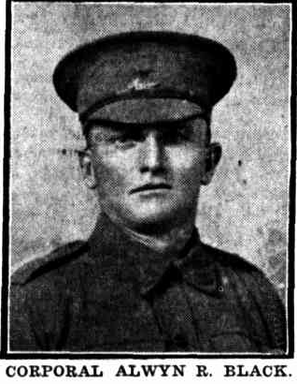

In February 1917 Mr. and Mrs. H. Black of “Kia Ora,” Beecroft, received word that their son, Corporal Alwyn R. Black, had been wounded in France. He enlisted in Queensland and left there in the 12th Reinforcements of the 25th Battalion, but joined his battalion in France.**2**

In June 1918 it was reported that Alwyn Rufus Black (now Sgt.) had died of wounds.**3**

TWO BEECROFT BOYS.

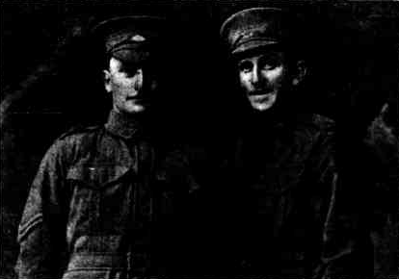

‘No. 4658, Sergeant Alwyn R. Black, 25th Battalion, D Company, 15th Platoon, died of wound 20th May, 1918, age 31 years, in front of Mericourt, when returning from fatigue duty, he was hit by a shell and taken by stretcher-bearer to dressing station at Heilley. He died there same day and was buried in Heilley military cemetery, near Albert. Padre Greg McGregor held the service. Sergeant Black enlisted from Rannes [?], Queensland 17th July 1915, left Enoggera Camp for the front, April 12, 1916. Was previously wounded 5th November of the same year. His comrades speak of him as a brave soldier in the lines and a real sport behind the lines.

No. 42A, Private Roy. E. Black, 14th Australian Light Trench Mortar, enlisted from Beecroft, N.S.W., in December 1915. He left for the front 13th May, 1916, with Carmichael’s Battalion. He has been lately gassed, and is now in hospital in France, reported doing well.

Both brave men are sons of Mr. and Mrs. H. G. Black, ‘Kia-Ora,’ Beecroft.’4

**Alwyn Rufus Black and an unidentified Australian**

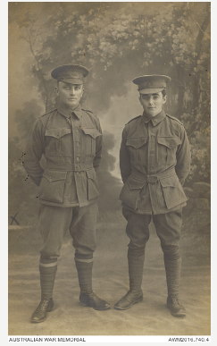

**Postcard from Alwyn Rufus Black**

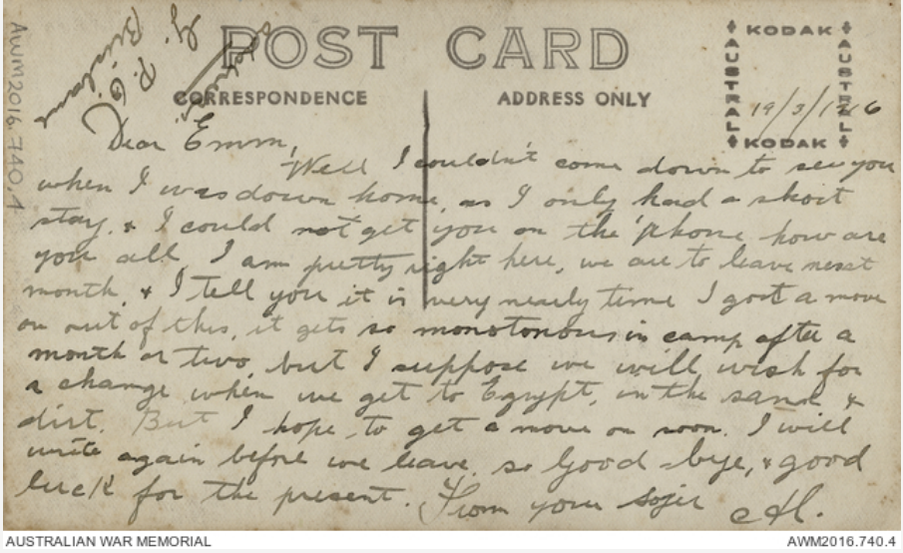

‘In action with the 25th Battalion on 5 November [1916], the start of the biting winter, Corporal Alwyn Black suffered a gunshot wound to the forehead. It did not keep him out of the line for long and he returned to duty a few days later. Perhaps it was the cold, perhaps it was the wound or simply the grind of military life, but a month later, in early December, he was in strife and charged with ‘neglecting to obey an order, in that he failed to salute his commanding officer’. Black had his corporal’s stripes taken off him and he reverted to the ranks. It must have been a tense Christmas in the 25th, but all was forgiven by 1917 and he was made a sergeant in May.’

‘Alwyn Black’s luck finally ran out on 19 May [1918]. The 31-year-old labourer had grown up in Glenorie but the family had moved to ‘Kia Ora’ in Beecroft Road, Beecroft. Alwyn had taken up a land selection in Queensland before he enlisted in July 1915. He served throughout the war with the 25th Battalion, made up of Queenslanders. On the night of 19 May he was leading a working party near Morlancourt when another random enemy artillery shell landed nearby and laid his spine open. His only words were” ‘Hooray. I’m done!’ He died a few hours later. According to the men in his unit, Alwyn was a soldier of the first order. He had survived being previously wounded on 5 November 1916. His will reveals the things a country boy valued, and he left them all to his father: the farm he had bought in Queensland, his work tools, his horse, his bridle and his saddle.’5

**Miscellaneous information**:

Fate: Died of wounds 20 May 1918

Rank: Sergeant

Unit: 25th Australian Infantry Battalion

Place of Death: Belgium

Place of burial: Ribemont Communal Cemetery Extension (Plot III, Row G, Grave No. 3), France

Panel number: Roll of Honour, Australian War Memorial: 103

Other details: War service: Western Front

Medals: British War Medal, Victory Medal

Recorded on Beecroft Church of England Roll of Honour, Beecroft War Memorial

**Bibliography**

1 AWM Records

2 The Cumberland Argus and Fruit growers Advocate, Sat 17 Feb 1917

3 The Brisbane Courier, Mon 17 Jun 1918; Sunday Times (Sydney), Sun 16 Jun 1918

4 The Cumberland Argus and Fruitgrowers Advocate, Sat 19 Oct 1918

5 “Beecroft and Cheltenham in WW1” by Tony Cunneen