# **BIBBY, Mary (Marie)**

Marie Bibby was born c1845 in Manchester, Lancashire, England, the daughter of John & Elizabeth Bibby.**1**

Marie was also the sister of John Walker Bibby of Beecroft.

It is not certain when she arrived in Sydney.

In 1891 she was a Methodist “sister” with the Sydney Mission, being the “sister” in charge of the Sisters’ Home as well as honorary secretary of the Methodist Sydney Mission.

The Methodist Mission, founded in 1890, assisted the poor, involving street rescue work, work among cabmen, and visitations from house to house.**2**

In 1893 Sister Bibby had six “sisters,” five of the home and one out-sister.**3**

In 1896 Sister Bibby was presented with a gold watch and guard as a token of the esteem of the Central Methodist Mission. She had been removed from Princess-street to take charge of a new mission district, extending from Goulburn-street to Ultimo.**4**

In 1897 Sister Bibby was involved in conducting a 10 days’ mission at Bathurst.**5**

In 1915 the death of Sister Bibby was reported.

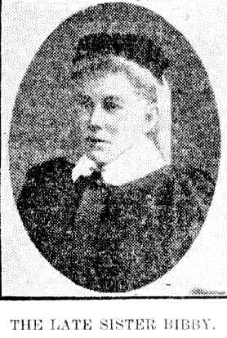

It was reported that Miss Marie Bibby, better known as Sister Bibby, had died on 23rd August 1915 shortly after midnight, at her residence at Beecroft (“Woonona,” Beecroft), was the second woman to enter the Sisterhood of the Sydney Central Methodist Mission, under the superintendency of Rev. W. G. Taylor, in 1890. She continued in the service of the mission for over 22 years, and in 1912 became an honorary Sister, still actively engaged in her work.

Sister Bibby was a well-known figure In Sydney, particularly amongst the poorer localities, where she was deeply loved and where a great many of her energies were expended. She had been in poor health for some months, so that her death was not quite unexpected. The burial will take place at the Waverley Cemetery. Services were conducted by Rev. W. G. Taylor.6

**Bibliography**

1 Ancestry.com

2 Freeman's Journal (Sydney, NSW: 1850 - 1932), Saturday 10 January 1891, Sydney Morning Herald (NSW: 1842 - 1954), Saturday 3 October 1891, Sydney Morning Herald (NSW: 1842 - 1954), Friday 27 May 1892

3 Clarence and Richmond Examiner (Grafton, NSW: 1889 - 1915), Tuesday 26 September 1893,

4 Sydney Morning Herald (NSW: 1842 - 1954), Saturday 22 August 1896

5 Sydney Morning Herald (NSW: 1842 - 1954), Saturday 11 September 1897

6 Daily Telegraph (Sydney, NSW: 1883 - 1930), Wednesday 25 August 1915, Sydney Morning Herald (NSW: 1842 - 1954), Thursday 26 August 1915, Maitland Daily Mercury (NSW: 1894 - 1939), Thursday 26 August 1915