## **BARKER, William Richard**

William Richard barker married Elizabeth W. Ackling in 1914, in the district of Randwick.1

In 1929 they were living at their home in Old Beecroft-road, Cheltenham, with their four children, the youngest being three years of age. The home was a five-roomed weatherboard cottage.

In the early hours of 20th June 1929, the owner, Mr. Barker, was awakened by his horse, Dave, who pulled his dealer’s cart. The horse was in a paddock by the house, and was galloping around the house and neighing. The house was on fire. Had not the squealing of his horse awakened Barker in the nick of time, the whole family might have perished in the flames.

When Mr. Barker opened his eyes, he saw that the ceiling was a mass of flame. He leapt from his bed and rushed to his wife's room. His wife rescued the baby, Sidney, while Barker raced out to the back verandah, where he found his second boy, asleep, in a bed of flame. Luckily, the boy was untouched. Mrs. Barker made valiant efforts to save some clothes, while her husband went for help through the scrub that surrounds the little weatherboard cottage.

In half an hour the fire had practically destroyed the home, and his furniture, which he had just bought on the instalment plan, was charred and broken.

For the previous three months Mr. Barker, had worked as a Iaborer, and dealing in bottles and bags, and a stack of bags, which he valued at £30, which went up in smoke with many other of his belongings. He seemed to have fared worse than the others as regards clothing, having now only a shirt, a pair of trousers, and shoes to his name. A neighbour sent him a coat and overcoat that morning. The baby looked a tragic little figure, standing among the ruins in his pyjamas.

The thing mostly worrying Mr. Barker was where he and his family will sleep that night, as he had no relatives.

Mr. Barker was a man with a long history of misfortune, having 22 accidents in 16 years.

He had been under trains, crushed by a steam-roller, stabbed with a knife, hit with a pick, had the fingers of his left hand taken off, and then the hand up to the wrist, and now he is homeless with his wife and family of four children.

But, through it all, Barker smiles, "It's not bad luck," he said. "I think I'm lucky to be alive after all I have gone through. I'll be on the road again to-morrow, buying bags and bottles. I'll borrow the money, and make a fresh start. It's no good getting your tail down!"

Mr. Barker's run of ill-luck began only a few weeks after he was married. He fell off an electric light pole, while working in Croydon, twisted his hip, and, after leaving hospital, was out of work for 12 months. In 1915, while he was driving a wagon, his two horses bolted. He was in the Western Suburbs Hospital for six weeks. In 1916, he was driving a load of concrete tubs across Newtown Bridge, when his horse dropped dead. The tubs came down on him and once more he went to hospital — with a broken foot this time. At Camperdown the following year, a master-carrier offered Barker a fresh start, gave him two horses and a wagon, and a month's feed, to be paid off as he went along. The horses bolted soon afterwards. One broke its leg, and the other was so badly injured as to be useless.

Undaunted, Barker borrowed money and bought a turnout with which he contracted for brick-carrying. But one day he backed his cart to the edge of the tip at St. Peters. The bank caved in and he lost both horse and cart.

"Then I joined a railway labouring gang," said Mr. Barker to-day, "but I had nine minor accidents there. Once a pick was driven through my arm; and on several occasions I was thrown under trains. But nothing can kill me after that. I must have at least nine lives."

The fingers of his left hand were taken off at Hornsby in 1927, when a steam roller ran over them. He received £450 compensation, but by the time he had paid off all his debts, he had only £11 left. Later he lost the rest of his left hand up to the wrist.

After 16 years of married life. Mr. and Mrs. Barker, and their four children, faced the world with a few furniture odds and ends, and 4s 6d in cash.2

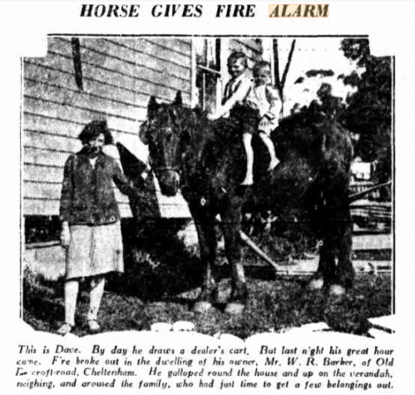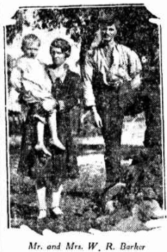

Unfortunately, the marriage did not last much longer. In January 1930 he was bound over at Hornsby Court on his own recognisance of £10 to keep the peace towards his wife, Elizabeth Winifred Barker, for six months.

According to the wife's story, defendant, who was living apart from her, went to a house In Beecroft-road, Cheltenham, on December 16, while she was ironing some clothes. He said he had divorce papers, and because she refused to take them, an argument ensued.

Owing to the intervention of her brother-in-law, defendant was induced to go away.3

[Further details could not be obtained.]

**Bibliography**

1 NSW Births Deaths & Marriages

2 Sun (Sydney, NSW), Thu 20 Jun 1929; Newcastle Morning Herald & Miners' Advocate, Fri 21 Jun 1929; Singleton Argus, Fri 21 Jun 1929

3 Evening News (Sydney, NSW), Fri 3 Jan 1930