## **WHITEMAN, George**

**George Whiteman**

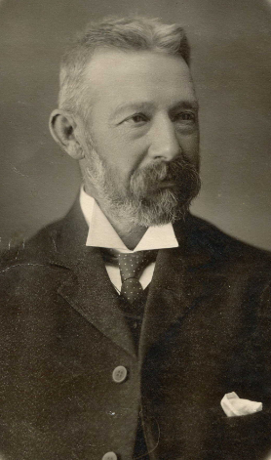

George Whiteman was born on 28th September 1844, at Lewes, Sussex, England, the son of Randall (1806-1866) & Ann (nee Marten; 1811-1883) Whiteman.**1**

1861 Census – Lewes: Randall Whiteman, tailor, employing four men and one boy; George, 16, printer-compositor.

On 15th April 1869, at Barcombe, Sussex, George married Ellis Gasston. She died the same year. Ellis Gasston, born 1846 at Barcombe, Sussex, was the daughter of John & Sarah Gasston.

Mr. Whiteman started his career as a reporter on a London newspaper, which he left to take a position as commercial traveller for Johnson and Company, London.

1871 Census – Lindfield, Sussex: George Whiteman, 25, widower, commercial traveller.

On 29th June 1875, at Kerrington, Surrey, George married Fanny Gasston.

Fanny Gasston, born 1854 at Barcombe, Sussex, was another daughter of John & Sarah Gasston. Fanny and George would produce 10 children.

1881 Census – Edmonton, Middlesex: George Whiteman, 36, manager of Fancy Paper Bot [?] Manufactory; wife Fanny; children: Mildred, 5; John R., 4; Ellis, 2; Aubrey, 1; Mary Ann Whiteman, unmarried sister, 41; and two teenage female domestic servants.

George & Fanny, along with their six children, arrived in Queensland, Australia, on 9th October 1884, aboard the ship *Duke of Sutherland*, which departed London on 12th August 1884. Another passenger was Lizzie Whiteman, perhaps a relation.

His son, George Dudley Whiteman, born April 1884, died at Townsville, QLD. On 22nd October 1884.

His next child, Joyce, was born on 4th May 1886 at “Hillside,” Hill-street, Enfield, N.S.W.

In 1887 he entered the brick trade, joining up with the Croydon Brick Company, Limited, in 1888.

His wife was named Fanny. A number of children were born in England.**2**

Known children of the marriage (born in Australia) were:

Joyce, born 1886, district of Burwood

Owen G., born 1887, district of Canterbury [died 1887]

Rupert Stanley, born 1890, district of Burwood

Madeline, born 1893, district of Burwood [died 1893]**3**

Fanny, wife of George Whiteman, died on 16th July 1902, district of Burwood.**4**

**St. Thomas Anglican Cemetery, Enfield, Burwood Municipality Portion 23 Row 2**

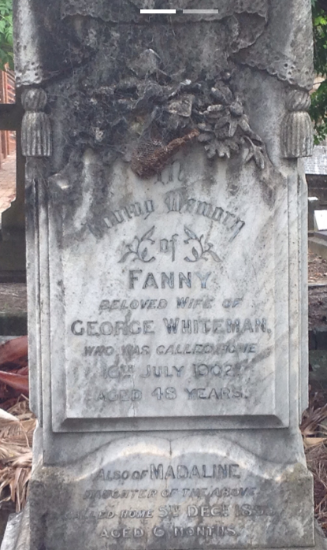

In August 1904, at “Rosebank,” Glebe, George Whiteman, widower, of Stanmore, married Madeline Boswell Blanche Filby.

Madeline was born in 1874, the daughter of William Boswell & Mary Filby, in the district of Grenfell, N.S.W. In 1899 William Boswell Filby was elected Mayor of Grenfell.**5**

Children of the marriage were:

19th June 1907 - Randall H., at “Waratah,” Springwood

4th June 1908 - Dora Blanche Boswell, at Beecroft

3rd May 1910 - Norma Beryl, at “Werong,” Sutherland-road, Beecroft**6**

In April 1907 Mr. Whiteman and family, newly arrived at Beecroft, would build along Sutherland-road, next to Mr. McKay.**7**

In June 1914 the son Rupert went on a business and pleasure trip to Europe. By March 1915 he had joined the 10th Battalion, Royal Fusiliers, stationed at Assaye Blocks, Goojerat Barracks, Colchester, Essex, before going to the front.**8**

On 20th January 1918, at her residence “Werong,” Sutherland-road, Beecroft, Madeleine Blanche Whiteman, wife of George Whiteman, died in her 46th year. The burial was at Carlingford cemetery. She was well-known in Grenfell, and in the earlier years of her residence in Sydney took an active part in various charitable and social movements.

Mrs. Whiteman had two brothers at Grenfell, Messrs. W. E. B. and C. A. B. Filby. Two daughters of the family had lately passed away.**9**

**L-R: Dora, Madeline, Rupert, George, Norma & Randall Whiteman (front)**

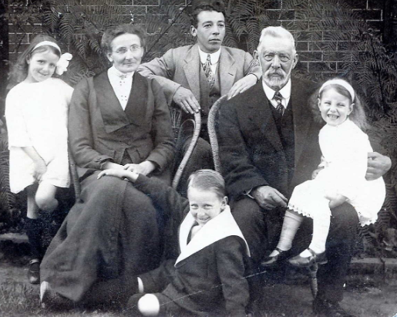

On 14th December 1923, at his residence, “Werong,” Sutherland-road, Beecroft, George Whiteman, died in his 79th year, after a long illness.

He had been managing director for the previous 20 years of the Croydon Brick Company, Limited.

The funeral was held at Carlingford cemetery.

A family of six boys and four girls survived him.**10**

**Carlingford Anglican Cemetery, Section F1.1**

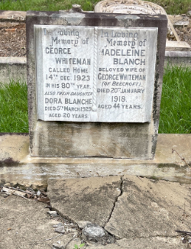

**Bibliography**

1 NSW Registry of Births Deaths and Marriages; Ancestry.com

2 Evening News (Sydney, NSW), Sat 15 Dec 1923; Ancestry.com

3 NSW Registry of Births Deaths and Marriages

4 NSW Registry of Births Deaths and Marriages; Ancestry.com

5 NSW Registry of Births Deaths and Marriages; New South Wales Government Gazette, Tue 21 Feb 1899; Grenfell Record and Lachlan District Advertiser (NSW), Sat 3 Sep 1904

6 NSW Registry of Births Deaths and Marriages; Grenfell Record and Lachlan District Advertiser (NSW), Sat 26 Jan 1907; Ancestry.com

7 Cumberland Argus and Fruitgrowers Advocate, Sat 6 Apr 1907

8 NSW Registry of Births Deaths and Marriages; Sunday Times (Sydney, NSW), Sun 28 Mar 1915; Newsletter: an Australian Paper for Australian People (Sydney, NSW), Sat 3 April 1915

9 Daily Telegraph (Sydney, NSW), Mon 21 Jan 1918; Grenfell Record and Lachlan District Advertiser (NSW), Fri 25 Jan 1918

10 Sydney Morning Herald, Sat 15 Dec 1923; Evening News (Sydney, NSW), Sat 15 Dec 1923; Ancestry.com

**NOTE**: Additional information contained within Beecroft Cheltenham History Group book ‘Beecroft and Cheltenham, the Shaping of a Sydney Community to 1914’.