## **WAY, John Thomas**

John Thomas Way was born on 15th September 1837, at Halberton, Devon, England, the son of James (1819-1898) & Sarah (nee Thomas; 1816-1860) Way.

He married Sarah Chipplin (‘Chaplin’ crossed out and ‘Chipplin’ substituted on marriage certificate) on 13th April 1863 in the Anglican Parish Church, Halberton, Devon.

Sarah was the daughter of Charles & Elizabeth, and was born about 1846 at Bampton, Devon.

In 1881 John Thomas Way was working as a dairyman at Halberton.**1**

He arrived in Australia in April 1887, aboard the ship *Orizaba* with his wife Sarah, and nine children (Emma, 15; John, 14; Elizabeth, 12; William, 11; Arthur, 10; Anna, 9; Walket, 8; Charles, 7, & Edith, 5). His occupation is given as ‘farmer.’  
No children were born in N.S.W.**2**

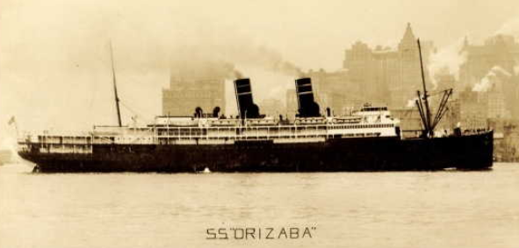

In 1892 Arthur James Way, aged 16 years, son of John Thomas Way, of Pennant-hills, died from the effects of a kick from a horse.**3**

In 1893 J. T. Way was a member of the Hornsby, Thornleigh, Pennant Hills, Beecroft and Carlingford Horticultural Association.**4**

In January 1894 Walcott [Walket] Way, aged 15 years, son of J. T. Way, of Wallace (Mulgoa [near Penrith]), was admitted to the local hospital, suffering from sunstroke. The parents took charge of him some five weeks later, then he became strange, played up, and finally cleared out. His parents and some neighbours found him in the bush that night wandering about. He was brought to the Hospital, and soon after ran away again. He was arrested by the police, and brought before the Court, charged with being of unsound mind. Way was sent to Parramatta Hospital for the Insane for treatment.

Mrs. J. T. Way stated ‘There has been no insanity in any member of the family. I have ten in the family altogether, although there are only two at home, one 10 and one 14; when my husband is at work he gets five shillings a day; we will try and pay 2s 6d per week.’

In April 1903 Walcot [Walket] Way committed suicide by shooting himself in the head with a revolver, in scrub just opposite the Beecroft railway station. He was a labourer, 25 years of age, son of Mr. John Thomas Way, orchard manager for Mr. Leslie Herring, of “Sheen,” Beecroft. The deceased, who was employed about Mr. Herring’s orchard, and who was a good workman, well conducted and highly respected, was, it appears, on several occasions, an inmate of the Hospital for the Insane at Gladesville. On the last occasion he was admitted in August 1900 and discharged in February 1902.**5**

In 1895 J. T. Way was a trustee of the Wesleyan Church. A meeting had subsequently been held on June 6, 1894, for the purpose of considering the advisability of erecting a church, when a building committee was formed. The corner stones of the church were laid on 1st October 1895.

On 6th May 1896, at the Wesleyan Church, Beecroft, Frederick Thomas Mason, second son of Mr. F. Mason, of Beecroft, and Miss Emma Way, the eldest daughter of Mr. John Thomas Way, of Wallace, Mulgoa, were married. Mr. and Mrs. F. T. Mason were presented with a Bible and hymn book on behalf of the Church trustees, the occasion being the first wedding in the new church.**6**

On 28th March 1906 a wedding was solemnised at the Beecroft Wesleyan Church, the bride being Miss Edith Way, youngest daughter of Mr. John Thomas Way, of “Sunningdale,” Beecroft, and the bridegroom being Mr. George Wheeler, a well-known and popular Beecroft identity. In February 1916, Edith Wheeler, wife of George Wheeler, and daughter of J. T. Way, died.**7**

In 1907, William Way, a son of J. T. Way, was living in Copeland Road, although with a postal address of Welham Street, Beecroft. The land had a frontage of 66 feet.

William Way married Elsie Gallard at Beecroft, in 1908.

In January 1913, William Way, aged 36, a dairy farmer [now] at Byrill Creek (near Murwillumbah), died, leaving a widow and five children. He had come from Beecroft about five years previously. The deceased died intestate.**8**

In September 1913 Sarah Way, wife of Mr. J. T. Way, of Welham-street, Beecroft, died.**9**

On 30th April 1929, John Thomas Way, orchardist, died at his late residence, “Alberton,” Welham St., Beecroft, aged 89 years and 7 months, the father of Walter, Emma, Elizabeth, Anna, and Charles, and brother of W. T. [Walket Thomas] Way, of Kirribilli Point. The funeral took place at the Methodist Cemetery, Pennant Hills West [also known as Cherrybrook Uniting Church Cemetery]. Probate was granted to Charles Henry Way of Batlow, Orchardist, the Executor in the said Will and Codicil named with leave reserved to Frederick Mason of Roseville, Bricklayer.**10**

In 1938 Mr. and Mrs. C. [Charles Henry] Way, residents at Batlow for over 20 years, left the district. Mr. Way had been managing “Belmont” orchard for Mr. Nigel Herring for most of that time and had been associated with the Herring family almost all of his life. His father was before him in charge of orchard work, for the late Mr. L. [Lesley] Herring, father of Councillor Herring and Messrs. Edgar and Nigel Herring, at Beecroft. Mr. C. Way had the reputation of being one of the most experienced and practical fruit men in this district.**11**

In 1940 Walket Thomas Way (brother of John Thomas Way), of Carabella Street, Kirribilli, died. He was born at Titterton, Devonshire, in 1856, and migrated to Australia in 1892, entering the service of the Fresh Food and Ice Co., Ltd., Sydney, as a factory foreman. In 1904 he went into business on his own account and he sold the business to Sargents Ltd., in 1912. Mr. Way then became a director of Sargents Ltd., a position he held for 27 years when he retired because of ill-health.**12**

**John Thomas Way & wife Sarah Way**

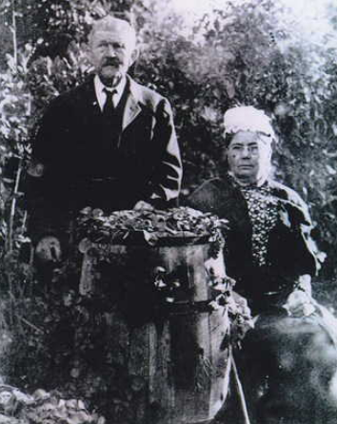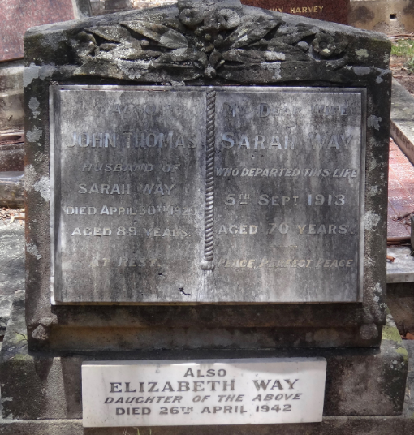

**Bibliography**

1 NSW Registry of Births Deaths & Marriages; Ancestry.com

2 Various newspaper accounts; Ancestry.com

3 The Daily Telegraph, Tue 30 Aug 1892; The Cumberland Argus and Fruitgrowers Advocate, Sat 3 Sep 1892

4 The Cumberland Mercury, Sat 8 Jul 1893

5 Nepean Times, Sat 17 Mar 1894; The Cumberland Argus and Fruitgrowers Advocate, Sat 25 Apr 1903

6 The Cumberland Argus and Fruitgrowers Advocate, Sat 5 Oct 1895; The Cumberland Argus and Fruitgrowers Advocate, Sat 9 May 1896

7 Cumberland Argus and Fruitgrowers Advocate, Sat 31 Mar 1906; The Daily Telegraph, Thu 24 Feb 1916

8 Hornsby Council Ratepayers List 1907; Sydney Morning Herald, Fri 10 Jan 1913; Government Gazette of the State of NSW, Wed 7 May 1913; NSW Registry of Births Deaths & Marriages

9 The Sydney Morning Herald, Sat 13 Sep 1913; NSW Registry of Births Deaths & Marriages

10 The Daily Telegraph, Wed 1 May 1929; The Sydney Morning Herald, Wed 1 May 1929; The Daily Telegraph, Thu 2 May 1929; The Daily Telegraph, Tue 7 May 1929

11 The Tumut and Adelong Times, Tue 1 Mar 1938

12 Sydney Morning Herald, Wed 11 Sep 1940

**Further References:**

‘Beecroft and Cheltenham, the Shaping of a Sydney Community to 1914’ by Beecroft Cheltenham History Group