## **LIDWILL, Mark Cowley**

**Mark Cowley Lidwill**

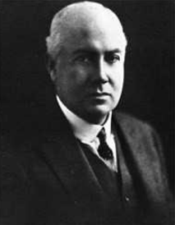

[‘Dr. Mark Cowley Lidwill was a medical pioneer in anaesthesiology and cardiology. Supported by physicist Edgar H. Booth, he invented the cardiac pacemaker, which has saved innumerable human lives and has been listed by Australian Geographic amongst the top ten Australian inventions that changed the world.

Dr Lidwill’s knowledge and expertise also extended to the design and manufacture in 1910 of his mechanical-anaesthesia apparatus, the “Lidwill Inter-tracheal Anaesthetic Machine”, which remained in use in operating theatres in hospitals throughout Australia for more than 30 years.’]**1**

Mark Cowley Lidwill, son of Robert Atkins Lidwill and Mary Jane Lidwill, was born in Cheltenham, England, on 7th April 1878 (baptised at Christ Church, Cheltenham on 29th September 1878) – address: 4 Lansdown Terrace, Cheltenham.**2**

In May 1894 Mark C. Lidwill arrived in Sydney on board the Orient liner *Ophir* from London,

with his mother and sister.**3**

In May 1895, at the 28th annual four-oared race between the Melbourne public schools, Mark Lidwill rowed for Melbourne Grammar School. His weight was 11st. 2lb and it was stated that he was an old Westminster boy.**4**

In May 1896 Mark completed the Matriculation Examination for Melbourne University. In December he passed in Chemistry and Physics.**5**

In December 1897 he had passed in First Year Medicine.**6**

His mother, Mary Jane Lidwill, died in July 1898.**7**

In December 1902 Mark qualified as a Bachelor of Medicine. In March 1903 he was conferred with a Bachelor of Surgery degree.**8**

By October 1903 Mark was a senior medical officer at the Ballarat Hospital in Victoria. He continued to work at the hospital until at least September 1904.**9**

In January 1905 Mark was on the New South Wales Medical Board, with the letters of ‘M.B. Bac Surg, Univ (Melb.)’. In March the University of Melbourne published his qualifications - Degree of Doctor of Medicine: Mark Cowley Lidwill (Queen's College).**10**

By January 1906 he had established his practice at Beecroft; and was a telephone subscriber. By June he was the president of the newly formed Beecroft golf club, which had secured the suitable grounds of Mr. Smith at Pennant Hills.**11**

On 19th July 1906 at Trinity Congregational Church, Strathfield, Mark Cowley, only son of Captain R. A. Lidwlll, of Armadale, Victoria, was married to Constance Emily, youngest daughter of Sir Philip Sydney-Jones, *Llandilo*, Strathfield.**12**

Children of the marriage were Sylvia Nora [1907] and Kathleen Constance Matilda [1909].**13**

In late 1906 and early 1907, at Beecroft School of Arts, flute solos were rendered by Dr. Mark Lidwill.**14**

In 1907, as a Hornsby Council ratepayer, his property “Lorne” consisted of two lots, of 100 x 195 ft. and 80 x 204 ft.

In February he was elected to the committee of the Beecroft Progress Association.

On 19th June, at “Lorne,” Beecroft, his wife gave birth to a daughter [Sylvia Nora].**15**

In September 1908 he advertised ‘For Sale, Mare, 5 yrs., quiet, hooded Sulky; Harness, splendid condition, seller having bought motor.’

In October his wife advertised ‘Wanted, Cook and Laundress, 3 in family, 3 others kept.’ That month he was elected Patron for the Beecroft Musical and Dramatic Society.**16**

In late December 1908 he was in Melbourne, the guest of his father, Captain Lidwill, at Armadale. On 5th January 1909 his father died at his residence “Covenbrook,” Denbigh-road, Armadale, Melbourne.**17**

On 31st May 1909 at “Lorne,” Beecroft, his wife gave birth to a daughter [Kathleen Constance Matilda].

In July 1909 he advertised ‘Wanted, a man, to clean car and look after gardens.’

Also that month it was remarked that ‘Dr. Lidwill's fine new residence is rapidly nearing completion. A big house, situated on a rise, it will, when finished, be a conspicuous landmark and a big improvement to that part of the district.’

In September Mrs. Lidwill advertised ‘House and Parlour Maid wanted, 3 others kept, 4 in family.’

Also in September it was remarked that ‘Dr. Lidwill is removing this month into his new residence on the main Beecroft-road. It is altogether a new class of building, being of Moorish style of architecture, with flat roof, upon which an assortment of pot plants will impart the appearance of a garden there. The ornamental coloured-glass windows are without doubt the finest the writer has ever seen; upon them growing palms are most artistically represented with birds flying above. This has been achieved by what is known as 'lead work.' The building cost, it is said about £3000. From the roof the outlook is extensive, including an excellent view of Botany Bay.’

In October ‘Miss Long has removed from the premises she has occupied for so many years into those recently vacated by Dr. Lidwill.’

In November was published an advertisement for Oswald Seale, Surgical and Mechanical Dentist, Beecroft Road, Beecroft, ‘next door to Dr. Lidwell’s new residence.’**18**

In February 1910 Dr. Lidwill went on a short holiday trip to the Myall Lakes, taking his motor car with him, but this was sent on to Newcastle by train.

In April it was reported that ‘Dr. Lidwill, of Beecroft, had disposed of his practice and house to Dr. Rygate, late of Wellington, N.S.W. Dr. Lidwill was very popular throughout the district, and his departure would be much regretted. Dr Lidwill would remove to Strathfield but would reside in Burwood. A farewell concert, chaired by Mr. Carlos, held in the billiard room at Mr. Osborne’s residence, was attended by about 40 gentlemen. Dr. Lidwill was presented with a case of four silver-mounted pipes, as a token of the residents' appreciation of his social and public services.’**19**

His departure may have been due to the design and manufacture in 1910 of his mechanical-anaesthesia apparatus, the “Lidwill Inter-tracheal Anaesthetic Machine”, which remained in use in operating theatres in hospitals throughout Australia for more than 30 years.**20**

On 8 February 1913, Dr Lidwill became the first angler to catch a black marlin with a rod and reel. He was an avid angler for most of his life.

In May 1913 Dr. Lidwill lectured to members of the Amateur Fishermen's Association on the subject of big-game fishing in New South Wales waters. ‘Practical to a degree, Dr. Lidwill clearly showed that he knew what he was talking about.’**21**

By 1930 he was a well-known Macquarie-street specialist. He was still a fishing enthusiast, taking trips in March to Kosciusko and the Upper Murray.**22**

In September 1935 the engagement was announced of Sylvia Nora, daughter of Dr. and Mrs. Mark Lidwill, of Bellevue Hill, and granddaughter of the late Sir Philip Sydney Jones, to David Surrey, only son of Mr. and Mrs. Stuart M. Littlemore, of Bundaberg, and grandson of the late Rev. Geo. Littlemore.**23**

In February 1938 the engagement was announced of Kathleen, younger daughter of Dr. and Mrs. Mark Lidwill, of Edgecliff, to Mr. Geoffrey Walker Powell, of Tamworth, second son of the late Mr. H. Powell, of *Drildool*, Burren Junction, and of Mrs. E. Holcombe, of Myall Park, Willow Tree.**24**

Mark Cowley Lidwill would remain on the New South Wales Medical Board Register up to his death on 4th July 1969, in the district of Newtown.**25**

**LIDWILL, Robert Atkins (father of Mark Cowley Lidwill)**

[Note: Last name sometimes spelt as LIDWELL.]

Robert Atkins Lidwill was born on 24th April 1840 (baptised 28th April 1840 at Templemore, Tipperary) in Clonmore & Comackstown Co., Tipperary, Ireland, the son of Robert Atkins Lidwill (1797-1850) and Isabella (nee Delmege; 1819-1863) Lidwill. Robert Lidwill was the justice for the peace in the said county. He owned a great deal of land and many houses.

On 27th January 1866, at Christ Church, South Yarra, by the Rev. John Watson, Robert Atkins Lidwill, Esq., of Clonmore-lodge, Williamstown, [Victoria], eldest son of the late Robert Atkins Lidwill, Esq., of Clonmore and Cormacstown, county Tipperary, Ireland, was married to Mary Jane Cowan, youngest daughter of William Edward [and Eliza] Florance Esq., surgeon, Richmond, and late of Corfe Castle, county of Dorset, England.**26**

Children of the marriage were:

Matilda Florance (‘Tottie’) Lidwill, born 5th December 1866, at Clonmore-lodge, Esplanade, Williamstown, Victoria.

Mark Cowley Lidwill, born 7th April 1878, in Cheltenham, Gloucestershire, England.**27**

In 1868 R. A. Lidwill was working as a solicitor under the partnership of COOMBS, LIDWILL AND ELLIS, at the offices of the Victorian Trade Protection Association, 36 Collins-street west, Melbourne.**28**

In 1873 R. A. Lidwill sold by public auction the contents of his residence (on account of his leaving the colony, Rosemount-lodge, Bourke-road, Upper Hawthorn, Melbourne, adjoining the residence of A. Stackpoole, Esquire.**29**

In February 1874 he journeyed from Melbourne to Sydney, aboard the ship *Alexandra*. That year, In the Supreme Court of New South Wales, letters of administration of all and singular the lands, goods, chattels, credits, and effects of the Frederick Wilkinson, deceased, intestate, was granted to Robert Atkins Lidwills [sic], of Williamstown, Victoria, gentleman, the duly constituted attorney of Elizabeth Wilkinson, of Taradale, Victoria, widow of the said deceased.30

In 1882 the partnership existing between Robert Atkins Lidwill, Esquire, and John Wilkinson, Esquire, trading as "Wilkinson and Company," carrying on business as squatters and sheep farmers at Lake Elder in South Australia, was mutually dissolved from the 10th day of February, 1882.**31**

1891 Census – 3 Stafford Terrace, Kensington, London: Robert A Lidwill, 50, living on means, born Ireland; Mary J. C. Lidwill, 40, born London; Matilda F. Lidwill, 24, born Australia; Mark C. Lidwill, 12, born Cheltenham, Glos. The household also had a cook, a housemaid and an indoor male servant.

In 1893 the London Registers of shares owned in The Bank of Victoria and Goldsborough, Mort & Company, Limited, listed small parcels of shares owned by Robert A., Mark C., and George Lidwill, all of London.**32**

In May 1894 Mrs. and Miss Lidwell (sic) and Mr. M. C. Lidwell (sic) arrived in Sydney on board the Orient liner *Ophir* from London.**33**

On 29th July 1898, at her residence, “Covenbrook,” Denbigh-road, Armadale, [Melbourne], Mary Jane Cowen, wife of Robert Atken Lidwell (sic), died aged 48 years. Her remains were interred in the St. Kilda Cemetery. In March 1899 Probate has been granted by the registrar to the will of Mary J. C. Lidwill; value £2,068.**34**

On the 5th January 1909, occurred the death at “Covenbrook,” [18] Denbigh-road, Armadale, Melbourne, Robert Atkins Lidwill, late V. [Fifth] Bat., Royal Munster Fusiliers, formerly of Tom's Lake, Riverina, N.S.W., and Lake Elder, S.A. (Interred privately January 6, alongside his wife.)

Probate was granted to his son, Mark Cowley Lidwill, and daughter, Matilda Florance Lidwill (of her father’s late address).**35**

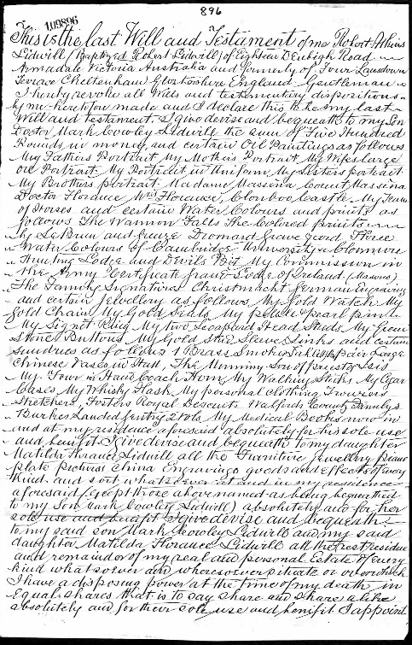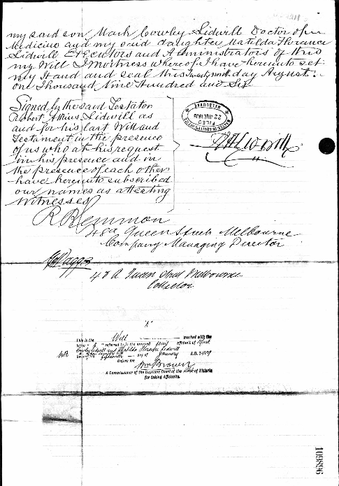

**Bibliography**

1 Wikipedia, the free encyclopedia

2 Wikipedia, the free encyclopedia; Ancestry.com

3 Sydney Morning Herald, Thu 22 Feb 1894

4 Australasian (Melbourne, Vic.), Sat 25 May 1895

5 Australasian (Melbourne, Vic.), Sat 6 Jun 1896; Australasian (Melbourne, Vic.), Sat 26 Dec 1896

6 Argus (Melbourne, Vic.), Sat 25 Dec 1897

7 Argus (Melbourne, Vic., Mon 1 Aug 1898

8 Bendigo Advertiser (Vic.), Tue 9 Dec 1902; Age (Melbourne, Vic.), Mon 30 Mar 1903

9 Ballarat Star (Vic.), Thur 22 Oct 1903; Ballarat Star (Vic.), Mon 26 Sep 1904

10 Sydney Morning Herald, Fri 13 Jan 1905; Argus (Melbourne, Vic.), Tue 28 Mar 1905

11 Daily Telegraph (Sydney, NSW), Sat 6 Jan 1906; Cumberland Argus and Fruitgrowers Advocate, Sat 30 Jun 1906

12 Sydney Morning Herald, Sat 28 Jul 1906; Australian Town and Country Journal (Sydney, NSW), Wed 1 Aug 1906

13 NSW Registry of Births Deaths & Marriages

14 Cumberland Argus and Fruitgrowers Advocate, Sat 10 Nov 1906; Cumberland Argus and Fruitgrowers Advocate, Sat 23 Feb 1907

15 Hornsby Council Ratepayers List 1907; Cumberland Argus and Fruitgrowers Advocate, Sat 2 Feb 1907; Daily Telegraph (Sydney, NSW), Sat 22 Jun 1907

16 Daily Telegraph (Sydney, NSW), Mon 14 Sep 1908; The Daily Telegraph, Wed 28 Oct 1908; Cumberland Argus and Fruitgrowers Advocate, Sat 31 Oct 1908

17 Punch (Melbourne, Vic), Thu 31 Dec 1908; Argus (Melbourne, Vic.), Thu 7 Jan 1909

18 Sydney Mail & NSW Advertiser, Wed 9 Jun 1909; Daily Telegraph (Sydney, NSW), Mon 12 Jul 1909; Cumberland Argus and Fruitgrowers Advocate, Sat 24 Jul 1909; Daily Telegraph (Sydney, NSW), Sat 11 Sep 1909; Cumberland Argus and Fruitgrowers Advocate, Sat 18 Sep 1909; Cumberland Argus and Fruitgrowers Advocate, Sat 2 Oct 1909; Cumberland Argus and Fruitgrowers Advocate, Sat 20 Nov 1909

19 Cumberland Argus and Fruitgrowers Advocate, Sat 5 Feb 1910; Cumberland Argus and Fruitgrowers Advocate, Sat 9 Apr 1910; Cumberland Argus and Fruitgrowers Advocate, Sat 30 Apr 1910; Sydney Morning Herald), Wed 5 Jul 1911

20 Wikipedia, the free encyclopedia

21 Wikipedia, the free encyclopedia; Sun (Sydney, NSW), Sun 18 May 1913

22 Tumut and Adelong Times, Tue 1 Apr 1930

23 Sydney Morning Herald, Sat 28 Sep 1935

24 Sydney Morning Herald, Wed 9 Feb 1938

25 Government Gazette of the State of NSW, Fri 18 Oct 1968; NSW Registry of Births Deaths & Marriages

26 Ancestry.com;Australasian (Melbourne, Vic.), Sat 3 Feb 1866

27 Argus (Melbourne, Vic.), Thu 6 Dec 1866; Victoria Registry of Births Deaths & Marriages; Wikipedia, the free encyclopedia

28 Argus (Melbourne, Vic.), Wed 20 May 1868; Ballarat Courier (Vic.), Tue 8 Feb 1870

29 Age (Melbourne, Vic.), Wed 30 Jul 1873

30 Ancestry.com;New South Wales Government Gazette, Fri 23 Jan 1874

31 Argus (Melbourne, Vic.), Fri 25 Aug 1882

32 Ancestry.com; Table Talk (Melbourne, Vic.), Fri 12 May 1893; Table Talk (Melbourne, Vic., Fri 30 Jun 1893

33 Sydney Morning Herald, Thu 22 Feb 1894

34 Argus (Melbourne, Vic., Mon 1 Aug 1898; Australasian (Melbourne, Vic.), Sat 18 Mar 1899

35 Argus (Melbourne, Vic.), Thu 7 Jan 1909; Age (Melbourne, Vic.), Thursday 18 March 1909

**NOTE**: Additional information contained within Beecroft Cheltenham History Group book ‘Beecroft and Cheltenham, the Shaping of a Sydney Community to 1914’.

**Further References:**

<https://en.wikipedia.org/wiki/Mark_Cowley_Lidwill>

<https://www.sydney.edu.au/.../museum/mwmuseum/index.php/Lidwill,_Mark_C>

<https://www.eoas.info/biogs/P005835b.htm>

<https://www.myheritage.com/names/mark_lidwill>