## **BRODRICK, Robert Hargreave**

Mr Brodrick was born c1860 in Cheshire, England, and come to Australia in 1882 having previously served an indenture in Manchester. The following year he entered the employ of the City Council, serving in various capacities.1

On 20th May 1896 at All Saints' Church, Petersham, Robert Hargreave, younger son of the late Robert [& Marie J.] Brodrick, of Macclesfield, Cheshire, England, was married to Emily Jane, youngest daughter of the late William [& Mary] Maher, of Darlington Ironworks, Sydney.

[Robert Brodrick senior, J. P., of Macclesfield, Cheshire, died at his residence on 13th February 1889.]2

Children of the marriage were:

Norman Hargreave, born 6th March 1897, at “Redland,” Addison-road, Petersham

Hilda M., born 1898, district of Marrickville

Alice Dorothy., born 24th November 1899, at “Maxfeld,” Scouller-street, Marrickville

Edith C., born 1902, district of Marrickville

Joan Meredith., born 1912, district of Ryde3

In 1896, Robert Broderick, draftsman, of Addison-road, Petersham, was a contributor of the Climo Patent Metallurgical Company, which was wound up in the Supreme Court of N.S.W. This company involved two draftsmen, a building inspector, a salesman and an engineer.4

In 1898 he was appointed to take charge of the City Architects department following the erection of the Queen Victoria Building.5

In 1901 Mr. R. H. Brodrick, city building surveyor, issued a lengthy report in connection with the amendment and enlargement of the City of Sydney Improvement Act of 1879.6

In February 1902 Mr. Brodrick, City Building Surveyor, along with the Mayor of Sydney, a number of the aldermen, Dr. Armstrong (City Health Officer) and Mr. W.M. Gordon (City Surveyor), paid a visit of inspection to the city to examine Phillip, Denison, and Pyrmont Wards. The party was accommodated in two four-horse drags, and its entry into the poorer portions of the wards was hailed after the manner of a circus. Streets which seemed dead were galvanised into life, while children by the score followed up the aldermen, subjecting them to the most personal, and occasionally caustic, comments.7

9

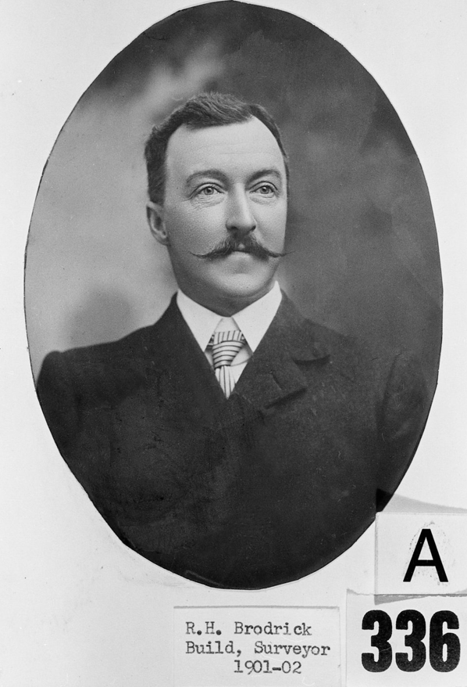

In April 1905 Mr. Brodrick was building next to Mr. Seale's place, at Beecroft. In August he was one of the auditors for the Beecroft School of Arts.8

In 1907 Mr. Brodrick was elected to the committee of the Beecroft Progress Association. His address was Boronia Avenue, Beecroft, area 3r 38p.10

In 1909 he was elected an honorary secretary of the Beecroft Parents’ and Residents’ Association, as well as honorary secretary of the Beecroft Progress Association.11

On 4th June 1918, Mr. Brodrick’s son, Norman, enlisted for war service. He was assigned to the New South Wales Reinforcement 12 unit, and embarked from Sydney on 17th July 1918, with the rank of gunner. His parent’s address is given as Beecroft Road, Beecroft.

Norman returned to Australia on 1st August 1919.12

In 1928 Mr. Brodrick, City Architect and Building Surveyor, retired, after serving the city for the previous 30 years within the City Architects department, following the announcement of the Sydney City Commissioners to merge the Departments of the City Building Constructor, City Architect and City Cleansing Engineer.

During his career he had planned the Ultimo fruit and fish markets and many electricity sub-stations.

He was responsible for the erection of nearly all of the city's buildings for the 30 years from the time of his appointment to the City Architects department to his retirement and including all buildings for the electric light department, numbering about 300. He also supervised the construction of the Domain Baths and the municipal markets.13

On 7th November 1928 Miss Edith Brodrick, third daughter of Mr. and Mrs. R. H. Brodrick, of Cheltenham, was married to Mr. Jack Johns, elder son of the late J. W. Johns, and Mrs. Johns, of Cheltenham, at St. John's Church of England, Beecroft.14

On 19th September 1934, Robert Hargreave Brodrick, of “Kainga,” Beecroft-road, Cheltenham, died, aged 74 years.

He was a bowler and secretary of the Cheltenham Recreation Club, for many years a member of the Masonic Order and a foundation member of the Cheltenham St Andrew’s Church of England.

He left a widow, a son, and four daughters.

The funeral left the Church of England Cheltenham for the Church of England Cemetery Northern Suburbs on 21st September. Director and Shareholders of CHELTENHAM RECREATION CLUB were requested to attend the funeral of their late esteemed Director and Secretary. Lodge Beecroft No. 359 UOL of N.S.W. were also invited to attend the funeral of their esteemed Brother.

Probate was granted on 30th November 1935 to Emily Jane Brodrick and Norman Hargreave Brodrick.15

On 7th April 1943, at St Anne’s, Strathfield, Jean Meredith, youngest daughter of Mrs. E. Brodrlck and the late R. H. Brodrick, of Cheltenham, was married to Lieut. John Tapping, only son of Mr. and Mrs. H. J. Hutchinson, of Croydon.16

In 1959 occurred the death of Emily Jane, widow of Robert Hargreave Brodrick.17

**Bibliography**

1 Sydney Morning Herald, Tue 25 Sep 1934

2 Sydney Morning Herald, Tue 9 Jun 1896; NSW Registry of Births Deaths & Marriages; Daily Telegraph (Sydney, NSW), Wed 3 Apr 1889

3 NSW Registry of Births Deaths & Marriages; Australian Town and Country Journal (Sydney, NSW), Sat 27 Mar 1897; Sydney Morning Herald, Sat 25 Nov 1899

4 Sydney Morning Herald, Tue 14 Jul 1896

5 Sydney Morning Herald, Tue 25 Sep 1934

6 Evening News (Sydney, NSW), Wed 7 Aug 1901

7 Evening News (Sydney, NSW), Fri 28 Feb 1902

8 Cumberland Argus and Fruitgrowers Advocate, Sat 22 Apr 1905; Cumberland Argus and Fruitgrowers Advocate, Sat 5 Aug 1905

9 The Sunday Sun, Sun 11 Nov 1906

10 Cumberland Argus and Fruitgrowers Advocate, Sat 2 Feb 1907; Hornsby Council Ratepayers List 1907

11 Cumberland Argus and Fruitgrowers Advocate, Sat 27 Feb 1909; Cumberland Argus and Fruitgrowers Advocate, Wed 14 Apr 1909

12 Australian War Memorial records

13 Construction and Local Government Journal (Sydney, NSW), Wed 5 Sep 1928; Daily Telegraph (Sydney, NSW), Sat 22 Sep 1934; Sydney Morning Herald, Tue 25 Sep 1934

14 Sydney Morning Herald, Sat 8 Dec 1928

15 Sydney Morning Herald, Fri 21 Sep 1934; Sydney Morning Herald, Sat 22 Sep 1934; Government Gazette of the State of New South Wales, Fri 15 Feb 1935

16 Sydney Morning Herald, Sat 24 Apr 1943

17 NSW Registry of Births Deaths & Marriages

**NOTE**: Additional information contained within Beecroft Cheltenham History Group website and book ‘Beecroft and Cheltenham, the Shaping of a Sydney Community to 1914’.